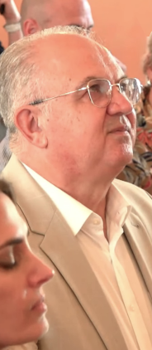
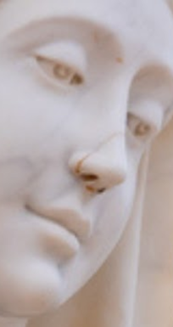
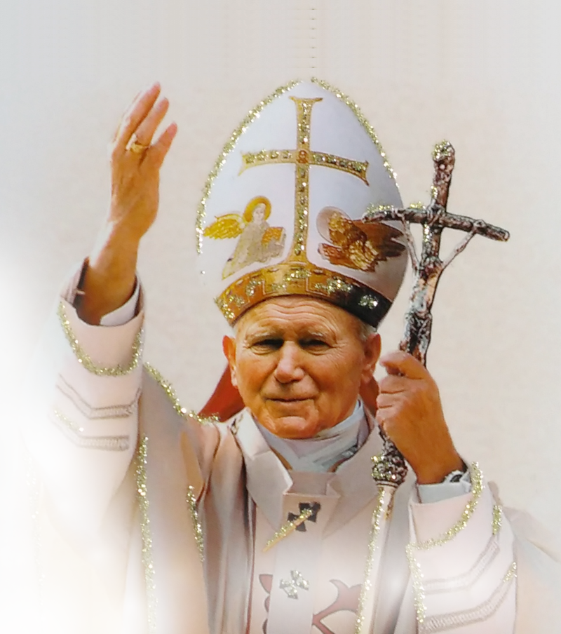
Our Lady’s Messages and Apparitions from July 25th 2025 to April 25th 2026
to Marija Pavlović Lunetti and Ivan Dragičević
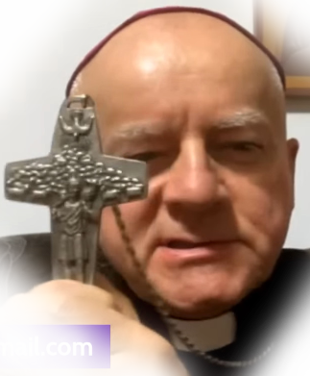
English
and yearly apparition messages to Jakov Čolo and Mirjana Dragičević

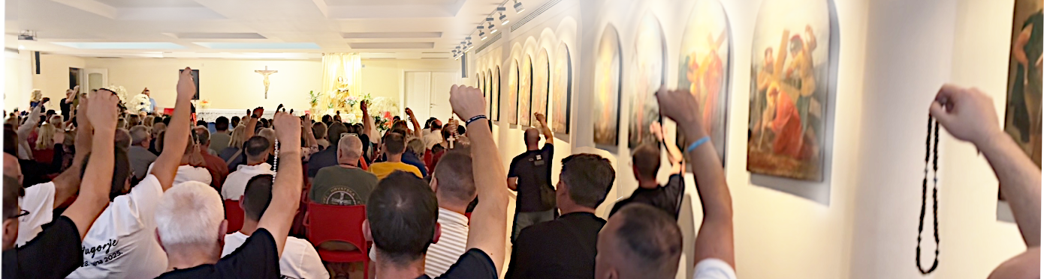
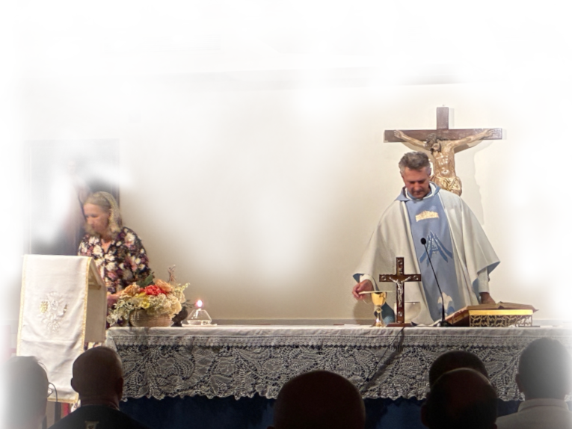

Međugorje

Our Lady’s Messages and Apparitions from July 25th 2025 to April 25th 2026
to Marija Pavlović Lunetti and Ivan Dragičević
and yearly apparition messages to Jakov Čolo and Mirjana Dragičević
English

Međugorje

Our Lady’s Messages and Apparitions from July 25th 2025 to April 25th 2026
to Marija Pavlović Lunetti and Ivan Dragičević
and yearly apparition messages to Jakov Čolo and Mirjana Dragičević
English

Međugorje

Our Lady’s Messages and Apparitions from July 25th 2025 to April 25th 2026
to Marija Pavlović Lunetti and Ivan Dragičević
and yearly apparition messages to Jakov Čolo and Mirjana Dragičević
English

Međugorje

Our Lady’s Messages and Apparitions from July 25th 2025 to April 25th 2026
to Marija Pavlović Lunetti and Ivan Dragičević
and yearly apparition messages to Jakov Čolo and Mirjana Dragičević
English

Međugorje


Our Lady came to Međugorje in 1981, and the Papal Commission (often called Ruini’s Commission after the cardinal who presided it) approved Her first apparitions as true, and found the visionaries authentic, without disclaiming later apparitions.

Near every QR-code the locations are written which it will give. Exactly those addresses you need to get. Examine carefully the reading of the QR-code, edit it if necessary, as well as the address track where the changes happen to take effect. The location is just like someone’s email address, unique address on the Internet of some content. Every Internet user should discern that much, if they want to browse the Internet as unobstructed as it gets.
The very address of the location you are visiting can be looked at and corrected in your browser in the address track, usually at the top of the browser, above the very content (in smartphones it can be in the bottom, underneath the content).

This booklet is made in Croatia due to an increasing need for the messages of Our Lady through Međugorje seers, and reports of Her apparitions, in English, in Croatia.

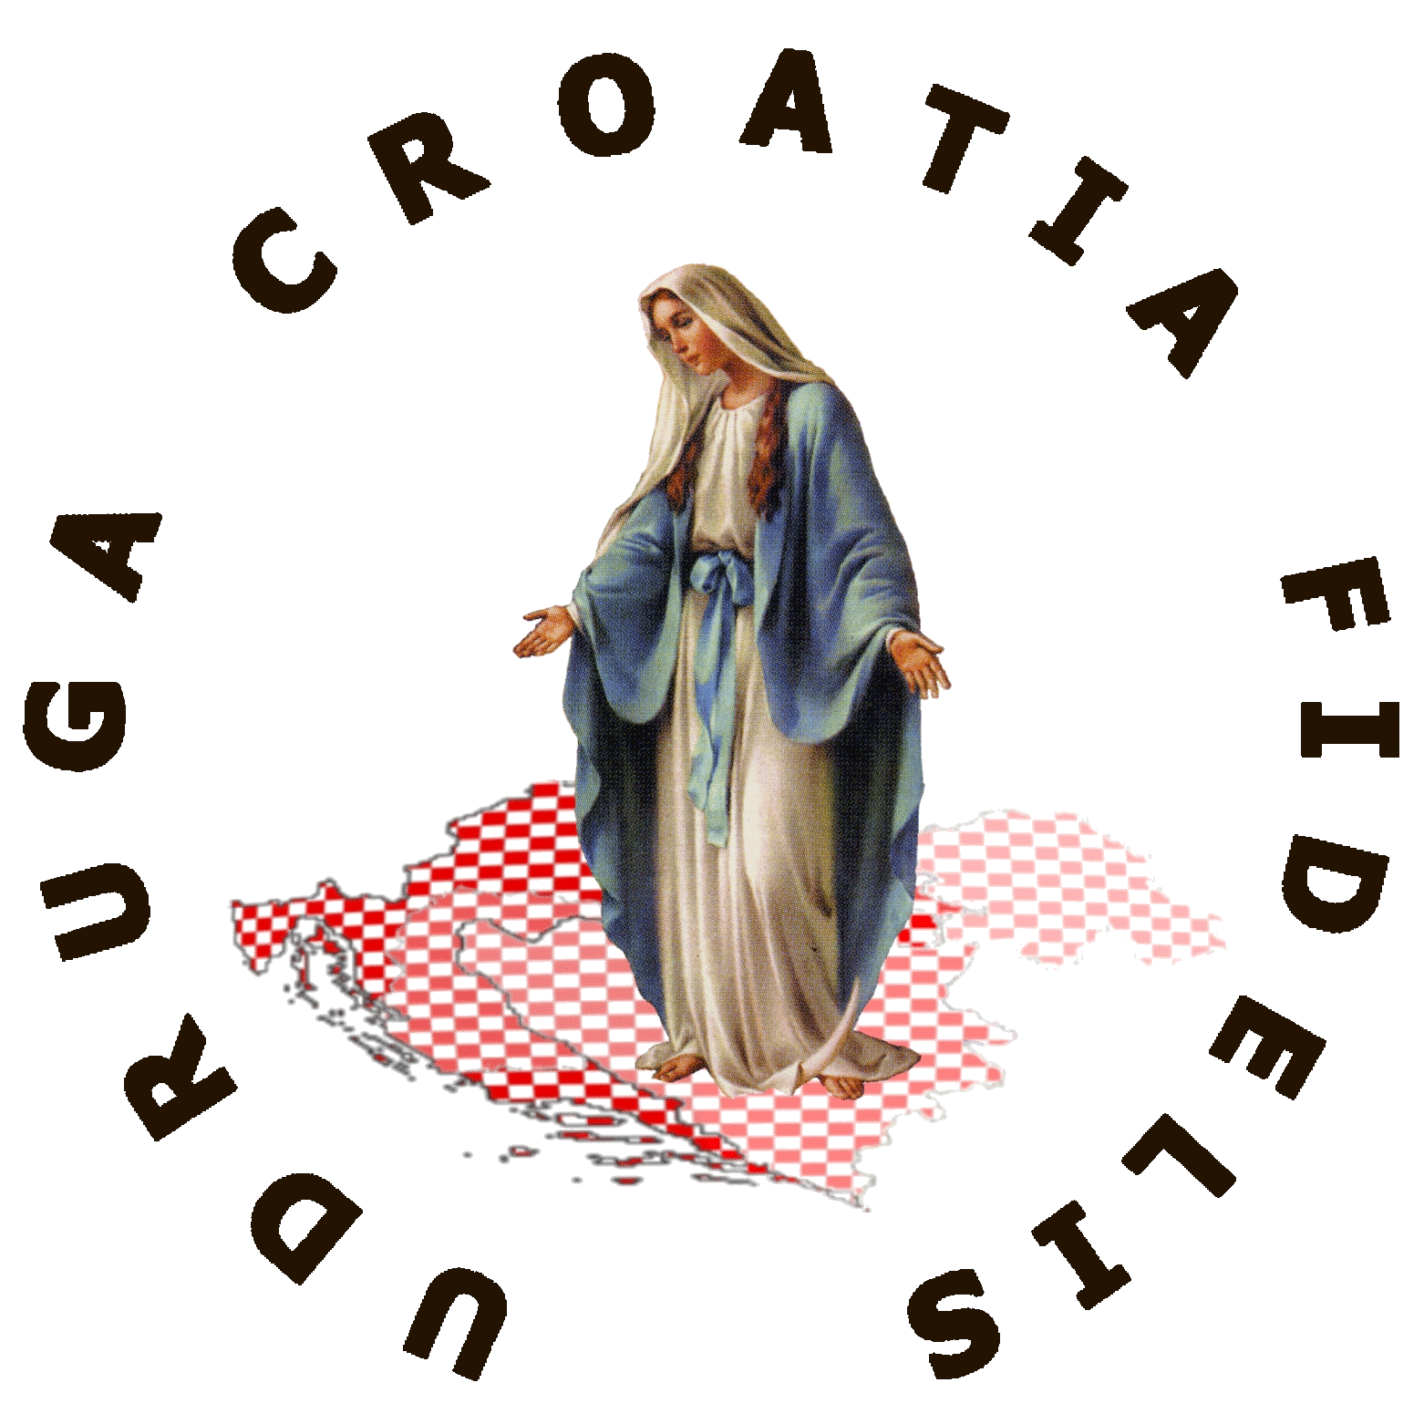
Unfortunately, regardless of all the efforts and precision in the making of this booklet, the censorship can give you additional hardship. There is no space here to explain very much, and we have unknowns in the Internet Tech as well.
Check on the right how stalling/diversions are injected in serving some website, if they don’t prevent you from viewing, of course.
The latter holds, although none of it is always usually the case, for any link anyway. The freedom of surfing, it seems, in Europe at least, remains on paper only.
https://rumble.com/v76pfqo-foreign-code-in-my-website.html

You have proofs of censorship if you manage to correctly access the materials we posted on the location given with the QR-code to the left.
The head of the association, see on the very left, was exposed to severe cyber assaults not by some maverick hackers, but from the surveillors, the deep system, in his country. Most of his SOHO computers attempted rooting into, sometimes left broken to (near) disrepair, and he is denied the possibility of most correspondence and of any transactions outside of his country (i.e. no smartphone bying nor receiving anything over Internet).
The bulk of our working efforts we will still be dedicating to preparing these booklets, and what free time remains on the solving of the above issues. We won’t abandon the road of salvation.
Some of the leaflets with messages and reports on apparitions were first printed as single leaflets, therefore some may still be marked with big note
so mostly Croatian
public would not confuse
them with Croatian leaflets.
version
2026-06-22

English
not for sale
Association Croatia Fidelis
contact: Miroslav Rovis, miro.rovis@croatiafidelis.hr,
miroslav.rovis@proton.me,
+385 1 6602633
+385 91 2660202
https://croatiafidelis.hr/cenz/

Our Lady came to Međugorje in 1981, and the Papal Commission (often called Ruini’s Commission after the cardinal who presided it) approved Her first apparitions as true, and found the visionaries authentic, without disclaiming later apparitions.

Near every QR-code the locations are written which it will give. Exactly those addresses you need to get. Examine carefully the reading of the QR-code, edit it if necessary, as well as the address track where the changes happen to take effect. The location is just like someone’s email address, unique address on the Internet of some content. Every Internet user should discern that much, if they want to browse the Internet as unobstructed as it gets.
The very address of the location you are visiting can be looked at and corrected in your browser in the address track, usually at the top of the browser, above the very content (in smartphones it can be in the bottom, underneath the content).
This booklet is made in Croatia due to an increasing need for the messages of Our Lady through Međugorje seers, and reports of Her apparitions, in English, in Croatia.
Unfortunately, regardless of all the efforts and precision in the making of this booklet, the censorship can give you additional hardship. There is no space here to explain very much, and we have unknowns in the Internet Tech as well.
Check on the right how stalling/diversions are injected in serving some website, if they don’t prevent you from viewing, of course.
The latter holds, although none of it is always usually the case, for any link anyway. The freedom of surfing, it seems, in Europe at least, remains on paper only.
https://rumble.com/v76pfqo-foreign-code-in-my-website.html

You have proofs of censorship if you manage to correctly access the materials we posted on the location given with the QR-code to the left.
The head of the association, see on the very left, was exposed to severe cyber assaults not by some maverick hackers, but from the surveillors, the deep system, in his country. Most of his SOHO computers attempted rooting into, sometimes left broken to (near) disrepair, and he is denied the possibility of most correspondence and of any transactions outside of his country (i.e. no smartphone bying nor receiving anything over Internet).
The bulk of our working efforts we will still be dedicating to preparing these booklets, and what free time remains on the solving of the above issues. We won’t abandon the road of salvation.
Some of the leaflets with messages and reports on apparitions were first printed as single leaflets, therefore some may still be marked with big note
so mostly Croatian
public would not confuse
them with Croatian leaflets.
version
2026-06-22
English
not for sale
https://croatiafidelis.hr/cenz/
Association Croatia Fidelis
contact: Miroslav Rovis, miro.rovis@croatiafidelis.hr,
miroslav.rovis@proton.me,
+385 1 6602633
+385 91 2660202

Our Lady came to Međugorje in 1981, and the Papal Commission (often called Ruini’s Commission after the cardinal who presided it) approved Her first apparitions as true, and found the visionaries authentic, without disclaiming later apparitions.

Near every QR-code the locations are written which it will give. Exactly those addresses you need to get. Examine carefully the reading of the QR-code, edit it if necessary, as well as the address track where the changes happen to take effect. The location is just like someone’s email address, unique address on the Internet of some content. Every Internet user should discern that much, if they want to browse the Internet as unobstructed as it gets.
The very address of the location you are visiting can be looked at and corrected in your browser in the address track, usually at the top of the browser, above the very content (in smartphones it can be in the bottom, underneath the content).
This booklet is made in Croatia due to an increasing need for the messages of Our Lady through Međugorje seers, and reports of Her apparitions, in English, in Croatia.
Unfortunately, regardless of all the efforts and precision in the making of this booklet, the censorship can give you additional hardship. There is no space here to explain very much, and we have unknowns in the Internet Tech as well.
Check on the right how stalling/diversions are injected in serving some website, if they don’t prevent you from viewing, of course.
The latter holds, although none of it is always usually the case, for any link anyway. The freedom of surfing, it seems, in Europe at least, remains on paper only.
https://rumble.com/v76pfqo-foreign-code-in-my-website.html

You have proofs of censorship if you manage to correctly access the materials we posted on the location given with the QR-code to the left.
The head of the association, see on the very left, was exposed to severe cyber assaults not by some maverick hackers, but from the surveillors, the deep system, in his country. Most of his SOHO computers attempted rooting into, sometimes left broken to (near) disrepair, and he is denied the possibility of most correspondence and of any transactions outside of his country (i.e. no smartphone bying nor receiving anything over Internet).
The bulk of our working efforts we will still be dedicating to preparing these booklets, and what free time remains on the solving of the above issues. We won’t abandon the road of salvation.
Some of the leaflets with messages and reports on apparitions were first printed as single leaflets, therefore some may still be marked with big note
so mostly Croatian
public would not confuse
them with Croatian leaflets.
version
2026-06-22
English
not for sale
https://croatiafidelis.hr/cenz/
Association Croatia Fidelis
contact: Miroslav Rovis, miro.rovis@croatiafidelis.hr,
miroslav.rovis@proton.me,
+385 1 6602633
+385 91 2660202

Our Lady came to Međugorje in 1981, and the Papal Commission (often called Ruini’s Commission after the cardinal who presided it) approved Her first apparitions as true, and found the visionaries authentic, without disclaiming later apparitions.

Near every QR-code the locations are written which it will give. Exactly those addresses you need to get. Examine carefully the reading of the QR-code, edit it if necessary, as well as the address track where the changes happen to take effect. The location is just like someone’s email address, unique address on the Internet of some content. Every Internet user should discern that much, if they want to browse the Internet as unobstructed as it gets.
The very address of the location you are visiting can be looked at and corrected in your browser in the address track, usually at the top of the browser, above the very content (in smartphones it can be in the bottom, underneath the content).
This booklet is made in Croatia due to an increasing need for the messages of Our Lady through Međugorje seers, and reports of Her apparitions, in English, in Croatia.
Unfortunately, regardless of all the efforts and precision in the making of this booklet, the censorship can give you additional hardship. There is no space here to explain very much, and we have unknowns in the Internet Tech as well.
Check on the right how stalling/diversions are injected in serving some website, if they don’t prevent you from viewing, of course.
The latter holds, although none of it is always usually the case, for any link anyway. The freedom of surfing, it seems, in Europe at least, remains on paper only.
https://rumble.com/v76pfqo-foreign-code-in-my-website.html

You have proofs of censorship if you manage to correctly access the materials we posted on the location given with the QR-code to the left.
The head of the association, see on the very left, was exposed to severe cyber assaults not by some maverick hackers, but from the surveillors, the deep system, in his country. Most of his SOHO computers attempted rooting into, sometimes left broken to (near) disrepair, and he is denied the possibility of most correspondence and of any transactions outside of his country (i.e. no smartphone bying nor receiving anything over Internet).
The bulk of our working efforts we will still be dedicating to preparing these booklets, and what free time remains on the solving of the above issues. We won’t abandon the road of salvation.
Some of the leaflets with messages and reports on apparitions were first printed as single leaflets, therefore some may still be marked with big note
so mostly Croatian
public would not confuse
them with Croatian leaflets.
version
2026-06-22
English
not for sale
https://croatiafidelis.hr/cenz/
Association Croatia Fidelis
contact: Miroslav Rovis, miro.rovis@croatiafidelis.hr,
miroslav.rovis@proton.me,
+385 1 6602633
+385 91 2660202

Our Lady came to Međugorje in 1981, and the Papal Commission (often called Ruini’s Commission after the cardinal who presided it) approved Her first apparitions as true, and found the visionaries authentic, without disclaiming later apparitions.

Near every QR-code the locations are written which it will give. Exactly those addresses you need to get. Examine carefully the reading of the QR-code, edit it if necessary, as well as the address track where the changes happen to take effect. The location is just like someone’s email address, unique address on the Internet of some content. Every Internet user should discern that much, if they want to browse the Internet as unobstructed as it gets.
The very address of the location you are visiting can be looked at and corrected in your browser in the address track, usually at the top of the browser, above the very content (in smartphones it can be in the bottom, underneath the content).
This booklet is made in Croatia due to an increasing need for the messages of Our Lady through Međugorje seers, and reports of Her apparitions, in English, in Croatia.
Unfortunately, regardless of all the efforts and precision in the making of this booklet, the censorship can give you additional hardship. There is no space here to explain very much, and we have unknowns in the Internet Tech as well.
Check on the right how stalling/diversions are injected in serving some website, if they don’t prevent you from viewing, of course.
The latter holds, although none of it is always usually the case, for any link anyway. The freedom of surfing, it seems, in Europe at least, remains on paper only.
https://rumble.com/v76pfqo-foreign-code-in-my-website.html

You have proofs of censorship if you manage to correctly access the materials we posted on the location given with the QR-code to the left.
The head of the association, see on the very left, was exposed to severe cyber assaults not by some maverick hackers, but from the surveillors, the deep system, in his country. Most of his SOHO computers attempted rooting into, sometimes left broken to (near) disrepair, and he is denied the possibility of most correspondence and of any transactions outside of his country (i.e. no smartphone bying nor receiving anything over Internet).
The bulk of our working efforts we will still be dedicating to preparing these booklets, and what free time remains on the solving of the above issues. We won’t abandon the road of salvation.
Some of the leaflets with messages and reports on apparitions were first printed as single leaflets, therefore some may still be marked with big note
so mostly Croatian
public would not confuse
them with Croatian leaflets.
version
2026-06-22
English
not for sale
https://croatiafidelis.hr/cenz/
Association Croatia Fidelis
contact: Miroslav Rovis, miro.rovis@croatiafidelis.hr,
miroslav.rovis@proton.me,
+385 1 6602633
+385 91 2660202

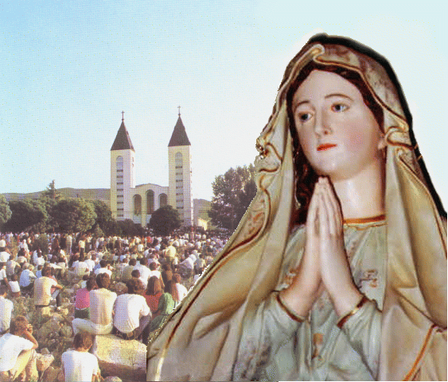
Our Lady’s message from Međugorje, July 25th 2025. through visionary Marija Pavlović Lunetti

Dear children!
In this time of grace, when the Most High permits me to love you and lead you on the way of holiness, Satan wants to entangle you with the cord of peacelessness and hatred. Do not permit him to prevail, but, little children, fight for the holiness of every life.
Thank you for having responded to my call.

(with Ecclesiastical approval)
from https://www.medjugorje.hr, compared to: https://marytv.tv/, https://medjugorje.org, https://spiritofedjugorje.org, https://consecratedhearts.com, https://www.privaterevelation.org/

Our Lady’s message from Međugorje, July 25th 2025. through visionary Marija Pavlović Lunetti

Dear children!
In this time of grace, when the Most High permits me to love you and lead you on the way of holiness, Satan wants to entangle you with the cord of peacelessness and hatred. Do not permit him to prevail, but, little children, fight for the holiness of every life.
Thank you for having responded to my call.

(with Ecclesiastical approval)
from https://www.medjugorje.hr, compared to: https://marytv.tv/, https://medjugorje.org, https://spiritofedjugorje.org, https://consecratedhearts.com, https://www.privaterevelation.org/

Our Lady’s message from Međugorje, July 25th 2025. through visionary Marija Pavlović Lunetti

Dear children!
In this time of grace, when the Most High permits me to love you and lead you on the way of holiness, Satan wants to entangle you with the cord of peacelessness and hatred. Do not permit him to prevail, but, little children, fight for the holiness of every life.
Thank you for having responded to my call.

(with Ecclesiastical approval)
from https://www.medjugorje.hr, compared to: https://marytv.tv/, https://medjugorje.org, https://spiritofedjugorje.org, https://consecratedhearts.com, https://www.privaterevelation.org/

Our Lady’s message from Međugorje, July 25th 2025. through visionary Marija Pavlović Lunetti

Dear children!
In this time of grace, when the Most High permits me to love you and lead you on the way of holiness, Satan wants to entangle you with the cord of peacelessness and hatred. Do not permit him to prevail, but, little children, fight for the holiness of every life.
Thank you for having responded to my call.

(with Ecclesiastical approval)
from https://www.medjugorje.hr, compared to: https://marytv.tv/, https://medjugorje.org, https://spiritofedjugorje.org, https://consecratedhearts.com, https://www.privaterevelation.org/

Our Lady’s message from Međugorje, July 25th 2025. through visionary Marija Pavlović Lunetti

Dear children!
In this time of grace, when the Most High permits me to love you and lead you on the way of holiness, Satan wants to entangle you with the cord of peacelessness and hatred. Do not permit him to prevail, but, little children, fight for the holiness of every life.
Thank you for having responded to my call.

(with Ecclesiastical approval)
from https://www.medjugorje.hr, compared to: https://marytv.tv/, https://medjugorje.org, https://spiritofedjugorje.org, https://consecratedhearts.com, https://www.privaterevelation.org/


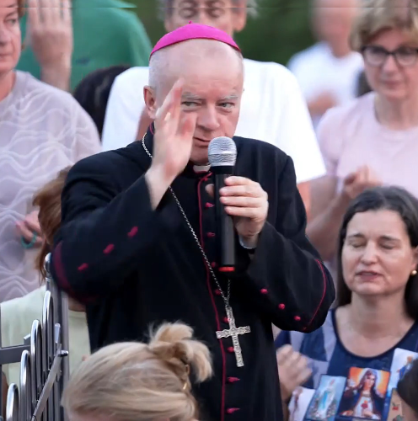
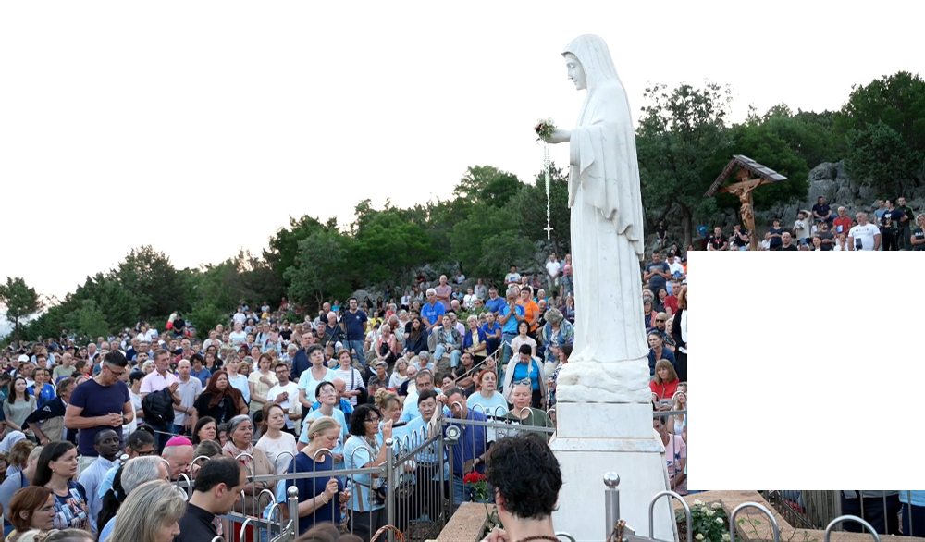
June 20th 2025
https://video.marytv.tv/watch/m7EuGpsaXgG
Međugorje 44th Anniversary Novena
5th Day
Visinary Marija describes the encounter:
“Today, during the time of the apparition, Our Blessed Mother was looking at us, and I presented all of us to her — all our intentions, everything we carry in our hearts, and also the people who couldn’t come and are not physically here but are spiritually present with us in prayer. Our Blessed Mother prayed over us for a long time and looked at us.”

“I especially asked her to intercede before her Son Jesus for peace in our hearts, peace in our families, and peace in the whole world. Our Blessed Mother again prayed for a long time for peace. She blessed all of us with the sign of the cross and then ascended to Heaven.”
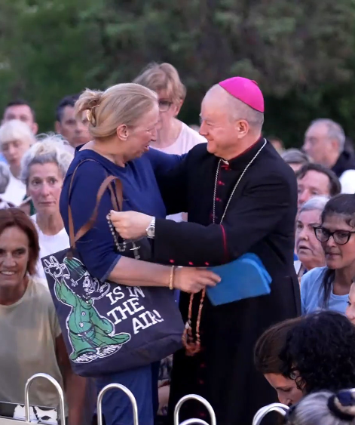
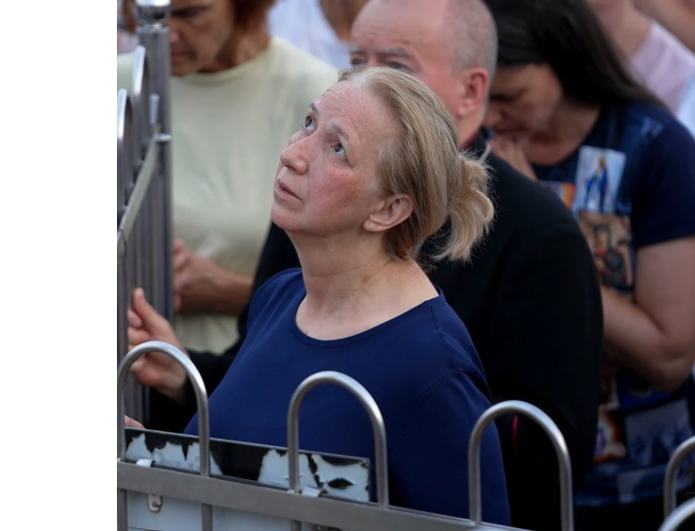

This message is a sample from the booklet with the messages and apparitions of roughly first half of year 2025


The text is from the report you get with the left QR-code (you get the long link in bottom). The top right QR-code and its link is to the video of the apparition.

https://centermirmedjugorje.com/2025/06/20/5th-day-of-the-novena-for-peace-our-blessed-mother-prayed-over-us-for-a-long-time-and-looked-at-us-marija-pavlovic/
June 20th 2025
https://video.marytv.tv/watch/m7EuGpsaXgG
5th Day
Međugorje 44th Anniversary Novena
Visinary Marija describes the encounter:
“Today, during the time of the apparition, Our Blessed Mother was looking at us, and I presented all of us to her — all our intentions, everything we carry in our hearts, and also the people who couldn’t come and are not physically here but are spiritually present with us in prayer. Our Blessed Mother prayed over us for a long time and looked at us.”

“I especially asked her to intercede before her Son Jesus for peace in our hearts, peace in our families, and peace in the whole world. Our Blessed Mother again prayed for a long time for peace. She blessed all of us with the sign of the cross and then ascended to Heaven.”

This message is a sample from the booklet with the messages and apparitions of roughly first half of year 2025

The text is from the report you get with the left QR-code (you get the long link in bottom). The top right QR-code and its link is to the video of the apparition.

https://centermirmedjugorje.com/2025/06/20/5th-day-of-the-novena-for-peace-our-blessed-mother-prayed-over-us-for-a-long-time-and-looked-at-us-marija-pavlovic/
June 20th 2025
https://video.marytv.tv/watch/m7EuGpsaXgG
5th Day
Međugorje 44th Anniversary Novena
Visinary Marija describes the encounter:
“Today, during the time of the apparition, Our Blessed Mother was looking at us, and I presented all of us to her — all our intentions, everything we carry in our hearts, and also the people who couldn’t come and are not physically here but are spiritually present with us in prayer. Our Blessed Mother prayed over us for a long time and looked at us.”

“I especially asked her to intercede before her Son Jesus for peace in our hearts, peace in our families, and peace in the whole world. Our Blessed Mother again prayed for a long time for peace. She blessed all of us with the sign of the cross and then ascended to Heaven.”

This message is a sample from the booklet with the messages and apparitions of roughly first half of year 2025

The text is from the report you get with the left QR-code (you get the long link in bottom). The top right QR-code and its link is to the video of the apparition.

https://centermirmedjugorje.com/2025/06/20/5th-day-of-the-novena-for-peace-our-blessed-mother-prayed-over-us-for-a-long-time-and-looked-at-us-marija-pavlovic/
June 20th 2025
https://video.marytv.tv/watch/m7EuGpsaXgG
5th Day
Međugorje 44th Anniversary Novena
Visinary Marija describes the encounter:
“Today, during the time of the apparition, Our Blessed Mother was looking at us, and I presented all of us to her — all our intentions, everything we carry in our hearts, and also the people who couldn’t come and are not physically here but are spiritually present with us in prayer. Our Blessed Mother prayed over us for a long time and looked at us.”

“I especially asked her to intercede before her Son Jesus for peace in our hearts, peace in our families, and peace in the whole world. Our Blessed Mother again prayed for a long time for peace. She blessed all of us with the sign of the cross and then ascended to Heaven.”

This message is a sample from the booklet with the messages and apparitions of roughly first half of year 2025

The text is from the report you get with the left QR-code (you get the long link in bottom). The top right QR-code and its link is to the video of the apparition.

https://centermirmedjugorje.com/2025/06/20/5th-day-of-the-novena-for-peace-our-blessed-mother-prayed-over-us-for-a-long-time-and-looked-at-us-marija-pavlovic/
June 20th 2025
https://video.marytv.tv/watch/m7EuGpsaXgG
5th Day
Međugorje 44th Anniversary Novena
Visinary Marija describes the encounter:
“Today, during the time of the apparition, Our Blessed Mother was looking at us, and I presented all of us to her — all our intentions, everything we carry in our hearts, and also the people who couldn’t come and are not physically here but are spiritually present with us in prayer. Our Blessed Mother prayed over us for a long time and looked at us.”

“I especially asked her to intercede before her Son Jesus for peace in our hearts, peace in our families, and peace in the whole world. Our Blessed Mother again prayed for a long time for peace. She blessed all of us with the sign of the cross and then ascended to Heaven.”

This message is a sample from the booklet with the messages and apparitions of roughly first half of year 2025

The text is from the report you get with the left QR-code (you get the long link in bottom). The top right QR-code and its link is to the video of the apparition.

https://centermirmedjugorje.com/2025/06/20/5th-day-of-the-novena-for-peace-our-blessed-mother-prayed-over-us-for-a-long-time-and-looked-at-us-marija-pavlovic/
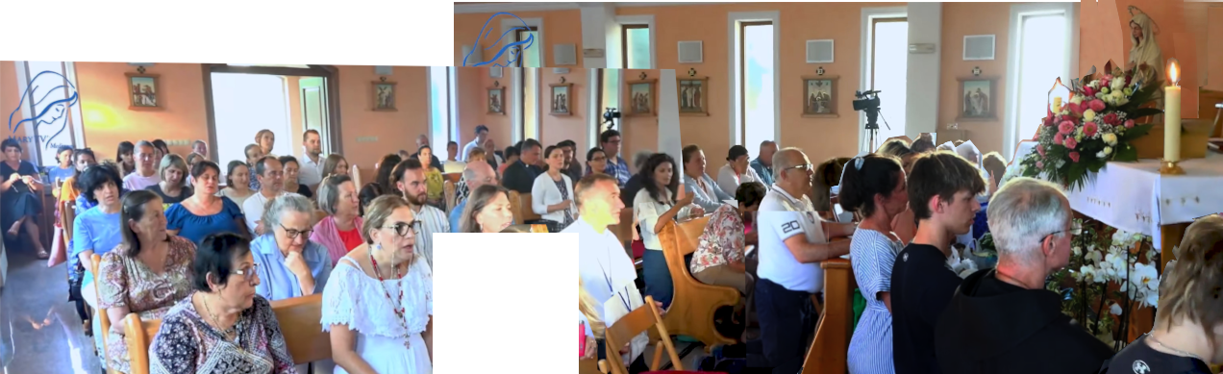

https://video.marytv.tv/watch/mgY8XusazRO
Our Lady’s Apparition and Message through Ivan Dragičević


Dear children!
Today in a special way I want to call you to, through this time, pray especially on my intentions. How many times have I said: dear children, I I need you. I can realize my plans with you. Therefore
I invite you anew, during this time pray, pray
especially for peace!
Thank you dear children
also today for having
responded to my call!
August 9th 2025

Above the code and link to the whole footage (1h 5m), in bottom to report (20m) with audible Ivan’s speech in Croatian
and subtitles.



https://rumble.com/v6y2qfy-medjugorje-ivan-dragicevic-apparition-2025-08-09.html

https://video.marytv.tv/watch/mgY8XusazRO
Our Lady’s Apparition and Message through Ivan Dragičević

Dear children!
Today in a special way I want to call you to, through this time, pray especially on my intentions. How many times have I said: dear children, I I need you. I can realize my plans with you. Therefore
I invite you anew, during this time pray, pray
especially for peace!
Thank you dear children
also today for having
responded to my call!
August 9th 2025

Above the code and link to the whole footage (1h 5m), in bottom to report (20m) with audible Ivan’s speech in Croatian
and subtitles.

https://rumble.com/v6y2qfy-medjugorje-ivan-dragicevic-apparition-2025-08-09.html

https://video.marytv.tv/watch/mgY8XusazRO
Our Lady’s Apparition and Message through Ivan Dragičević

Dear children!
Today in a special way I want to call you to, through this time, pray especially on my intentions. How many times have I said: dear children, I I need you. I can realize my plans with you. Therefore
I invite you anew, during this time pray, pray
especially for peace!
Thank you dear children
also today for having
responded to my call!
August 9th 2025

Above the code and link to the whole footage (1h 5m), in bottom to report (20m) with audible Ivan’s speech in Croatian
and subtitles.

https://rumble.com/v6y2qfy-medjugorje-ivan-dragicevic-apparition-2025-08-09.html

https://video.marytv.tv/watch/mgY8XusazRO
Our Lady’s Apparition and Message through Ivan Dragičević

Dear children!
Today in a special way I want to call you to, through this time, pray especially on my intentions. How many times have I said: dear children, I I need you. I can realize my plans with you. Therefore
I invite you anew, during this time pray, pray
especially for peace!
Thank you dear children
also today for having
responded to my call!
August 9th 2025

Above the code and link to the whole footage (1h 5m), in bottom to report (20m) with audible Ivan’s speech in Croatian
and subtitles.

https://rumble.com/v6y2qfy-medjugorje-ivan-dragicevic-apparition-2025-08-09.html

https://video.marytv.tv/watch/mgY8XusazRO
Our Lady’s Apparition and Message through Ivan Dragičević

Dear children!
Today in a special way I want to call you to, through this time, pray especially on my intentions. How many times have I said: dear children, I I need you. I can realize my plans with you. Therefore
I invite you anew, during this time pray, pray
especially for peace!
Thank you dear children
also today for having
responded to my call!
August 9th 2025

Above the code and link to the whole footage (1h 5m), in bottom to report (20m) with audible Ivan’s speech in Croatian
and subtitles.

https://rumble.com/v6y2qfy-medjugorje-ivan-dragicevic-apparition-2025-08-09.html

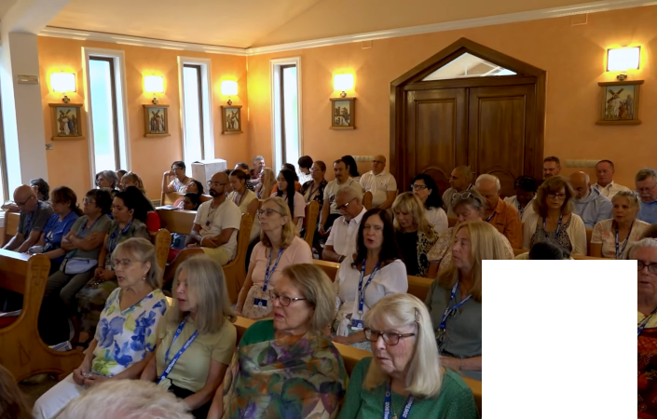
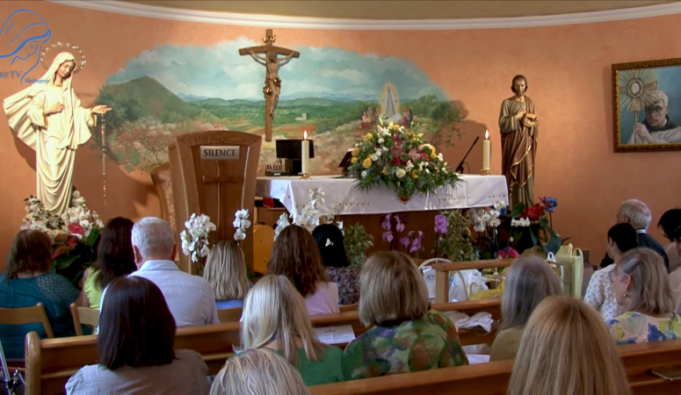

https://video.marytv.tv/watch/mgZKKWsaBYt
Our Lady’s Apparition and Message through Ivan Dragičević

Dear children!
Today in a special way I wish to call you to pray for togetherness, togetherness of Christians. I call you today in a special way to forgiveness, that you forgive each other.
Do not search faults in others. Pray for the others. Only if you do
so will you be open to the Holy Spirit and you will receive graces.
Pray, pray, pray!
Thank you dear children also today for having responded to my call!

August 16th 2025

Above the code and link to entire video (1h 19m), to the right to report (22m) with audible Ivan’s speech and closer translation
subtitles.

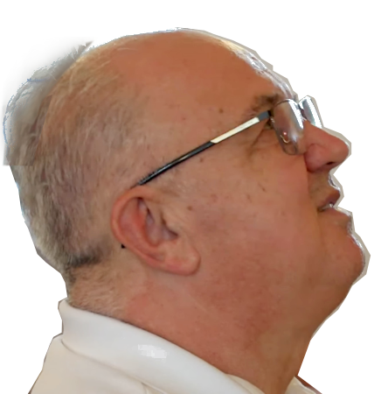

https://rumble.com/v6y4d6k-medjugorje-ivan-dragicevic-apparition-2025-08-16.html
https://video.marytv.tv/watch/mgZKKWsaBYt
Our Lady’s Apparition and Message through Ivan Dragičević
Dear children!
Today in a special way I wish to call you to pray for togetherness, togetherness of Christians. I call you today in a special way to forgiveness, that you forgive each other.
Do not search faults in others. Pray for the others. Only if you do
so will you be open to the Holy Spirit and you will receive graces.
Pray, pray, pray!
Thank you dear children also today for having responded to my call!

August 16th 2025

Above the code and link to entire video (1h 19m), to the right to report (22m) with audible Ivan’s speech and closer translation
subtitles.

https://rumble.com/v6y4d6k-medjugorje-ivan-dragicevic-apparition-2025-08-16.html
https://video.marytv.tv/watch/mgZKKWsaBYt
Our Lady’s Apparition and Message through Ivan Dragičević
Dear children!
Today in a special way I wish to call you to pray for togetherness, togetherness of Christians. I call you today in a special way to forgiveness, that you forgive each other.
Do not search faults in others. Pray for the others. Only if you do
so will you be open to the Holy Spirit and you will receive graces.
Pray, pray, pray!
Thank you dear children also today for having responded to my call!

August 16th 2025

Above the code and link to entire video (1h 19m), to the right to report (22m) with audible Ivan’s speech and closer translation
subtitles.

https://rumble.com/v6y4d6k-medjugorje-ivan-dragicevic-apparition-2025-08-16.html
https://video.marytv.tv/watch/mgZKKWsaBYt
Our Lady’s Apparition and Message through Ivan Dragičević
Dear children!
Today in a special way I wish to call you to pray for togetherness, togetherness of Christians. I call you today in a special way to forgiveness, that you forgive each other.
Do not search faults in others. Pray for the others. Only if you do
so will you be open to the Holy Spirit and you will receive graces.
Pray, pray, pray!
Thank you dear children also today for having responded to my call!

August 16th 2025

Above the code and link to entire video (1h 19m), to the right to report (22m) with audible Ivan’s speech and closer translation
subtitles.

https://rumble.com/v6y4d6k-medjugorje-ivan-dragicevic-apparition-2025-08-16.html
https://video.marytv.tv/watch/mgZKKWsaBYt
Our Lady’s Apparition and Message through Ivan Dragičević
Dear children!
Today in a special way I wish to call you to pray for togetherness, togetherness of Christians. I call you today in a special way to forgiveness, that you forgive each other.
Do not search faults in others. Pray for the others. Only if you do
so will you be open to the Holy Spirit and you will receive graces.
Pray, pray, pray!
Thank you dear children also today for having responded to my call!

August 16th 2025

Above the code and link to entire video (1h 19m), to the right to report (22m) with audible Ivan’s speech and closer translation
subtitles.

https://rumble.com/v6y4d6k-medjugorje-ivan-dragicevic-apparition-2025-08-16.html
Our Lady’s message from Međugorje, August 25th 2025. through visionary Marija Pavlović Lunetti

Dear children, my little children, my beloved ones!
You are chosen because you have responded, you have put into practice my instructions and love God above all else. Therefore, little children, pray with all your heart that my words may be realized. Fast, sacrifice yourselves, love out of love for God who created you, and be, little children, my extended hands to this world that has not come to know the God of love.
Thank you for having responded to my call.

(with Ecclesiastical approval)
from https://www.medjugorje.hr, compared to: https://marytv.tv/, https://medjugorje.org, https://centermirmedjugorje.com , https://www.medjugorje.ws, https://www.privaterevelation.org/

Our Lady’s message from Međugorje, August 25th 2025. through visionary Marija Pavlović Lunetti

Dear children, my little children, my beloved ones!
You are chosen because you have responded, you have put into practice my instructions and love God above all else. Therefore, little children, pray with all your heart that my words may be realized. Fast, sacrifice yourselves, love out of love for God who created you, and be, little children, my extended hands to this world that has not come to know the God of love.
Thank you for having responded to my call.

(with Ecclesiastical approval)
from https://www.medjugorje.hr, compared to: https://marytv.tv/, https://medjugorje.org, https://centermirmedjugorje.com , https://www.medjugorje.ws, https://www.privaterevelation.org/

Our Lady’s message from Međugorje, August 25th 2025. through visionary Marija Pavlović Lunetti

Dear children, my little children, my beloved ones!
You are chosen because you have responded, you have put into practice my instructions and love God above all else. Therefore, little children, pray with all your heart that my words may be realized. Fast, sacrifice yourselves, love out of love for God who created you, and be, little children, my extended hands to this world that has not come to know the God of love.
Thank you for having responded to my call.

(with Ecclesiastical approval)
from https://www.medjugorje.hr, compared to: https://marytv.tv/, https://medjugorje.org, https://centermirmedjugorje.com , https://www.medjugorje.ws, https://www.privaterevelation.org/

Our Lady’s message from Međugorje, August 25th 2025. through visionary Marija Pavlović Lunetti

Dear children, my little children, my beloved ones!
You are chosen because you have responded, you have put into practice my instructions and love God above all else. Therefore, little children, pray with all your heart that my words may be realized. Fast, sacrifice yourselves, love out of love for God who created you, and be, little children, my extended hands to this world that has not come to know the God of love.
Thank you for having responded to my call.

(with Ecclesiastical approval)
from https://www.medjugorje.hr, compared to: https://marytv.tv/, https://medjugorje.org, https://centermirmedjugorje.com , https://www.medjugorje.ws, https://www.privaterevelation.org/

Our Lady’s message from Međugorje, August 25th 2025. through visionary Marija Pavlović Lunetti

Dear children, my little children, my beloved ones!
You are chosen because you have responded, you have put into practice my instructions and love God above all else. Therefore, little children, pray with all your heart that my words may be realized. Fast, sacrifice yourselves, love out of love for God who created you, and be, little children, my extended hands to this world that has not come to know the God of love.
Thank you for having responded to my call.

(with Ecclesiastical approval)
from https://www.medjugorje.hr, compared to: https://marytv.tv/, https://medjugorje.org, https://centermirmedjugorje.com , https://www.medjugorje.ws, https://www.privaterevelation.org/

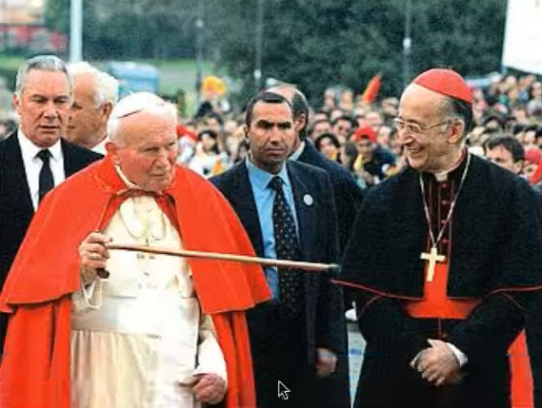
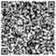
Cardinal Camillo Ruini in 2024 on Our Lady of Međugorje
The international Papal Commission for Međugorje was established by Pope Benedict XVI in 2010. The members were cardinals Jozef Tomko, Vinko Puljić, Josip Bozanić, Julian Herranz, archbishop Angelo Amato, and lower ranking Tony Anatrella, Pierangelo Sequeri, Zdzislaw Jozef Kijas, Salvatore Perrella, Achim Schutz, Franjo Topić, Mijo Nikić, Mihaly Szentmartoni, s. Veronica Nela Gaspar, and was presided by Crd. Ruini.
It concluded its work in 2014. But the report is (as of 2025) still unavilable to the public.
What is known is that it found that the Međugorje seers were authentic and that Our Lady truly appeared and spoke in the first seven apparitions, not disclaming other apparitions.

The scan-code gives the link in bottom to the article in Corriere della Sera of December 8th 2024. On Međugorje there is only as much as what we present, in Italian and translation.
Oggi è l’Immacolata Concenzione. Lei ha presieduto la commissione internazionale d’inchiesta su Medjugorje. Che idea si è fatto?
«Che le prime apparizioni siano autentiche. Era davvero la Madonna a parlare. Sulle altre sospendo il giudizio.»

[journalist Aldo Cazzullo:] It’s the Immaculate Conception today. You presided over the international investigative commission for Međugorje. What do you make of it?
[Cardinal Camillo Ruini:] «That the first apparitions were authentic. It really was Our Lady who spoke. I suspend judgement on the others.»

Crd. Ruini was among the closest associates of both John Paul II and Benedict XVI, long ago emeritus at Pope Francis’ installment. 93 years of age and 71 years of priesthood. Still much listened to and read in the Curch and the world.

https://www.corriere.it/cronache/24_dicembre_08/cardinale-ruini-intervista-48ea898d-3703-49ee-bb64-e5646b24axlk.shtml
Sends us the link if you know of mentions of that article in sites in English.

Cardinal Camillo Ruini in 2024 on Our Lady of Međugorje
The international Papal Commission for Međugorje was established by Pope Benedict XVI in 2010. The members were cardinals Jozef Tomko, Vinko Puljić, Josip Bozanić, Julian Herranz, archbishop Angelo Amato, and lower ranking Tony Anatrella, Pierangelo Sequeri, Zdzislaw Jozef Kijas, Salvatore Perrella, Achim Schutz, Franjo Topić, Mijo Nikić, Mihaly Szentmartoni, s. Veronica Nela Gaspar, and was presided by Crd. Ruini.
It concluded its work in 2014. But the report is (as of 2025) still unavilable to the public.
What is known is that it found that the Međugorje seers were authentic and that Our Lady truly appeared and spoke in the first seven apparitions, not disclaming other apparitions.

The scan-code gives the link in bottom to the article in Corriere della Sera of December 8th 2024. On Međugorje there is only as much as what we present, in Italian and translation.
Oggi è l’Immacolata Concenzione. Lei ha presieduto la commissione internazionale d’inchiesta su Medjugorje. Che idea si è fatto?
«Che le prime apparizioni siano autentiche. Era davvero la Madonna a parlare. Sulle altre sospendo il giudizio.»

[journalist Aldo Cazzullo:] It’s the Immaculate Conception today. You presided over the international investigative commission for Međugorje. What do you make of it?
[Cardinal Camillo Ruini:] «That the first apparitions were authentic. It really was Our Lady who spoke. I suspend judgement on the others.»

Crd. Ruini was among the closest associates of both John Paul II and Benedict XVI, long ago emeritus at Pope Francis’ installment. 93 years of age and 71 years of priesthood. Still much listened to and read in the Curch and the world.

https://www.corriere.it/cronache/24_dicembre_08/cardinale-ruini-intervista-48ea898d-3703-49ee-bb64-e5646b24axlk.shtml
Sends us the link if you know of mentions of that article in sites in English.

Cardinal Camillo Ruini in 2024 on Our Lady of Međugorje
The international Papal Commission for Međugorje was established by Pope Benedict XVI in 2010. The members were cardinals Jozef Tomko, Vinko Puljić, Josip Bozanić, Julian Herranz, archbishop Angelo Amato, and lower ranking Tony Anatrella, Pierangelo Sequeri, Zdzislaw Jozef Kijas, Salvatore Perrella, Achim Schutz, Franjo Topić, Mijo Nikić, Mihaly Szentmartoni, s. Veronica Nela Gaspar, and was presided by Crd. Ruini.
It concluded its work in 2014. But the report is (as of 2025) still unavilable to the public.
What is known is that it found that the Međugorje seers were authentic and that Our Lady truly appeared and spoke in the first seven apparitions, not disclaming other apparitions.

The scan-code gives the link in bottom to the article in Corriere della Sera of December 8th 2024. On Međugorje there is only as much as what we present, in Italian and translation.
Oggi è l’Immacolata Concenzione. Lei ha presieduto la commissione internazionale d’inchiesta su Medjugorje. Che idea si è fatto?
«Che le prime apparizioni siano autentiche. Era davvero la Madonna a parlare. Sulle altre sospendo il giudizio.»

[journalist Aldo Cazzullo:] It’s the Immaculate Conception today. You presided over the international investigative commission for Međugorje. What do you make of it?
[Cardinal Camillo Ruini:] «That the first apparitions were authentic. It really was Our Lady who spoke. I suspend judgement on the others.»

Crd. Ruini was among the closest associates of both John Paul II and Benedict XVI, long ago emeritus at Pope Francis’ installment. 93 years of age and 71 years of priesthood. Still much listened to and read in the Curch and the world.

https://www.corriere.it/cronache/24_dicembre_08/cardinale-ruini-intervista-48ea898d-3703-49ee-bb64-e5646b24axlk.shtml
Sends us the link if you know of mentions of that article in sites in English.

Cardinal Camillo Ruini in 2024 on Our Lady of Međugorje
The international Papal Commission for Međugorje was established by Pope Benedict XVI in 2010. The members were cardinals Jozef Tomko, Vinko Puljić, Josip Bozanić, Julian Herranz, archbishop Angelo Amato, and lower ranking Tony Anatrella, Pierangelo Sequeri, Zdzislaw Jozef Kijas, Salvatore Perrella, Achim Schutz, Franjo Topić, Mijo Nikić, Mihaly Szentmartoni, s. Veronica Nela Gaspar, and was presided by Crd. Ruini.
It concluded its work in 2014. But the report is (as of 2025) still unavilable to the public.
What is known is that it found that the Međugorje seers were authentic and that Our Lady truly appeared and spoke in the first seven apparitions, not disclaming other apparitions.

The scan-code gives the link in bottom to the article in Corriere della Sera of December 8th 2024. On Međugorje there is only as much as what we present, in Italian and translation.
Oggi è l’Immacolata Concenzione. Lei ha presieduto la commissione internazionale d’inchiesta su Medjugorje. Che idea si è fatto?
«Che le prime apparizioni siano autentiche. Era davvero la Madonna a parlare. Sulle altre sospendo il giudizio.»

[journalist Aldo Cazzullo:] It’s the Immaculate Conception today. You presided over the international investigative commission for Međugorje. What do you make of it?
[Cardinal Camillo Ruini:] «That the first apparitions were authentic. It really was Our Lady who spoke. I suspend judgement on the others.»

Crd. Ruini was among the closest associates of both John Paul II and Benedict XVI, long ago emeritus at Pope Francis’ installment. 93 years of age and 71 years of priesthood. Still much listened to and read in the Curch and the world.

https://www.corriere.it/cronache/24_dicembre_08/cardinale-ruini-intervista-48ea898d-3703-49ee-bb64-e5646b24axlk.shtml
Sends us the link if you know of mentions of that article in sites in English.

Cardinal Camillo Ruini in 2024 on Our Lady of Međugorje
The international Papal Commission for Međugorje was established by Pope Benedict XVI in 2010. The members were cardinals Jozef Tomko, Vinko Puljić, Josip Bozanić, Julian Herranz, archbishop Angelo Amato, and lower ranking Tony Anatrella, Pierangelo Sequeri, Zdzislaw Jozef Kijas, Salvatore Perrella, Achim Schutz, Franjo Topić, Mijo Nikić, Mihaly Szentmartoni, s. Veronica Nela Gaspar, and was presided by Crd. Ruini.
It concluded its work in 2014. But the report is (as of 2025) still unavilable to the public.
What is known is that it found that the Međugorje seers were authentic and that Our Lady truly appeared and spoke in the first seven apparitions, not disclaming other apparitions.

The scan-code gives the link in bottom to the article in Corriere della Sera of December 8th 2024. On Međugorje there is only as much as what we present, in Italian and translation.
Oggi è l’Immacolata Concenzione. Lei ha presieduto la commissione internazionale d’inchiesta su Medjugorje. Che idea si è fatto?
«Che le prime apparizioni siano autentiche. Era davvero la Madonna a parlare. Sulle altre sospendo il giudizio.»

[journalist Aldo Cazzullo:] It’s the Immaculate Conception today. You presided over the international investigative commission for Međugorje. What do you make of it?
[Cardinal Camillo Ruini:] «That the first apparitions were authentic. It really was Our Lady who spoke. I suspend judgement on the others.»

Crd. Ruini was among the closest associates of both John Paul II and Benedict XVI, long ago emeritus at Pope Francis’ installment. 93 years of age and 71 years of priesthood. Still much listened to and read in the Curch and the world.

https://www.corriere.it/cronache/24_dicembre_08/cardinale-ruini-intervista-48ea898d-3703-49ee-bb64-e5646b24axlk.shtml
Sends us the link if you know of mentions of that article in sites in English.
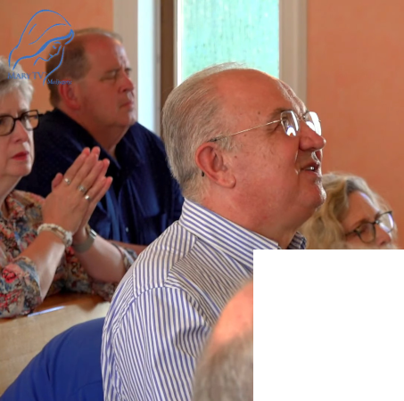
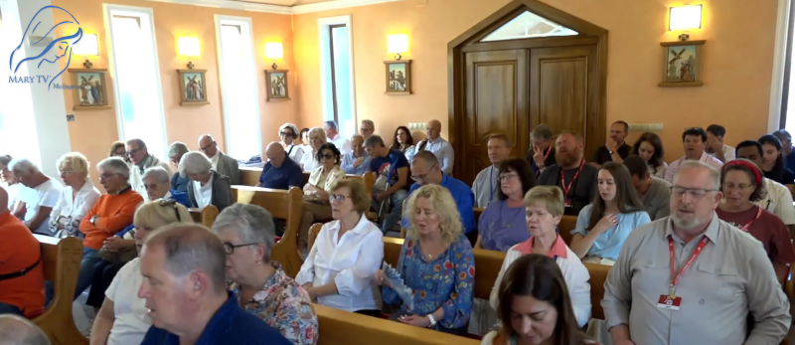

Our Lady’s Message through Ivan Dragičević September 6th 2025
https://video.marytv.tv/watch/mp9Yy8sXiLu

Dear children!
Also today I call you to complete surrender to God.
I invite you to great joy and peace that only God gives.
I am with you and I plead before God
every day for each of you.
Live my messages dear children!
And I desire to keep guiding you
through these messages to my Son.
Thank you dear children also today
for having responded to my call!

Above the code and link to entire video (1h 25m), to the right to report (23m) with audible Ivan’s speech and closer translation
subtitles.



https://rumble.com/v6z7x84-medjugorje-ivan-dragicevic-apparition-2025-09-06.html
https://video.marytv.tv/watch/mp9Yy8sXiLu
Our Lady’s Message through Ivan Dragičević September 6th 2025
Dear children!
Also today I call you to complete surrender to God.
I invite you to great joy and peace that only God gives.
I am with you and I plead before God
every day for each of you.
Live my messages dear children!
And I desire to keep guiding you
through these messages to my Son.`
Thank you dear children also today
for having responded to my call!

Above the code and link to entire video (1h 25m), to the right to report (23m) with audible Ivan’s speech and closer translation
subtitles.

https://rumble.com/v6z7x84-medjugorje-ivan-dragicevic-apparition-2025-09-06.html
https://video.marytv.tv/watch/mp9Yy8sXiLu
Our Lady’s Message through Ivan Dragičević September 6th 2025
Dear children!
Also today I call you to complete surrender to God.
I invite you to great joy and peace that only God gives.
I am with you and I plead before God
every day for each of you.
Live my messages dear children!
And I desire to keep guiding you
through these messages to my Son.`
Thank you dear children also today
for having responded to my call!

Above the code and link to entire video (1h 25m), to the right to report (23m) with audible Ivan’s speech and closer translation
subtitles.

https://rumble.com/v6z7x84-medjugorje-ivan-dragicevic-apparition-2025-09-06.html
https://video.marytv.tv/watch/mp9Yy8sXiLu
Our Lady’s Message through Ivan Dragičević September 6th 2025
Dear children!
Also today I call you to complete surrender to God.
I invite you to great joy and peace that only God gives.
I am with you and I plead before God
every day for each of you.
Live my messages dear children!
And I desire to keep guiding you
through these messages to my Son.`
Thank you dear children also today
for having responded to my call!

Above the code and link to entire video (1h 25m), to the right to report (23m) with audible Ivan’s speech and closer translation
subtitles.

https://rumble.com/v6z7x84-medjugorje-ivan-dragicevic-apparition-2025-09-06.html
https://video.marytv.tv/watch/mp9Yy8sXiLu
Our Lady’s Message through Ivan Dragičević September 6th 2025
Dear children!
Also today I call you to complete surrender to God.
I invite you to great joy and peace that only God gives.
I am with you and I plead before God
every day for each of you.
Live my messages dear children!
And I desire to keep guiding you
through these messages to my Son.`
Thank you dear children also today
for having responded to my call!

Above the code and link to entire video (1h 25m), to the right to report (23m) with audible Ivan’s speech and closer translation
subtitles.

https://rumble.com/v6z7x84-medjugorje-ivan-dragicevic-apparition-2025-09-06.html
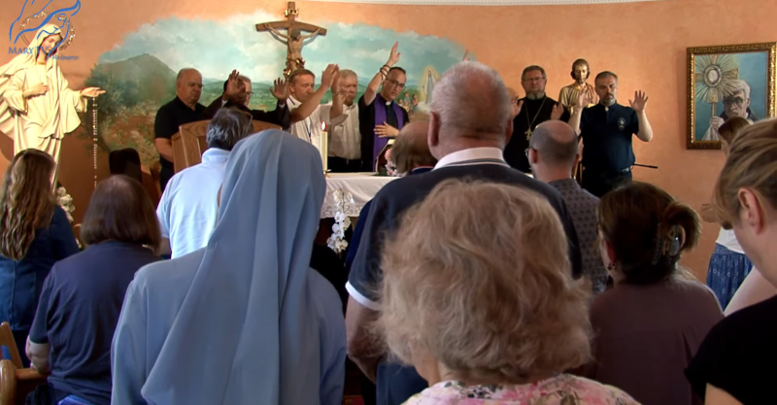
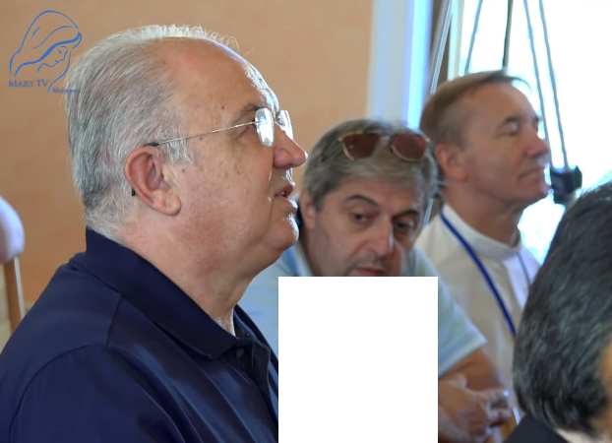

https://video.marytv.tv/watch/mp8T7rsXqTE
Our Lady’s Message through Ivan Dragičević
September 13th 2025
Ivan describes:
It is certainly hardest for me to describe the love of the Mother, how much She loves us, and guides us with that love. […] She lifts her gaze upon all of us. With joy She extends her hands and prays here over us all in her Aramaic language.
After that She prays here especially over you sick and over you priests present. After that Our Lady keeps for some time especially praying for peace in the world. […]
After than Our Lady keeps for some time in particular praying for the family, and in that prayer She leaves in the sign of the light of the cross with the greeting:
"Go in peace, my dear children!"

Above the code and link to entire video (1h 16m), to the right to report (19m) with audible Ivan’s speech and
subtitles.


https://rumble.com/v6z7xr6-medjugorje-ivan-dragicevic-apparition-2025-09-13.html

https://video.marytv.tv/watch/mp8T7rsXqTE
Our Lady’s Message through Ivan Dragičević
September 13th 2025
Ivan describes:
It is certainly hardest for me to describe the love of the Mother, how much She loves us, and guides us with that love. […] She lifts her gaze upon all of us. With joy She extends her hands and prays here over us all in her Aramaic language.
After that She prays here especially over you sick and over you priests present. After that Our Lady keeps for some time especially praying for peace in the world. […]
After than Our Lady keeps for some time in particular praying for the family, and in that prayer She leaves in the sign of the light of the cross with the greeting:
"Go in peace, my dear children!"
Above the code and link to entire video (1h 16m), to the right to report (19m) with audible Ivan’s speech and
subtitles.

https://rumble.com/v6z7xr6-medjugorje-ivan-dragicevic-apparition-2025-09-13.html

https://video.marytv.tv/watch/mp8T7rsXqTE
Our Lady’s Message through Ivan Dragičević
September 13th 2025
Ivan describes:
It is certainly hardest for me to describe the love of the Mother, how much She loves us, and guides us with that love. […] She lifts her gaze upon all of us. With joy She extends her hands and prays here over us all in her Aramaic language.
After that She prays here especially over you sick and over you priests present. After that Our Lady keeps for some time especially praying for peace in the world. […]
After than Our Lady keeps for some time in particular praying for the family, and in that prayer She leaves in the sign of the light of the cross with the greeting:
"Go in peace, my dear children!"
Above the code and link to entire video (1h 16m), to the right to report (19m) with audible Ivan’s speech and
subtitles.

https://rumble.com/v6z7xr6-medjugorje-ivan-dragicevic-apparition-2025-09-13.html

https://video.marytv.tv/watch/mp8T7rsXqTE
Our Lady’s Message through Ivan Dragičević
September 13th 2025
Ivan describes:
It is certainly hardest for me to describe the love of the Mother, how much She loves us, and guides us with that love. […] She lifts her gaze upon all of us. With joy She extends her hands and prays here over us all in her Aramaic language.
After that She prays here especially over you sick and over you priests present. After that Our Lady keeps for some time especially praying for peace in the world. […]
After than Our Lady keeps for some time in particular praying for the family, and in that prayer She leaves in the sign of the light of the cross with the greeting:
"Go in peace, my dear children!"
Above the code and link to entire video (1h 16m), to the right to report (19m) with audible Ivan’s speech and
subtitles.

https://rumble.com/v6z7xr6-medjugorje-ivan-dragicevic-apparition-2025-09-13.html

https://video.marytv.tv/watch/mp8T7rsXqTE
Our Lady’s Message through Ivan Dragičević
September 13th 2025
Ivan describes:
It is certainly hardest for me to describe the love of the Mother, how much She loves us, and guides us with that love. […] She lifts her gaze upon all of us. With joy She extends her hands and prays here over us all in her Aramaic language.
After that She prays here especially over you sick and over you priests present. After that Our Lady keeps for some time especially praying for peace in the world. […]
After than Our Lady keeps for some time in particular praying for the family, and in that prayer She leaves in the sign of the light of the cross with the greeting:
"Go in peace, my dear children!"
Above the code and link to entire video (1h 16m), to the right to report (19m) with audible Ivan’s speech and
subtitles.

https://rumble.com/v6z7xr6-medjugorje-ivan-dragicevic-apparition-2025-09-13.html

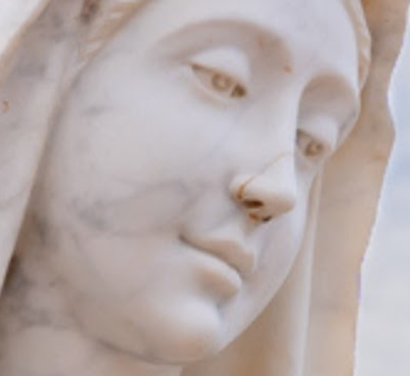
Our Lady’s message from Međugorje, September 25th 2025. through visionary Marija Pavlović Lunetti
Dear children!
May this time for you be a time of prayer for peace.
Thank you for having responded to my call.

(with Ecclesiastical approval)
from https://www.medjugorje.hr, compared to loccations https://centermirmedjugorje.com, https://marytv.tv/, https://www.medjugorje.org/, https://www.themedjugorjewitness.org/, https://www.medjugorje.ws/

Our Lady’s message from Međugorje, September 25th 2025. through visionary Marija Pavlović Lunetti
Dear children!
May this time for you be a time of prayer for peace.
Thank you for having responded to my call.

(with Ecclesiastical approval)
from https://www.medjugorje.hr, compared to loccations https://centermirmedjugorje.com, https://marytv.tv/, https://www.medjugorje.org/, https://www.themedjugorjewitness.org/, https://www.medjugorje.ws/

Our Lady’s message from Međugorje, September 25th 2025. through visionary Marija Pavlović Lunetti
Dear children!
May this time for you be a time of prayer for peace.
Thank you for having responded to my call.

(with Ecclesiastical approval)
from https://www.medjugorje.hr, compared to loccations https://centermirmedjugorje.com, https://marytv.tv/, https://www.medjugorje.org/, https://www.themedjugorjewitness.org/, https://www.medjugorje.ws/

Our Lady’s message from Međugorje, September 25th 2025. through visionary Marija Pavlović Lunetti
Dear children!
May this time for you be a time of prayer for peace.
Thank you for having responded to my call.

(with Ecclesiastical approval)
from https://www.medjugorje.hr, compared to loccations https://centermirmedjugorje.com, https://marytv.tv/, https://www.medjugorje.org/, https://www.themedjugorjewitness.org/, https://www.medjugorje.ws/

Our Lady’s message from Međugorje, September 25th 2025. through visionary Marija Pavlović Lunetti
Dear children!
May this time for you be a time of prayer for peace.
Thank you for having responded to my call.

(with Ecclesiastical approval)
from https://www.medjugorje.hr, compared to loccations https://centermirmedjugorje.com, https://marytv.tv/, https://www.medjugorje.org/, https://www.themedjugorjewitness.org/, https://www.medjugorje.ws/
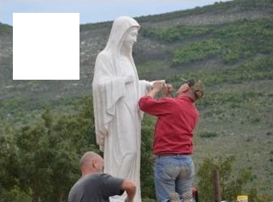

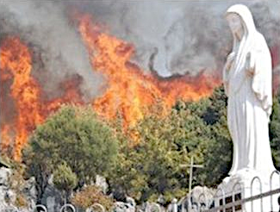
https://mysticpost.com/the-miracle-that-built-the-famous-statue-on-apparition-hill-20-years-ago/
info is from the link on the
left, picture on front side is from youtube channel of centermirmedjugorje.com
On the night between 28 and 29 August 2008, someone hit the statue with a hammer, scarring it in the face and taking off its left hand.

On the front of this leaflet the “scar” is visible where the nose of the statue was taken off with a strike of a hammer.
A few days later, in the first days of September 2008, someone maliciously ignited a fire in several places on the Hill of Apparitions which was almost completely on fire. When the fire, driven by the strong wind, reached about 10 meters from the mutilated statue, it suddenly changed direction, leaving the holy place intact..

At the time of the fire (picture on the right) the hand of the statue still hadn’t been mended, the statue is missing its left hand. On the left, the photo shows sculptors repairing it. But the scar has remained.
Association Croatia Fidelis contact: Miroslav Rovis, miro.rovis@croatiafidelis.hr,
miroslav.rovis@proton.me,
+385 1 6602633
+385 91 2660202

https://mysticpost.com/the-miracle-that-built-the-famous-statue-on-apparition-hill-20-years-ago/
info is from the link on the
left, picture on front side is from youtube channel of centermirmedjugorje.com
On the night between 28 and 29 August 2008, someone hit the statue with a hammer, scarring it in the face and taking off its left hand.

On the front of this leaflet the “scar” is visible where the nose of the statue was taken off with a strike of a hammer.
A few days later, in the first days of September 2008, someone maliciously ignited a fire in several places on the Hill of Apparitions which was almost completely on fire. When the fire, driven by the strong wind, reached about 10 meters from the mutilated statue, it suddenly changed direction, leaving the holy place intact..

At the time of the fire (picture on the right) the hand of the statue still hadn’t been mended, the statue is missing its left hand. On the left, the photo shows sculptors repairing it. But the scar has remained.
Association Croatia Fidelis contact: Miroslav Rovis, miro.rovis@croatiafidelis.hr,
miroslav.rovis@proton.me,
+385 1 6602633
+385 91 2660202

https://mysticpost.com/the-miracle-that-built-the-famous-statue-on-apparition-hill-20-years-ago/
info is from the link on the
left, picture on front side is from youtube channel of centermirmedjugorje.com
On the night between 28 and 29 August 2008, someone hit the statue with a hammer, scarring it in the face and taking off its left hand.

On the front of this leaflet the “scar” is visible where the nose of the statue was taken off with a strike of a hammer.
A few days later, in the first days of September 2008, someone maliciously ignited a fire in several places on the Hill of Apparitions which was almost completely on fire. When the fire, driven by the strong wind, reached about 10 meters from the mutilated statue, it suddenly changed direction, leaving the holy place intact..

At the time of the fire (picture on the right) the hand of the statue still hadn’t been mended, the statue is missing its left hand. On the left, the photo shows sculptors repairing it. But the scar has remained.
Association Croatia Fidelis contact: Miroslav Rovis, miro.rovis@croatiafidelis.hr,
miroslav.rovis@proton.me,
+385 1 6602633
+385 91 2660202

https://mysticpost.com/the-miracle-that-built-the-famous-statue-on-apparition-hill-20-years-ago/
info is from the link on the
left, picture on front side is from youtube channel of centermirmedjugorje.com
On the night between 28 and 29 August 2008, someone hit the statue with a hammer, scarring it in the face and taking off its left hand.

On the front of this leaflet the “scar” is visible where the nose of the statue was taken off with a strike of a hammer.
A few days later, in the first days of September 2008, someone maliciously ignited a fire in several places on the Hill of Apparitions which was almost completely on fire. When the fire, driven by the strong wind, reached about 10 meters from the mutilated statue, it suddenly changed direction, leaving the holy place intact..

At the time of the fire (picture on the right) the hand of the statue still hadn’t been mended, the statue is missing its left hand. On the left, the photo shows sculptors repairing it. But the scar has remained.
Association Croatia Fidelis contact: Miroslav Rovis, miro.rovis@croatiafidelis.hr,
miroslav.rovis@proton.me,
+385 1 6602633
+385 91 2660202

https://mysticpost.com/the-miracle-that-built-the-famous-statue-on-apparition-hill-20-years-ago/
info is from the link on the
left, picture on front side is from youtube channel of centermirmedjugorje.com
On the night between 28 and 29 August 2008, someone hit the statue with a hammer, scarring it in the face and taking off its left hand.

On the front of this leaflet the “scar” is visible where the nose of the statue was taken off with a strike of a hammer.
A few days later, in the first days of September 2008, someone maliciously ignited a fire in several places on the Hill of Apparitions which was almost completely on fire. When the fire, driven by the strong wind, reached about 10 meters from the mutilated statue, it suddenly changed direction, leaving the holy place intact..

At the time of the fire (picture on the right) the hand of the statue still hadn’t been mended, the statue is missing its left hand. On the left, the photo shows sculptors repairing it. But the scar has remained.
Association Croatia Fidelis contact: Miroslav Rovis, miro.rovis@croatiafidelis.hr,
miroslav.rovis@proton.me,
+385 1 6602633
+385 91 2660202

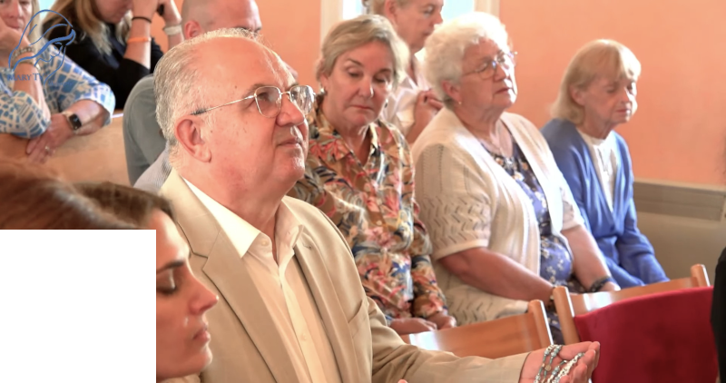
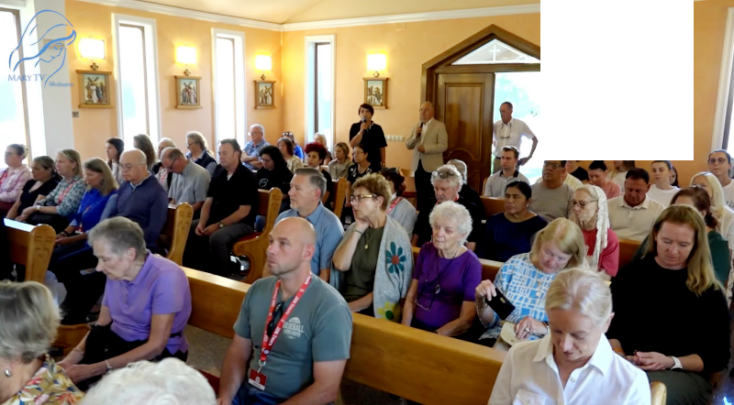

https://video.marytv.tv/watch/mVKKR2sX0nn
Our Lady’s Apparition and Message
through Ivan Dragičević
September 27th 2025
Međugorje

Dear children! Also today I call you again, persevere in prayer for peace. Pray for all those statesmen who lead countries who decide on peace. Let peace be in the first place. Peace, and not war!
Therefore, persevere in prayer! I have been with you all these years and I pray together with you for peace. I place all of you under my mantle of peace.
Thank you dear children also today for having responded to my call!



Links: top right entire prayer with apparition, 1h 18m, to the left: check the transmitting
of the message itself, 1m 13s, whence you also get an abbreviated report.

https://rumble.com/v6zq5r8-medjugorje-ivan-dragicevic-gospa-msg-2025-09-27.html
https://video.marytv.tv/watch/mVKKR2sX0nn
Our Lady’s Apparition and Message
through Ivan Dragičević
September 27th 2025
Međugorje

Dear children! Also today I call you again, persevere in prayer for peace. Pray for all those statesmen who lead countries who decide on peace. Let peace be in the first place. Peace, and not war!
Therefore, persevere in prayer! I have been with you all these years and I pray together with you for peace. I place all of you under my mantle of peace.
Thank you dear children also today for having responded to my call!

Links: top right entire prayer with apparition, 1h 18m, to the left: check the transmitting
of the message itself, 1m 13s, whence you also get an abbreviated report.

https://rumble.com/v6zq5r8-medjugorje-ivan-dragicevic-gospa-msg-2025-09-27.html
Gospino ukazanje i poruka preko
Ivana Dragičevića
https://video.marytv.tv/watch/mVKKR2sX0nn
September 27th 2025
Međugorje

Dear children! Also today I call you again, persevere in prayer for peace. Pray for all those statesmen who lead countries who decide on peace. Let peace be in the first place. Peace, and not war!
Therefore, persevere in prayer! I have been with you all these years and I pray together with you for peace. I place all of you under my mantle of peace.
Thank you dear children also today for having responded to my call!

Links: top right entire prayer with apparition, 1h 18m, to the left: check the transmitting
of the message itself, 1m 13s, whence you also get an abbreviated report.

https://rumble.com/v6zq5r8-medjugorje-ivan-dragicevic-gospa-msg-2025-09-27.html
https://video.marytv.tv/watch/mVKKR2sX0nn
Our Lady’s Apparition and Message
through Ivan Dragičević
September 27th 2025
Međugorje

Dear children! Also today I call you again, persevere in prayer for peace. Pray for all those statesmen who lead countries who decide on peace. Let peace be in the first place. Peace, and not war!
Therefore, persevere in prayer! I have been with you all these years and I pray together with you for peace. I place all of you under my mantle of peace.
Thank you dear children also today for having responded to my call!

Links: top right entire prayer with apparition, 1h 18m, to the left: check the transmitting
of the message itself, 1m 13s, whence you also get an abbreviated report.

https://rumble.com/v6zq5r8-medjugorje-ivan-dragicevic-gospa-msg-2025-09-27.html
https://video.marytv.tv/watch/mVKKR2sX0nn
Our Lady’s Apparition and Message
through Ivan Dragičević
September 27th 2025
Međugorje

Dear children! Also today I call you again, persevere in prayer for peace. Pray for all those statesmen who lead countries who decide on peace. Let peace be in the first place. Peace, and not war!
Therefore, persevere in prayer! I have been with you all these years and I pray together with you for peace. I place all of you under my mantle of peace.
Thank you dear children also today for having responded to my call!

Links: top right entire prayer with apparition, 1h 18m, to the left: check the transmitting
of the message itself, 1m 13s, whence you also get an abbreviated report.

https://rumble.com/v6zq5r8-medjugorje-ivan-dragicevic-gospa-msg-2025-09-27.html
asd
Our Lady’s Apparition and Message through Marija Pavlović, Međugorje
Dear children! I pray for your intentions. And you, pray for peace in your hearts,
in your families and in the whole world. Thank you, dear children!
Men from entire Croatia who pray Rosary the
first Saturday in public had a retreat in Međugorje and with many other faithful attended to this apparition and listened to Our Lady’s message.
left: the seer Marija Pavlović, right: spiritual director of the men who pray in public Marinko Miličević
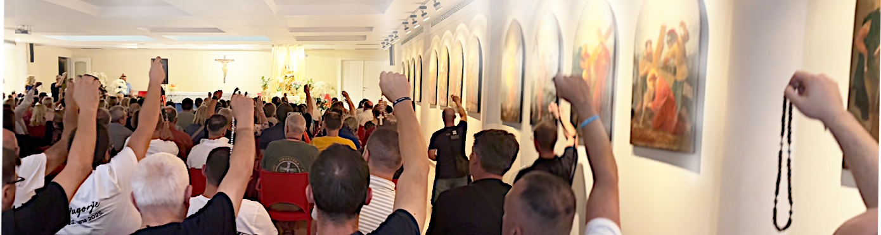
September 27th 2025
to the best remembering of the faithful who heard the message, nothing was recorded or filmed
asd
September 27th 2025
Dear children! I pray for your intentions. And you, pray for peace in your hearts,
in your families and in the whole world. Thank you, dear children!
Our Lady’s Apparition and Message through Marija Pavlović, Međugorje
left: the seer Marija Pavlović, right: spiritual director of the men who pray in public Marinko Miličević
Men from entire Croatia who pray Rosary the
first Saturday in public had a retreat in Međugorje and with many other faithful attended to this apparition and listened to Our Lady’s message.
to the best remembering of the faithful who heard the message, nothing was recorded or filmed
asd
Dear children! I pray for your intentions. And you, pray for peace in your hearts,
in your families and in the whole world. Thank you, dear children!
Our Lady’s Apparition and Message through Marija Pavlović, Međugorje
left: the seer Marija Pavlović, right: the spiritual director of men who pray in public Marinko Miličević
September 27th 2025
Men from entire Croatia who pray Rosary the
first Saturday in public had a retreat in Međugorje and with many other faithful attended to this apparition and listened to Our Lady’s message.
left: the seer Marija Pavlović, right: spiritual director of the men who pray in public Marinko Miličević
to the best remembering of the faithful who heard the message, nothing was recorded or filmed
asd
Men from entire Croatia who pray Rosary the
first Saturday in public had a retreat in Međugorje and with many other faithful attended to this apparition and listened to Our Lady’s message.
September 27th 2025
Our Lady’s Apparition and Message through Marija Pavlović, Međugorje
Dear children! I pray for your intentions. And you, pray for peace in your hearts,
in your families and in the whole world. Thank you, dear children!
left: the seer Marija Pavlović, right: spiritual director of the men who pray in public Marinko Miličević
to the best remembering of the faithful who heard the message, nothing was recorded or filmed
asd
Our Lady’s Apparition and Message through Marija Pavlović, Međugorje
September 27th 2025
Dear children! I pray for your intentions. And you, pray for peace in your hearts,
in your families and in the whole world. Thank you, dear children!
Men from entire Croatia who pray Rosary the
first Saturday in public had a retreat in Međugorje and with many other faithful attended to this apparition and listened to Our Lady’s message.
to the best remembering of the faithful who heard the message, nothing was recorded or filmed
left: the seer Marija Pavlović, right: spiritual director of the men who pray in public Marinko Miličević

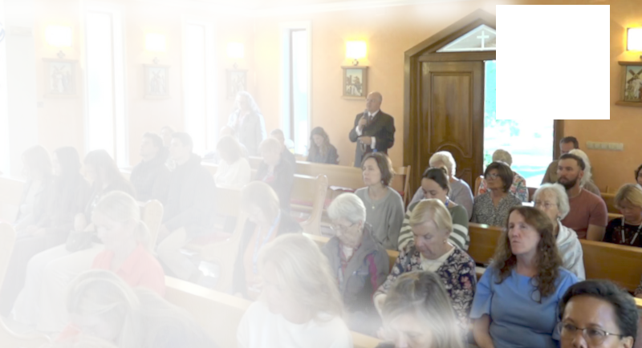
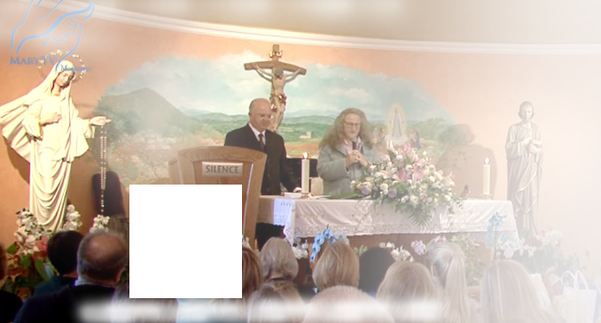

October 4th 2025
https://video.marytv.tv/watch/mVnYLmsXfrF
Our Lady’s Apparition and Message through Ivan Dragičević
Also today She came
to us joyful and merry and greets us all with Her motherly greeting:
“Praised be Jesus,
my dear
children!"
Ivan relates:
After that Our Lady raises Her gaze on us all, extends Her hands and, for a while prays over all of us in Her Aramaic language. Our Lady also prays, turning Her gaze toward the church, over all the pilgrims and priests in the church at the prayer program.
After that She addresses us all briefly:

After that Our Lady prays today especially for vocations in the Church.
And after that She leaves in prayer in the sign of the light of the Cross with the greeting:
"Go in peace, my dear children!"
I want to stress once more that Our Lady today prayed for a longer time over us all,
and also a strong invitation that we through this time pray for peace. It is plain to see Her deep, strong call to us that through this time our prayers be directed for peace.


Dear children!
Today as well Mother prays with you.
I pray together with you for peace.
Today as well I call you anew to be perseverant in prayer.
Pray for peace!
Thank you dear children also today for having responded to my call!
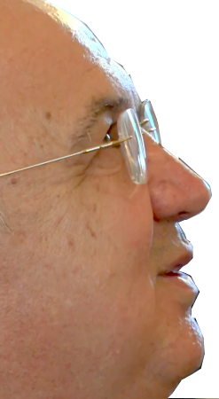


https://rumble.com/v70qkw0-medjugorje-ivan-dragicevic-gospa-msg-2025-10-04.html
Left: QR-code gives link to 45s of transmitting of Our Lady’s message, above the source, 1h 15m
https://video.marytv.tv/watch/mVnYLmsXfrF
Our Lady’s Apparition and Message through Ivan Dragičević
October 4th 2025
Ivan relates:
Also today She came
to us joyful and merry and greets us all with Her motherly greeting:
“Praised be Jesus,
my dear
children!"
After that Our Lady raises Her gaze on us all, extends Her hands and, for a while prays over all of us in Her Aramaic language. Our Lady also prays, turning Her gaze toward the church, over all the pilgrims and priests in the church at the prayer program.
After that She addresses us all briefly:

After that Our Lady prays today especially for vocations in the Church.
And after that She leaves in prayer in the sign of the light of the Cross with the greeting:
"Go in peace, my dear children!"
I want to stress once more that Our Lady today prayed for a longer time over us all,
and also a strong invitation that we through this time pray for peace. It is plain to see Her deep, strong call to us that through this time our prayers be directed for peace.

Dear children!
Today as well Mother prays with you.
I pray together with you for peace.
Today as well I call you anew to be perseverant in prayer.
Pray for peace!
Thank you dear children also today for having responded to my call!

https://rumble.com/v70qkw0-medjugorje-ivan-dragicevic-gospa-msg-2025-10-04.html
Left: QR-code gives link to 45s of transmitting of Our Lady’s message, above the source, 1h 15m
https://video.marytv.tv/watch/mVnYLmsXfrF
Our Lady’s Apparition and Message through Ivan Dragičević
October 4th 2025
After that Our Lady prays today especially for vocations in the Church.
And after that She leaves in prayer in the sign of the light of the Cross with the greeting:
"Go in peace, my dear children!"
I want to stress once more that Our Lady today prayed for a longer time over us all,
and also a strong invitation that we through this time pray for peace. It is plain to see Her deep, strong call to us that through this time our prayers be directed for peace.
Ivan relates:
Also today She came
to us joyful and merry and greets us all with Her motherly greeting:
“Praised be Jesus,
my dear
children!"
After that Our Lady raises Her gaze on us all, extends Her hands and, for a while prays over all of us in Her Aramaic language. Our Lady also prays, turning Her gaze toward the church, over all the pilgrims and priests in the church at the prayer program.
After that She addresses us all briefly:

Dear children!
Today as well Mother prays with you.
I pray together with you for peace.
Today as well I call you anew to be perseverant in prayer.
Pray for peace!
Thank you dear children also today for having responded to my call!

https://rumble.com/v70qkw0-medjugorje-ivan-dragicevic-gospa-msg-2025-10-04.html
Left: QR-code gives link to 45s of transmitting of Our Lady’s message, above the source, 1h 15m
https://video.marytv.tv/watch/mVnYLmsXfrF
Our Lady’s Apparition and Message through Ivan Dragičević
October 4th 2025
After that Our Lady prays today especially for vocations in the Church.
And after that She leaves in prayer in the sign of the light of the Cross with the greeting:
"Go in peace, my dear children!"
I want to stress once more that Our Lady today prayed for a longer time over us all,
and also a strong invitation that we through this time pray for peace. It is plain to see Her deep, strong call to us that through this time our prayers be directed for peace.
Ivan relates:
Also today She came
to us joyful and merry and greets us all with Her motherly greeting:
“Praised be Jesus,
my dear
children!"
After that Our Lady raises Her gaze on us all, extends Her hands and, for a while prays over all of us in Her Aramaic language. Our Lady also prays, turning Her gaze toward the church, over all the pilgrims and priests in the church at the prayer program.
After that She addresses us all briefly:

Dear children!
Today as well Mother prays with you.
I pray together with you for peace.
Today as well I call you anew to be perseverant in prayer.
Pray for peace!
Thank you dear children also today for having responded to my call!

https://rumble.com/v70qkw0-medjugorje-ivan-dragicevic-gospa-msg-2025-10-04.html
Left: QR-code gives link to 45s of transmitting of Our Lady’s message, above the source, 1h 15m
https://video.marytv.tv/watch/mVnYLmsXfrF
October 4th 2025
Our Lady’s Apparition and Message through Ivan Dragičević
After that Our Lady prays today especially for vocations in the Church.
And after that She leaves in prayer in the sign of the light of the Cross with the greeting:
"Go in peace, my dear children!"
I want to stress once more that Our Lady today prayed for a longer time over us all,
and also a strong invitation that we through this time pray for peace. It is plain to see Her deep, strong call to us that through this time our prayers be directed for peace.
Ivan relates:
Also today She came
to us joyful and merry and greets us all with Her motherly greeting:
“Praised be Jesus,
my dear
children!"
After that Our Lady raises Her gaze on us all, extends Her hands and, for a while prays over all of us in Her Aramaic language. Our Lady also prays, turning Her gaze toward the church, over all the pilgrims and priests in the church at the prayer program.
After that She addresses us all briefly:

Dear children!
Today as well Mother prays with you.
I pray together with you for peace.
Today as well I call you anew to be perseverant in prayer.
Pray for peace!
Thank you dear children also today for having responded to my call!

https://rumble.com/v70qkw0-medjugorje-ivan-dragicevic-gospa-msg-2025-10-04.html
Left: QR-code gives link to 45s of transmitting of Our Lady’s message, above the source, 1h 15m
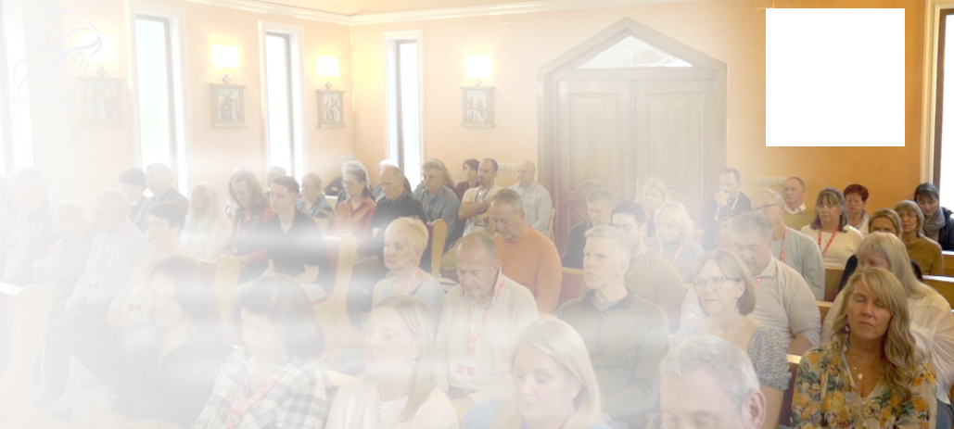
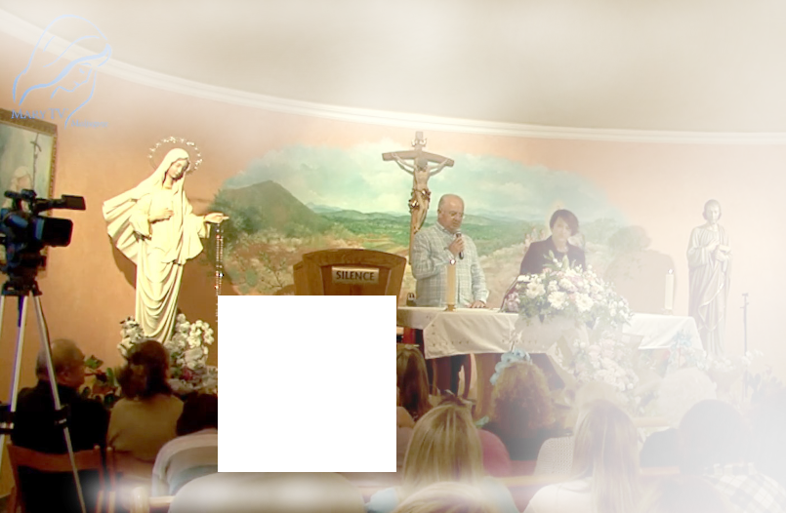

October 18th 2025
https://video.marytv.tv/watch/maJ3BVsXM3R
Our Lady’s Apparition and Message through Ivan Dragičević
Ivan relates: Also today Mother came
to us joyful and merry and greets us all with Her motherly greeting: “Praised be Jesus,
my dear children!"
After that Our Lady raises Her gaze, so much joy on Her face, in Her eyes, on us all,
extends Her hands and prays here in Her Aramaic language over all of us. She prays especially over you priests present and you sick present.

After that Our Lady directs Her gaze toward the church
and prays over all the pilgrims at the
evening prayer program and all the priests.
After that She bestows on us all Her motherly blessing. […] After that Our Lady keeps
for some time praying for peace.
And in that prayer She leaves
in the sign of the light
of the Cross
with the greeting:
"Go in peace,
my dear children!"


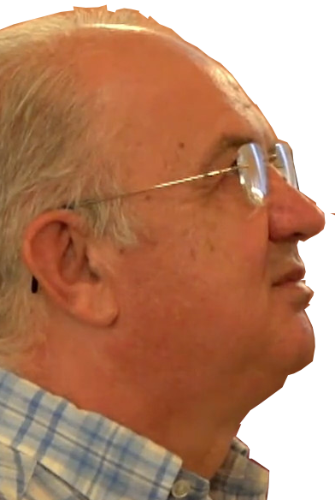
After that Our Lady briefly addresses us all with these words:
Dear children!
Today as well my prayer with you is for peace.
Also today dear children, through this time, good and evil
are battling and want to prevail in the hearts of men.
Dear children, you be men of hope and prayer and great confidence.
May peace, little children, prevail in you and around you.
I bless you with my motherly blessing and I plead before my Son for all of you.
Thank you, dear children, also today for having responded to my call!



https://rumble.com/v70qm2o-medjugorje-ivan-dragicevic-gospa-msg-2025-10-18.html
left: QR-code gives link to 1m 24s of transmitting of Our Lady’s message, above the source, 1h 20m
https://video.marytv.tv/watch/maJ3BVsXM3R
Our Lady’s Apparition and Message through Ivan Dragičević
October 18th 2025
After that Our Lady directs Her gaze toward the church
and prays over all the pilgrims at the
evening prayer program and all the priests.
After that She bestows on us all Her motherly blessing. […] After that Our Lady keeps
for some time praying for peace.
And in that prayer She leaves
in the sign of the light
of the Cross
with the greeting:
"Go in peace,
my dear children!"
Ivan relates: Also today Mother came
to us joyful and merry and greets us all with Her motherly greeting: “Praised be Jesus,
my dear children!"
After that Our Lady raises Her gaze, so much joy on Her face, in Her eyes, on us all,
extends Her hands and prays here in Her Aramaic language over all of us. She prays especially over you priests present and you sick present.

After that Our Lady briefly addresses us all with these words:
Dear children!
Today as well my prayer with you is for peace.
Also today dear children, through this time, good and evil
are battling and want to prevail in the hearts of men.
Dear children, you be men of hope and prayer and great confidence.
May peace, little children, prevail in you and around you.
I bless you with my motherly blessing and I plead before my Son for all of you.
Thank you, dear children, also today for having responded to my call!

https://rumble.com/v70qm2o-medjugorje-ivan-dragicevic-gospa-msg-2025-10-18.html
left: QR-code gives link to 1m 24s of transmitting of Our Lady’s message, above the source, 1h 20m
https://video.marytv.tv/watch/maJ3BVsXM3R
Our Lady’s Apparition and Message through Ivan Dragičević
October 18th 2025
After that Our Lady directs Her gaze toward the church
and prays over all the pilgrims at the
evening prayer program and all the priests.
After that She bestows on us all Her motherly blessing. […] After that Our Lady keeps
for some time praying for peace.
And in that prayer She leaves
in the sign of the light
of the Cross
with the greeting:
"Go in peace,
my dear children!"
Ivan relates: Also today Mother came
to us joyful and merry and greets us all with Her motherly greeting: “Praised be Jesus,
my dear children!"
After that Our Lady raises Her gaze, so much joy on Her face, in Her eyes, on us all,
extends Her hands and prays here in Her Aramaic language over all of us. She prays especially over you priests present and you sick present.

After that Our Lady briefly addresses us all with these words:
Dear children!
Today as well my prayer with you is for peace.
Also today dear children, through this time, good and evil
are battling and want to prevail in the hearts of men.
Dear children, you be men of hope and prayer and great confidence.
May peace, little children, prevail in you and around you.
I bless you with my motherly blessing and I plead before my Son for all of you.
Thank you, dear children, also today for having responded to my call!

https://rumble.com/v70qm2o-medjugorje-ivan-dragicevic-gospa-msg-2025-10-18.html
left: QR-code gives link to 1m 24s of transmitting of Our Lady’s message, above the source, 1h 20m
https://video.marytv.tv/watch/maJ3BVsXM3R
Our Lady’s Apparition and Message through Ivan Dragičević
October 18th 2025
After that Our Lady directs Her gaze toward the church
and prays over all the pilgrims at the
evening prayer program and all the priests.
After that She bestows on us all Her motherly blessing. […] After that Our Lady keeps
for some time praying for peace.
And in that prayer She leaves
in the sign of the light
of the Cross
with the greeting:
"Go in peace,
my dear children!"
Ivan relates: Also today Mother came
to us joyful and merry and greets us all with Her motherly greeting: “Praised be Jesus,
my dear children!"
After that Our Lady raises Her gaze, so much joy on Her face, in Her eyes, on us all,
extends Her hands and prays here in Her Aramaic language over all of us. She prays especially over you priests present and you sick present.

After that Our Lady briefly addresses us all with these words:
Dear children!
Today as well my prayer with you is for peace.
Also today dear children, through this time, good and evil
are battling and want to prevail in the hearts of men.
Dear children, you be men of hope and prayer and great confidence.
May peace, little children, prevail in you and around you.
I bless you with my motherly blessing and I plead before my Son for all of you.
Thank you, dear children, also today for having responded to my call!

https://rumble.com/v70qm2o-medjugorje-ivan-dragicevic-gospa-msg-2025-10-18.html
left: QR-code gives link to 1m 24s of transmitting of Our Lady’s message, above the source, 1h 20m
https://video.marytv.tv/watch/maJ3BVsXM3R
Our Lady’s Apparition and Message through Ivan Dragičević
October 18th 2025
After that Our Lady directs Her gaze toward the church
and prays over all the pilgrims at the
evening prayer program and all the priests.
After that She bestows on us all Her motherly blessing. […] After that Our Lady keeps
for some time praying for peace.
And in that prayer She leaves
in the sign of the light
of the Cross
with the greeting:
"Go in peace,
my dear children!"
Ivan relates: Also today Mother came
to us joyful and merry and greets us all with Her motherly greeting: “Praised be Jesus,
my dear children!"
After that Our Lady raises Her gaze, so much joy on Her face, in Her eyes, on us all,
extends Her hands and prays here in Her Aramaic language over all of us. She prays especially over you priests present and you sick present.

After that Our Lady briefly addresses us all with these words:
Dear children!
Today as well my prayer with you is for peace.
Also today dear children, through this time, good and evil
are battling and want to prevail in the hearts of men.
Dear children, you be men of hope and prayer and great confidence.
May peace, little children, prevail in you and around you.
I bless you with my motherly blessing and I plead before my Son for all of you.
Thank you, dear children, also today for having responded to my call!

https://rumble.com/v70qm2o-medjugorje-ivan-dragicevic-gospa-msg-2025-10-18.html
left: QR-code gives link to 1m 24s of transmitting of Our Lady’s message, above the source, 1h 20m
Our Lady’s message from Međugorja, October 25th 2025. through visionary Marija Pavlović Lunetti

Dear children!
The Most High in his goodness gave me to you to lead you on the way of peace. Many have responded and pray, but creatures that have no peace and have not come to know the God of love are many. Therefore, little children, pray and love, create prayer groups, to encourage each other to good. I am with you and pray for your conversion.
Thank you for having responded to my call.

(with Ecclesiastical approval)
from https://www.medjugorje.hr, compared to: https://marytv.tv/, https://medjugorje.org, https://spiritofedjugorje.org, https://consecratedhearts.com, https://www.privaterevelation.org/

Our Lady’s message from Međugorja, October 25th 2025. through visionary Marija Pavlović Lunetti

Dear children!
The Most High in his goodness gave me to you to lead you on the way of peace. Many have responded and pray, but creatures that have no peace and have not come to know the God of love are many. Therefore, little children, pray and love, create prayer groups, to encourage each other to good. I am with you and pray for your conversion.
Thank you for having responded to my call.

(with Ecclesiastical approval)
from https://www.medjugorje.hr, compared to: https://marytv.tv/, https://medjugorje.org, https://spiritofedjugorje.org, https://consecratedhearts.com, https://www.privaterevelation.org/

Our Lady’s message from Međugorja, October 25th 2025. through visionary Marija Pavlović Lunetti

Dear children!
The Most High in his goodness gave me to you to lead you on the way of peace. Many have responded and pray, but creatures that have no peace and have not come to know the God of love are many. Therefore, little children, pray and love, create prayer groups, to encourage each other to good. I am with you and pray for your conversion.
Thank you for having responded to my call.

(with Ecclesiastical approval)
from https://www.medjugorje.hr, compared to: https://marytv.tv/, https://medjugorje.org, https://spiritofedjugorje.org, https://consecratedhearts.com, https://www.privaterevelation.org/

Our Lady’s message from Međugorja, October 25th 2025. through visionary Marija Pavlović Lunetti

Dear children!
The Most High in his goodness gave me to you to lead you on the way of peace. Many have responded and pray, but creatures that have no peace and have not come to know the God of love are many. Therefore, little children, pray and love, create prayer groups, to encourage each other to good. I am with you and pray for your conversion.
Thank you for having responded to my call.

(with Ecclesiastical approval)
from https://www.medjugorje.hr, compared to: https://marytv.tv/, https://medjugorje.org, https://spiritofedjugorje.org, https://consecratedhearts.com, https://www.privaterevelation.org/

Our Lady’s message from Međugorja, October 25th 2025. through visionary Marija Pavlović Lunetti

Dear children!
The Most High in his goodness gave me to you to lead you on the way of peace. Many have responded and pray, but creatures that have no peace and have not come to know the God of love are many. Therefore, little children, pray and love, create prayer groups, to encourage each other to good. I am with you and pray for your conversion.
Thank you for having responded to my call.

(with Ecclesiastical approval)
from https://www.medjugorje.hr, compared to: https://marytv.tv/, https://medjugorje.org, https://spiritofedjugorje.org, https://consecratedhearts.com, https://www.privaterevelation.org/

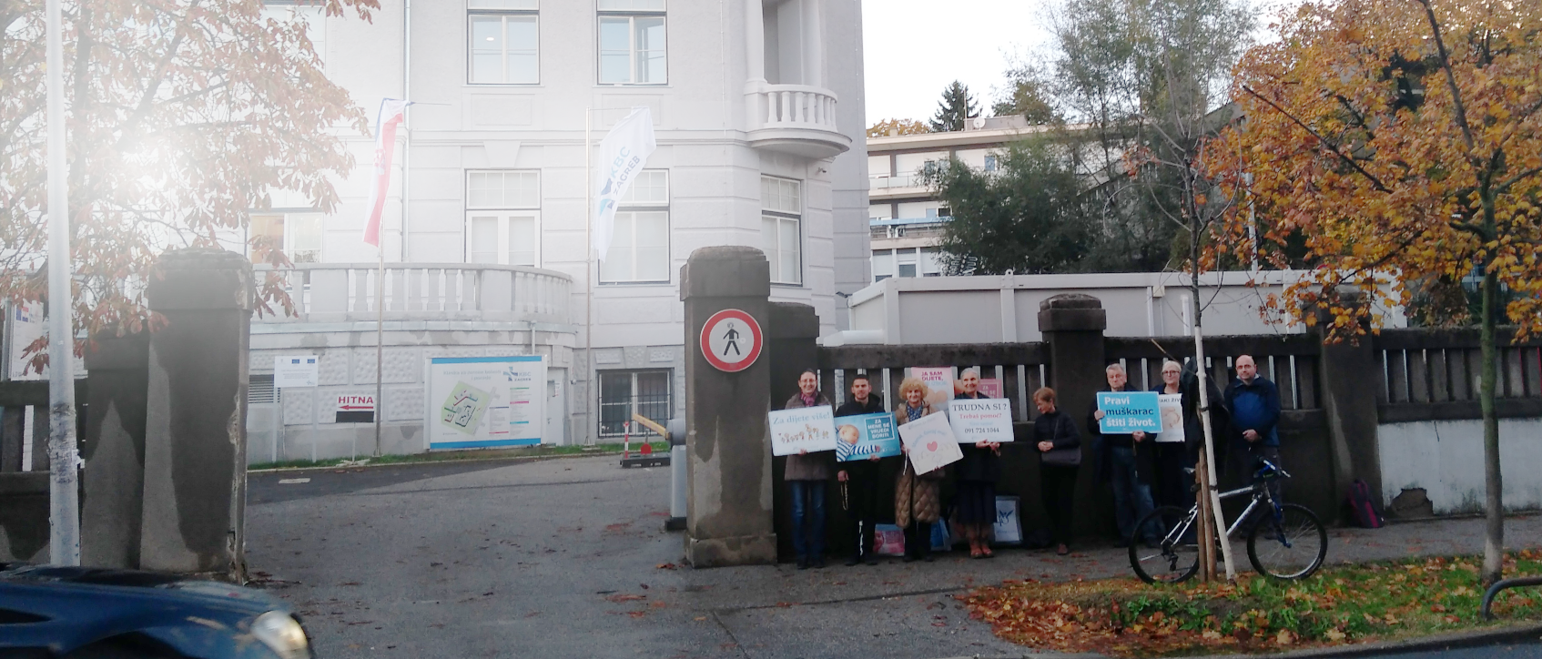

The autumn campaign “40 days for life” in 2025 goes on in 37 Croatian cities. Thousands of faithful and volonteers keep vigil daily
before hospitals, praying for
the unborn, for mothers in difficulties
and for the conversion of the
medical personnel.
Sign from Heaven in midst of “40 days for life” campaign
Zagreb, Peter’s Hospital (in the photo). Abortions on demand have been temporarily suspended. Reason? Most of the nurses there have decided to call on their right to consciencious objection. The news came in the vigil of the feast of John Paul II, October 22nd 2025, the great friend of the unborn.

QR code gives link to the article in Croatian which is the source of this info
https://vjera.hr/crkva/cudesno-usred-kampanje-40-dana-za-zivot-petrova-prestala-raditi-pobacaje/
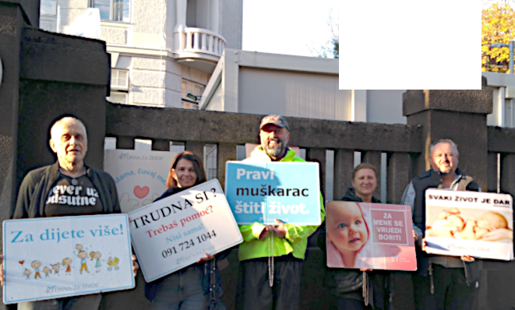



Association Croatia Fidelis contact: Miroslav Rovis, miro.rovis@croatiafidelis.hr,
miroslav.rovis@proton.me,
+385 1 6602633
+385 91 2660202

https://vjera.hr/crkva/cudesno-usred-kampanje-40-dana-za-zivot-petrova-prestala-raditi-pobacaje/
QR code gives link to the article in Croatian which is the source of this info
The autumn campaign “40 days for life” in 2025 goes on in 37 Croatian cities. Thousands of faithful and volonteers keep vigil daily
before hospitals, praying for
the unborn, for mothers in difficulties
and for the conversion of the
medical personnel.
Sign from Heaven in midst of “40 days for life” campaign
Zagreb, Peter’s Hospital (in the photo). Abortions on demand have been temporarily suspended. Reason? Most of the nurses there have decided to call on their right to consciencious objection. The news came in the vigil of the feast of John Paul II, October 22nd 2025, the great friend of the unborn.

Association Croatia Fidelis contact: Miroslav Rovis, miro.rovis@croatiafidelis.hr,
miroslav.rovis@proton.me,
+385 1 6602633
+385 91 2660202

https://vjera.hr/crkva/cudesno-usred-kampanje-40-dana-za-zivot-petrova-prestala-raditi-pobacaje/
QR code gives link to the article in Croatian which is the source of this info
The autumn campaign “40 days for life” in 2025 goes on in 37 Croatian cities. Thousands of faithful and volonteers keep vigil daily
before hospitals, praying for
the unborn, for mothers in difficulties
and for the conversion of the
medical personnel.
Sign from Heaven in midst of “40 days for life” campaign
Zagreb, Peter’s Hospital (in the photo). Abortions on demand have been temporarily suspended. Reason? Most of the nurses there have decided to call on their right to consciencious objection. The news came in the vigil of the feast of John Paul II, October 22nd 2025, the great friend of the unborn.

Association Croatia Fidelis contact: Miroslav Rovis, miro.rovis@croatiafidelis.hr,
miroslav.rovis@proton.me,
+385 1 6602633
+385 91 2660202

https://vjera.hr/crkva/cudesno-usred-kampanje-40-dana-za-zivot-petrova-prestala-raditi-pobacaje/
QR code gives link to the article in Croatian which is the source of this info
The autumn campaign “40 days for life” in 2025 goes on in 37 Croatian cities. Thousands of faithful and volonteers keep vigil daily
before hospitals, praying for
the unborn, for mothers in difficulties
and for the conversion of the
medical personnel.
Sign from Heaven in midst of “40 days for life” campaign
Zagreb, Peter’s Hospital (in the photo). Abortions on demand have been temporarily suspended. Reason? Most of the nurses there have decided to call on their right to consciencious objection. The news came in the vigil of the feast of John Paul II, October 22nd 2025, the great friend of the unborn.

Association Croatia Fidelis contact: Miroslav Rovis, miro.rovis@croatiafidelis.hr,
miroslav.rovis@proton.me,
+385 1 6602633
+385 91 2660202

https://vjera.hr/crkva/cudesno-usred-kampanje-40-dana-za-zivot-petrova-prestala-raditi-pobacaje/
QR code gives link to the article in Croatian which is the source of this info
The autumn campaign “40 days for life” in 2025 goes on in 37 Croatian cities. Thousands of faithful and volonteers keep vigil daily
before hospitals, praying for
the unborn, for mothers in difficulties
and for the conversion of the
medical personnel.
Sign from Heaven in midst of “40 days for life” campaign
Zagreb, Peter’s Hospital (in the photo). Abortions on demand have been temporarily suspended. Reason? Most of the nurses there have decided to call on their right to consciencious objection. The news came in the vigil of the feast of John Paul II, October 22nd 2025, the great friend of the unborn.

Association Croatia Fidelis contact: Miroslav Rovis, miro.rovis@croatiafidelis.hr,
miroslav.rovis@proton.me,
+385 1 6602633
+385 91 2660202

Our Lady’s message from Međugorje November 25th 2025 through visionary Marija Pavlović Lunetti

Dear children!
In this time of grace, I am calling you to follow me. Pray for those who do not pray and do not want peace and joy, which only the Most High can give. May your souls be united in the joy of expectancy and your heart will be filled with peace. You will be convinced, little children, that all will be good and that God will bless all, because the good that you give will return to you, and joy will enfold your heart because you are with God and in God.
Thank you for having responded to my call.

(with Ecclesiastical approval)
from https://www.medjugorje.hr, compared to: https://marytv.tv/, https://www.privaterevelation.org, https://revelationstwelve.wordpress.com, https://www.81tours.com

Our Lady’s message from Međugorje November 25th 2025 through visionary Marija Pavlović Lunetti

Dear children!
In this time of grace, I am calling you to follow me. Pray for those who do not pray and do not want peace and joy, which only the Most High can give. May your souls be united in the joy of expectancy and your heart will be filled with peace. You will be convinced, little children, that all will be good and that God will bless all, because the good that you give will return to you, and joy will enfold your heart because you are with God and in God.
Thank you for having responded to my call.

(with Ecclesiastical approval)
from https://www.medjugorje.hr, compared to: https://marytv.tv/, https://www.privaterevelation.org, https://revelationstwelve.wordpress.com, https://www.81tours.com

Our Lady’s message from Međugorje November 25th 2025 through visionary Marija Pavlović Lunetti

Dear children!
In this time of grace, I am calling you to follow me. Pray for those who do not pray and do not want peace and joy, which only the Most High can give. May your souls be united in the joy of expectancy and your heart will be filled with peace. You will be convinced, little children, that all will be good and that God will bless all, because the good that you give will return to you, and joy will enfold your heart because you are with God and in God.
Thank you for having responded to my call.

(with Ecclesiastical approval)
from https://www.medjugorje.hr, compared to: https://marytv.tv/, https://www.privaterevelation.org, https://revelationstwelve.wordpress.com, https://www.81tours.com

Our Lady’s message from Međugorje November 25th 2025 through visionary Marija Pavlović Lunetti

Dear children!
In this time of grace, I am calling you to follow me. Pray for those who do not pray and do not want peace and joy, which only the Most High can give. May your souls be united in the joy of expectancy and your heart will be filled with peace. You will be convinced, little children, that all will be good and that God will bless all, because the good that you give will return to you, and joy will enfold your heart because you are with God and in God.
Thank you for having responded to my call.

(with Ecclesiastical approval)
from https://www.medjugorje.hr, compared to: https://marytv.tv/, https://www.privaterevelation.org, https://revelationstwelve.wordpress.com, https://www.81tours.com

Our Lady’s message from Međugorje November 25th 2025 through visionary Marija Pavlović Lunetti

Dear children!
In this time of grace, I am calling you to follow me. Pray for those who do not pray and do not want peace and joy, which only the Most High can give. May your souls be united in the joy of expectancy and your heart will be filled with peace. You will be convinced, little children, that all will be good and that God will bless all, because the good that you give will return to you, and joy will enfold your heart because you are with God and in God.
Thank you for having responded to my call.

(with Ecclesiastical approval)
from https://www.medjugorje.hr, compared to: https://marytv.tv/, https://www.privaterevelation.org, https://revelationstwelve.wordpress.com, https://www.81tours.com

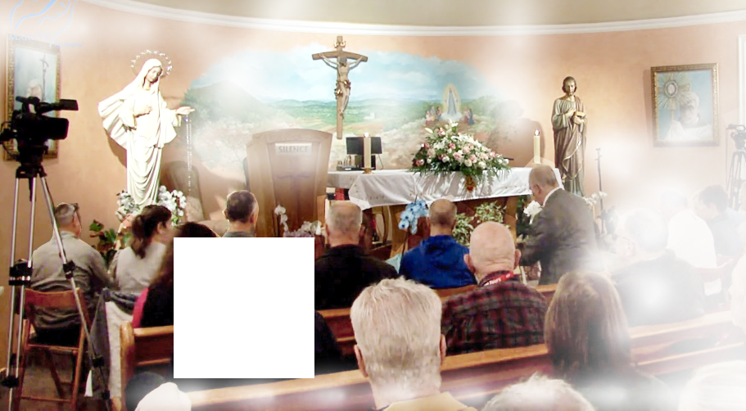
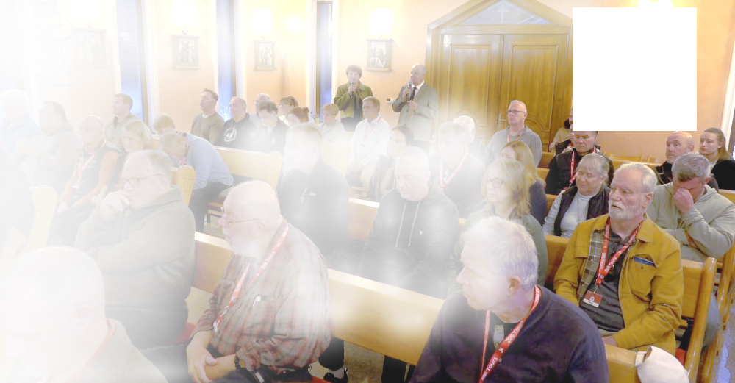

https://video.marytv.tv/watch/mXCL4zsXaAc
November 9th 2025
Our Lady’s Apparition and Message through Ivan Dragičević
Ivan relates:
because I see Her every day, that She is the best Mother, Teacher and Friend

Through all
these years
in Her school,
school of prayer,
school of love,
I feel that She is
the best,
…[Our Lady] lifts her gaze with so much joy on us all, extends her hands and prays over all of us. […] After that She
addresses us all with these words:

who wishes to
guide us all.
My dear children!
Today as well in a special way I wish to call you to pray for my beloved priests.
Pray for vocations in the Church.
And in a special way, dear children, I call you to renew the family prayer.
And the family prayer is the condition for vocations in the Church.
Therefore be perseverant in prayer.
Also today, dear children, I wish to thank
you for having responded to my call.
Our Lady bestows Her motherly blessing on all of us and She blesses all that we brought for blessing. […] After that Our Lady continues also today, like yesterday as well, particularly for some time She prays for peace in the world.
And in that prayer She leaves in the sign of the light of the Cross with the greeting: "Go in peace, my dear children!"
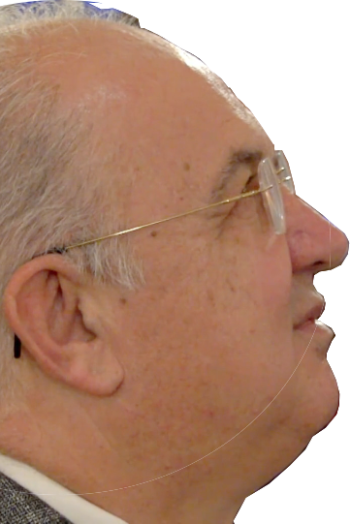

left: QR-code gives link to
3m 16s transmitting of Our Lady’s message, top right: the source 1h 18m

https://rumble.com/v7206rm-medjugorje-ivan-dragicevic-gospa-msg-2025-11-09.html
https://video.marytv.tv/watch/mXCL4zsXaAc
Our Lady’s Apparition and Message through Ivan Dragičević
November 9th 2025
Ivan relates:
because I see Her every day, that She is the best Mother, Teacher and Friend

Through all
these years
in Her school,
school of prayer,
school of love,
I feel that She is
the best,
…[Our Lady] lifts her gaze with so much joy on us all, extends her hands and prays over all of us. […] After that She
addresses us all with these words:
who wishes to
guide us all.
My dear children!
Today as well in a special way I wish to call you to pray for my beloved priests.
Pray for vocations in the Church.
And in a special way, dear children, I call you to renew the family prayer.
And the family prayer is the condition for vocations in the Church.
Therefore be perseverant in prayer.
Also today, dear children, I wish to thank
you for having responded to my call.
Our Lady bestows Her motherly blessing on all of us and She blesses all that we brought for blessing. […] After that Our Lady continues also today, like yesterday as well, particularly for some time She prays for peace in the world.
And in that prayer She leaves in the sign of the light of the Cross with the greeting: "Go in peace, my dear children!"
left: QR-code gives link to
3m 16s transmitting of Our Lady’s message, top right: the source 1h 18m

https://rumble.com/v7206rm-medjugorje-ivan-dragicevic-gospa-msg-2025-11-09.html
https://video.marytv.tv/watch/mXCL4zsXaAc
Our Lady’s Apparition and Message through Ivan Dragičević
November 9th 2025
Ivan relates:
because I see Her every day, that She is the best Mother, Teacher and Friend

Through all
these years
in Her school,
school of prayer,
school of love,
I feel that She is
the best,
…[Our Lady] lifts her gaze with so much joy on us all, extends her hands and prays over all of us. […] After that She
addresses us all with these words:
who wishes to
guide us all.
My dear children!
Today as well in a special way I wish to call you to pray for my beloved priests.
Pray for vocations in the Church.
And in a special way, dear children, I call you to renew the family prayer.
And the family prayer is the condition for vocations in the Church.
Therefore be perseverant in prayer.
Also today, dear children, I wish to thank
you for having responded to my call.
Our Lady bestows Her motherly blessing on all of us and She blesses all that we brought for blessing. […] After that Our Lady continues also today, like yesterday as well, particularly for some time She prays for peace in the world.
And in that prayer She leaves in the sign of the light of the Cross with the greeting: "Go in peace, my dear children!"
left: QR-code gives link to
3m 16s transmitting of Our Lady’s message, top right: the source 1h 18m

https://rumble.com/v7206rm-medjugorje-ivan-dragicevic-gospa-msg-2025-11-09.html
https://video.marytv.tv/watch/mXCL4zsXaAc
Our Lady’s Apparition and Message through Ivan Dragičević
November 9th 2025
Ivan relates:
because I see Her every day, that She is the best Mother, Teacher and Friend

Through all
these years
in Her school,
school of prayer,
school of love,
I feel that She is
the best,
…[Our Lady] lifts her gaze with so much joy on us all, extends her hands and prays over all of us. […] After that She
addresses us all with these words:
who wishes to
guide us all.
My dear children!
Today as well in a special way I wish to call you to pray for my beloved priests.
Pray for vocations in the Church.
And in a special way, dear children, I call you to renew the family prayer.
And the family prayer is the condition for vocations in the Church.
Therefore be perseverant in prayer.
Also today, dear children, I wish to thank
you for having responded to my call.
Our Lady bestows Her motherly blessing on all of us and She blesses all that we brought for blessing. […] After that Our Lady continues also today, like yesterday as well, particularly for some time She prays for peace in the world.
And in that prayer She leaves in the sign of the light of the Cross with the greeting: "Go in peace, my dear children!"
left: QR-code gives link to
3m 16s transmitting of Our Lady’s message, top right: the source 1h 18m

https://rumble.com/v7206rm-medjugorje-ivan-dragicevic-gospa-msg-2025-11-09.html
https://video.marytv.tv/watch/mXCL4zsXaAc
Our Lady’s Apparition and Message through Ivan Dragičević
November 9th 2025
Ivan relates:
because I see Her every day, that She is the best Mother, Teacher and Friend

Through all
these years
in Her school,
school of prayer,
school of love,
I feel that She is
the best,
…[Our Lady] lifts her gaze with so much joy on us all, extends her hands and prays over all of us. […] After that She
addresses us all with these words:
who wishes to
guide us all.
My dear children!
Today as well in a special way I wish to call you to pray for my beloved priests.
Pray for vocations in the Church.
And in a special way, dear children, I call you to renew the family prayer.
And the family prayer is the condition for vocations in the Church.
Therefore be perseverant in prayer.
Also today, dear children, I wish to thank
you for having responded to my call.
Our Lady bestows Her motherly blessing on all of us and She blesses all that we brought for blessing. […] After that Our Lady continues also today, like yesterday as well, particularly for some time She prays for peace in the world.
And in that prayer She leaves in the sign of the light of the Cross with the greeting: "Go in peace, my dear children!"
left: QR-code gives link to
3m 16s transmitting of Our Lady’s message, top right: the source 1h 18m

https://rumble.com/v7206rm-medjugorje-ivan-dragicevic-gospa-msg-2025-11-09.html
Our Lady’s message from Međugorje, December 25th 2025 through seer Marija Pavlović Lunetti
Dear children!
Also today, when God permits me to carry to you in my arms little Jesus, the King of Peace, that He may fill you with the ardor of love and peace, so that every heart may be similar to His Heart in this time of grace, be bold and courageous defenders of the love of your God, that in this time of grace He may give you His peace.
Thank you for having responded to my call.

taken from https://www.medjugorje.hr, compared to locations https://marytv.tv/, https://centermirmedjugorje.com/, https://wwww.medjugorje.org/, https://sremmanuel.org/, https://spiritdaily.org/, https://www.medjugorje.cc/, https://www.callofthekingdom.com/
(with Ecclesiastical approval)
Our Lady’s annual apparition message from Međugorje, December 25th 2025 through seer Jakov Čolo
Dear children!
Today, on this day of grace, in a special way I am calling you to complete surrender to Jesus. Little children, surrender to Him your wounds and pains, your past and future, and permit Jesus to rule in your lives. My children, only with complete surrender, Jesus gives Himself into your life, and this is the greatest gift that you can receive. Pray that you may comprehend how precious you are for Jesus and how much He loves you. Thank you for responding to my call.
(with Ecclesiastical approval)
taken from https://www.medjugorje.hr, compared to locations https://marytv.tv/, https://wwww.medjugorje.org/, https://sremmanuel.org/, https://www.medjugorje.cc/, https://www.callofthekingdom.com/

Our Lady’s message from Međugorje, December 25th 2025 through seer Marija Pavlović Lunetti
Dear children!
Also today, when God permits me to carry to you in my arms little Jesus, the King of Peace, that He may fill you with the ardor of love and peace, so that every heart may be similar to His Heart in this time of grace, be bold and courageous defenders of the love of your God, that in this time of grace He may give you His peace.
Thank you for having responded to my call.

taken from https://www.medjugorje.hr, compared to locations https://marytv.tv/, https://centermirmedjugorje.com/, https://wwww.medjugorje.org/, https://sremmanuel.org/, https://spiritdaily.org/, https://www.medjugorje.cc/, https://www.callofthekingdom.com/
(with Ecclesiastical approval)
Our Lady’s annual apparition message from Međugorje, December 25th 2025 through seer Jakov Čolo
Dear children!
Today, on this day of grace, in a special way I am calling you to complete surrender to Jesus. Little children, surrender to Him your wounds and pains, your past and future, and permit Jesus to rule in your lives. My children, only with complete surrender, Jesus gives Himself into your life, and this is the greatest gift that you can receive. Pray that you may comprehend how precious you are for Jesus and how much He loves you. Thank you for responding to my call.
(with Ecclesiastical approval)
taken from https://www.medjugorje.hr, compared to locations https://marytv.tv/, https://wwww.medjugorje.org/, https://sremmanuel.org/, https://www.medjugorje.cc/, https://www.callofthekingdom.com/

Our Lady’s message from Međugorje, December 25th 2025 through seer Marija Pavlović Lunetti
Dear children!
Also today, when God permits me to carry to you in my arms little Jesus, the King of Peace, that He may fill you with the ardor of love and peace, so that every heart may be similar to His Heart in this time of grace, be bold and courageous defenders of the love of your God, that in this time of grace He may give you His peace.
Thank you for having responded to my call.

taken from https://www.medjugorje.hr, compared to locations https://marytv.tv/, https://centermirmedjugorje.com/, https://wwww.medjugorje.org/, https://sremmanuel.org/, https://spiritdaily.org/, https://www.medjugorje.cc/, https://www.callofthekingdom.com/
(with Ecclesiastical approval)
Our Lady’s annual apparition message from Međugorje, December 25th 2025 through seer Jakov Čolo
Dear children!
Today, on this day of grace, in a special way I am calling you to complete surrender to Jesus. Little children, surrender to Him your wounds and pains, your past and future, and permit Jesus to rule in your lives. My children, only with complete surrender, Jesus gives Himself into your life, and this is the greatest gift that you can receive. Pray that you may comprehend how precious you are for Jesus and how much He loves you. Thank you for responding to my call.
(with Ecclesiastical approval)
taken from https://www.medjugorje.hr, compared to locations https://marytv.tv/, https://wwww.medjugorje.org/, https://sremmanuel.org/, https://www.medjugorje.cc/, https://www.callofthekingdom.com/

Our Lady’s message from Međugorje, December 25th 2025 through seer Marija Pavlović Lunetti
Dear children!
Also today, when God permits me to carry to you in my arms little Jesus, the King of Peace, that He may fill you with the ardor of love and peace, so that every heart may be similar to His Heart in this time of grace, be bold and courageous defenders of the love of your God, that in this time of grace He may give you His peace.
Thank you for having responded to my call.

taken from https://www.medjugorje.hr, compared to locations https://marytv.tv/, https://centermirmedjugorje.com/, https://wwww.medjugorje.org/, https://sremmanuel.org/, https://spiritdaily.org/, https://www.medjugorje.cc/, https://www.callofthekingdom.com/
(with Ecclesiastical approval)
Our Lady’s annual apparition message from Međugorje, December 25th 2025 through seer Jakov Čolo
Dear children!
Today, on this day of grace, in a special way I am calling you to complete surrender to Jesus. Little children, surrender to Him your wounds and pains, your past and future, and permit Jesus to rule in your lives. My children, only with complete surrender, Jesus gives Himself into your life, and this is the greatest gift that you can receive. Pray that you may comprehend how precious you are for Jesus and how much He loves you. Thank you for responding to my call.
(with Ecclesiastical approval)
taken from https://www.medjugorje.hr, compared to locations https://marytv.tv/, https://wwww.medjugorje.org/, https://sremmanuel.org/, https://www.medjugorje.cc/, https://www.callofthekingdom.com/

Our Lady’s message from Međugorje, December 25th 2025 through seer Marija Pavlović Lunetti
Dear children!
Also today, when God permits me to carry to you in my arms little Jesus, the King of Peace, that He may fill you with the ardor of love and peace, so that every heart may be similar to His Heart in this time of grace, be bold and courageous defenders of the love of your God, that in this time of grace He may give you His peace.
Thank you for having responded to my call.

taken from https://www.medjugorje.hr, compared to locations https://marytv.tv/, https://centermirmedjugorje.com/, https://wwww.medjugorje.org/, https://sremmanuel.org/, https://spiritdaily.org/, https://www.medjugorje.cc/, https://www.callofthekingdom.com/
(with Ecclesiastical approval)
Our Lady’s annual apparition message from Međugorje, December 25th 2025 through seer Jakov Čolo
Dear children!
Today, on this day of grace, in a special way I am calling you to complete surrender to Jesus. Little children, surrender to Him your wounds and pains, your past and future, and permit Jesus to rule in your lives. My children, only with complete surrender, Jesus gives Himself into your life, and this is the greatest gift that you can receive. Pray that you may comprehend how precious you are for Jesus and how much He loves you. Thank you for responding to my call.
(with Ecclesiastical approval)
taken from https://www.medjugorje.hr, compared to locations https://marytv.tv/, https://wwww.medjugorje.org/, https://sremmanuel.org/, https://www.medjugorje.cc/, https://www.callofthekingdom.com/

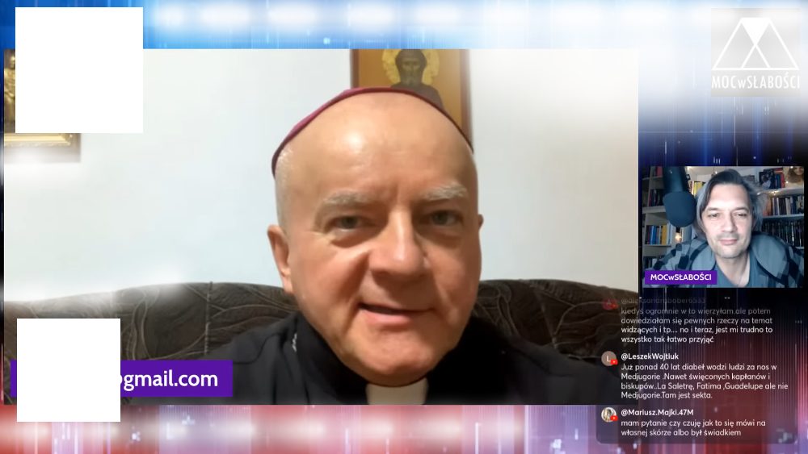

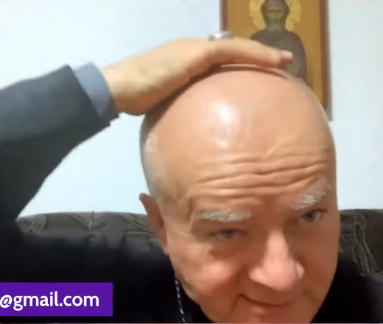
https://exDeo.net/medjugor/sobilo-touch-of-mother-of-god/
Visit this link for my first source on this story.
That was at an apparition to Ivan Dragičević, likely during novena to the 44th anniversary in Međugorje, likely in the chapel alongside Ivan’s home. Ukrainian Bishop Jan Sobiło, a Pole, speaks (from 0:35:32 of the video on youtube, in Polish):
above: Bishop shows where Our Lady laid Her hand on him
below: Bishop blesses everybody, also the viewers over internet
Here I felt [he lays his hand on top of his head] that something is delicately touching my head.
I look around, at the faithful who were at Ivan’s [in his chapel]. They were all about one meter away from me. […] And then I feel that something is touching me again.
[…] Mary touched me to heal my heart.


The pictures and translation are from the live-stream below of the Polish podcast “Moc w słabości” (The Strength in Weakness) of October 28th 2025:
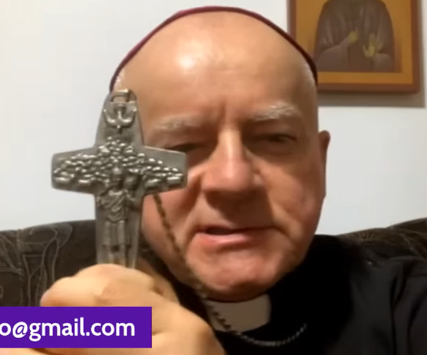


The above translation is not completely certain. If you know Polish, help us translate! The entire video is worth the effort! And we keep working on the translation, and with what we do, or get, or find, we will, God willing, update this page:

https://exdeo.net/medjugor/sobilo/
https://www.youtube.com/watch?v=eHwsmxxykmQ
https://exDeo.net/medjugor/sobilo-touch-of-mother-of-god/
Visit this link for my first source on this story.
above: Bishop shows where Our Lady laid Her hand on him
below: Bishop blesses everybody, also the viewers over internet
That was at an apparition to Ivan Dragičević, likely during novena to the 44th anniversary in Međugorje, likely in the chapel alongside Ivan’s home. Ukrainian Bishop Jan Sobiło, a Pole, speaks (from 0:35:32 of the video on youtube, in Polish):
Here I felt [he lays his hand on top of his head] that something is delicately touching my head.
I look around, at the faithful who were at Ivan’s [in his chapel]. They were all about one meter away from me. […] And then I feel that something is touching me again.
[…] Mary touched me to heal my heart.

The pictures and translation are from the live-stream below of the Polish podcast “Moc w słabości” (The Strength in Weakness) of October 28th 2025:

The above translation is not completely certain. If you know Polish, help us translate! The entire video is worth the effort! And we keep working on the translation, and with what we do, or get, or find, we will, God willing, update this page:

https://exdeo.net/medjugor/sobilo/
https://www.youtube.com/watch?v=eHwsmxxykmQ
https://exDeo.net/medjugor/sobilo-touch-of-mother-of-god/
Visit this link for my first source on this story.
above: Bishop shows where Our Lady laid Her hand on him
below: Bishop blesses everybody, also the viewers over internet
That was at an apparition to Ivan Dragičević, likely during novena to the 44th anniversary in Međugorje, likely in the chapel alongside Ivan’s home. Ukrainian Bishop Jan Sobiło, a Pole, speaks (from 0:35:32 of the video on youtube, in Polish):
Here I felt [he lays his hand on top of his head] that something is delicately touching my head.
I look around, at the faithful who were at Ivan’s [in his chapel]. They were all about one meter away from me. […] And then I feel that something is touching me again.
[…] Mary touched me to heal my heart.

The pictures and translation are from the live-stream below of the Polish podcast “Moc w słabości” (The Strength in Weakness) of October 28th 2025:

The above translation is not completely certain. If you know Polish, help us translate! The entire video is worth the effort! And we keep working on the translation, and with what we do, or get, or find, we will, God willing, update this page:

https://exdeo.net/medjugor/sobilo/
https://www.youtube.com/watch?v=eHwsmxxykmQ
https://exDeo.net/medjugor/sobilo-touch-of-mother-of-god/
Visit this link for my first source on this story.
above: Bishop shows where Our Lady laid Her hand on him
below: Bishop blesses everybody, also the viewers over internet
That was at an apparition to Ivan Dragičević, likely during novena to the 44th anniversary in Međugorje, likely in the chapel alongside Ivan’s home. Ukrainian Bishop Jan Sobiło, a Pole, speaks (from 0:35:32 of the video on youtube, in Polish):
Here I felt [he lays his hand on top of his head] that something is delicately touching my head.
I look around, at the faithful who were at Ivan’s [in his chapel]. They were all about one meter away from me. […] And then I feel that something is touching me again.
[…] Mary touched me to heal my heart.

The pictures and translation are from the live-stream below of the Polish podcast “Moc w słabości” (The Strength in Weakness) of October 28th 2025:

The above translation is not completely certain. If you know Polish, help us translate! The entire video is worth the effort! And we keep working on the translation, and with what we do, or get, or find, we will, God willing, update this page:

https://exdeo.net/medjugor/sobilo/
https://www.youtube.com/watch?v=eHwsmxxykmQ
https://exDeo.net/medjugor/sobilo-touch-of-mother-of-god/
Visit this link for my first source on this story.
above: Bishop shows where Our Lady laid Her hand on him
below: Bishop blesses everybody, also the viewers over internet
That was at an apparition to Ivan Dragičević, likely during novena to the 44th anniversary in Međugorje, likely in the chapel alongside Ivan’s home. Ukrainian Bishop Jan Sobiło, a Pole, speaks (from 0:35:32 of the video on youtube, in Polish):
Here I felt [he lays his hand on top of his head] that something is delicately touching my head.
I look around, at the faithful who were at Ivan’s [in his chapel]. They were all about one meter away from me. […] And then I feel that something is touching me again.
[…] Mary touched me to heal my heart.

The pictures and translation are from the live-stream below of the Polish podcast “Moc w słabości” (The Strength in Weakness) of October 28th 2025:

The above translation is not completely certain. If you know Polish, help us translate! The entire video is worth the effort! And we keep working on the translation, and with what we do, or get, or find, we will, God willing, update this page:

https://exdeo.net/medjugor/sobilo/
https://www.youtube.com/watch?v=eHwsmxxykmQ
Our Lady’s message from Međugorje, January 25th 2026 through seer Marija Pavlović Lunetti

Dear children!
Today I call you to be prayer and blessing for all those who have not come to know God's love. Little children, be different from others and be positive people of prayer and love towards God, that with your lives, you may be a sign of God's love to others. I bless you with my motherly blessing and intercede for each of you before my Son Jesus.
Thank you for responding to my call.

(with Ecclesiastical approval)
The official translation at time of announcement has: I am calling you to be prayer and a blessing. Both that and the above correspond to Croatian original but here the belief is the use of the progressive tense and the indefinite article is not needed. It is unnatural and the original is normal colloquial.
based on Croatian original from https://www.medjugorje.hr/, current official English translation found also at locations https://marytv.tv/, https://www.medjugorje.ws/, https://www.privaterevelation.org/, https://www.medjugorje.org/, https://mysticpost.com/

Our Lady’s message from Međugorje, January 25th 2026 through seer Marija Pavlović Lunetti

Dear children!
Today I call you to be prayer and blessing for all those who have not come to know God's love. Little children, be different from others and be positive people of prayer and love towards God, that with your lives, you may be a sign of God's love to others. I bless you with my motherly blessing and intercede for each of you before my Son Jesus.
Thank you for responding to my call.

The official translation at time of announcement has: I am calling you to be prayer and a blessing. Both that and the above correspond to Croatian original but here the belief is the use of the progressive tense and the indefinite article is not needed. It is unnatural and the original is normal colloquial.
(with Ecclesiastical approval)
based on Croatian original from https://www.medjugorje.hr/, current official English translation found also at locations https://marytv.tv/, https://www.medjugorje.ws/, https://www.privaterevelation.org/, https://www.medjugorje.org/, https://mysticpost.com/

Our Lady’s message from Međugorje, January 25th 2026 through seer Marija Pavlović Lunetti

Dear children!
Today I call you to be prayer and blessing for all those who have not come to know God's love. Little children, be different from others and be positive people of prayer and love towards God, that with your lives, you may be a sign of God's love to others. I bless you with my motherly blessing and intercede for each of you before my Son Jesus.
Thank you for responding to my call.

The official translation at time of announcement has: I am calling you to be prayer and a blessing. Both that and the above correspond to Croatian original but here the belief is the use of the progressive tense and the indefinite article is not needed. It is unnatural and the original is normal colloquial.
(with Ecclesiastical approval)
based on Croatian original from https://www.medjugorje.hr/, current official English translation found also at locations https://marytv.tv/, https://www.medjugorje.ws/, https://www.privaterevelation.org/, https://www.medjugorje.org/, https://mysticpost.com/

Our Lady’s message from Međugorje, January 25th 2026 through seer Marija Pavlović Lunetti

Dear children!
Today I call you to be prayer and blessing for all those who have not come to know God's love. Little children, be different from others and be positive people of prayer and love towards God, that with your lives, you may be a sign of God's love to others. I bless you with my motherly blessing and intercede for each of you before my Son Jesus.
Thank you for responding to my call.

The official translation at time of announcement has: I am calling you to be prayer and a blessing. Both that and the above correspond to Croatian original but here the belief is the use of the progressive tense and the indefinite article is not needed. It is unnatural and the original is normal colloquial.
(with Ecclesiastical approval)
based on Croatian original from https://www.medjugorje.hr/, current official English translation found also at locations https://marytv.tv/, https://www.medjugorje.ws/, https://www.privaterevelation.org/, https://www.medjugorje.org/, https://mysticpost.com/

Our Lady’s message from Međugorje, January 25th 2026 through seer Marija Pavlović Lunetti

Dear children!
Today I call you to be prayer and blessing for all those who have not come to know God's love. Little children, be different from others and be positive people of prayer and love towards God, that with your lives, you may be a sign of God's love to others. I bless you with my motherly blessing and intercede for each of you before my Son Jesus.
Thank you for responding to my call.

The official translation at time of announcement has: I am calling you to be prayer and a blessing. Both that and the above correspond to Croatian original but here the belief is the use of the progressive tense and the indefinite article is not needed. It is unnatural and the original is normal colloquial.
(with Ecclesiastical approval)
based on Croatian original from https://www.medjugorje.hr/, current official English translation found also at locations https://marytv.tv/, https://www.medjugorje.ws/, https://www.privaterevelation.org/, https://www.medjugorje.org/, https://mysticpost.com/

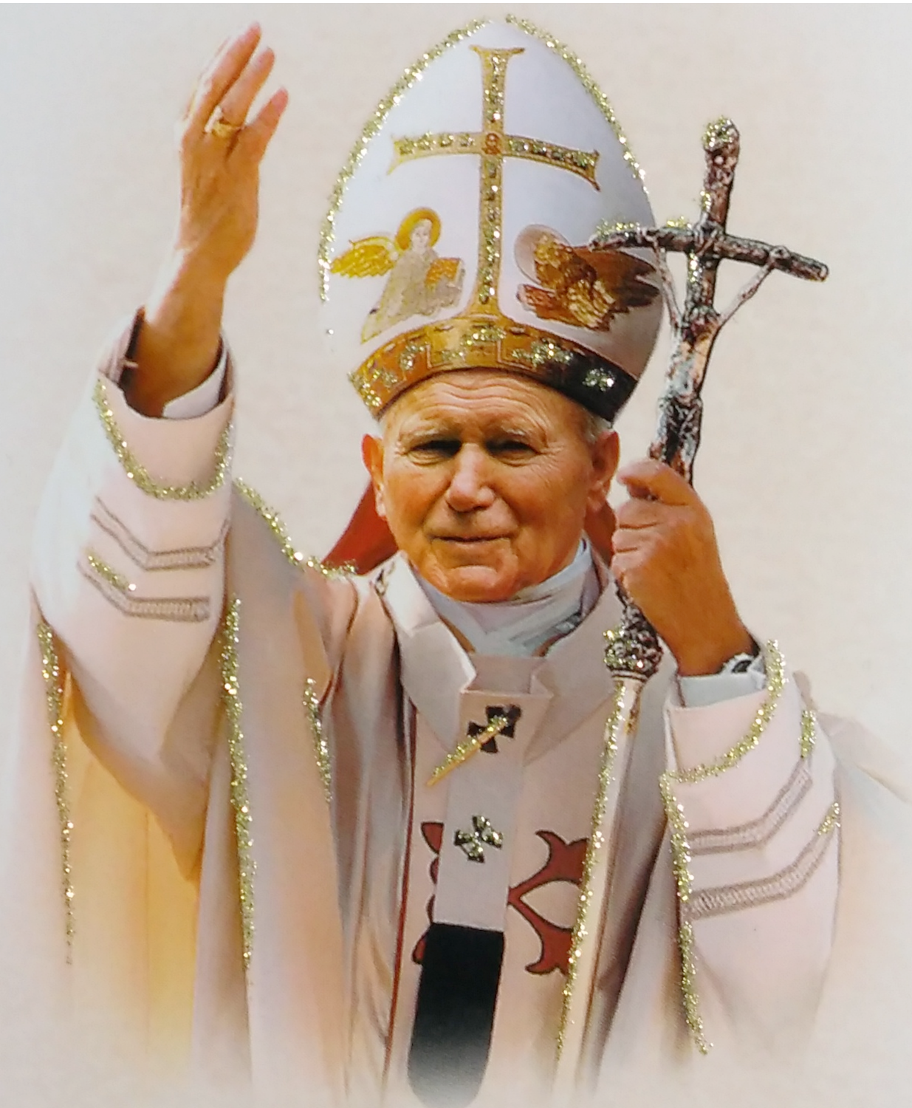
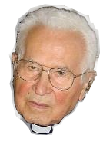
B.P.H: In 1991 (10 years after the first message: “Peace, peace and only peace”), when the war broke out in Croatia, I met the Pope once again, and he asked me: “How can the apparitions of Medjugorje be explained in the midst of the war in Bosnia?” Really, the war was terrible, so I answered: “It seems that we are in the same situation as in Fatima. If Russia had immediately been consecrated to the Immaculate Heart of Mary, the Second World War and the spreading of the Communism and atheism would have been avoided.
From Interview with Bishop Pavol Hnilica for German Politik und Religion, December 2004
- Why is it so important that other bishops should have done the same in the sense of what Holy Father has done?
B.P.H. – It is expressing the collegiality of the Church; in other words, the unity of the bishops with the Pope gives to it a far deeper meaning. When Carol Woytila was elected a Pope in 1978, I congratulated him, but I immediately told him that something would be missing to his pontificate if he does not consecrate Russia together with all the bishops.

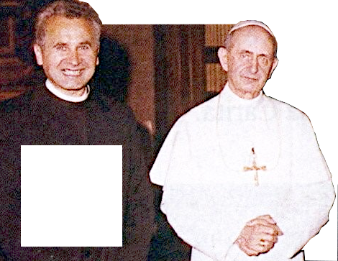
He told me then: “If you manage to convince bishops about this, I will do it tomorrow.” This is why, after the consecration (25.03.1984), he asked me how many bishops concelebrated with me. As I could not answer him to this question, the Pope said: “Every bishop must prepare his diocese […]”
Holy Father, as soon as, in 1984, you consecrated Russia to the Immaculate Heart of Mary, countless changes took place in Russia, and the fall of
the communism began. Nobody took these messages seriously.
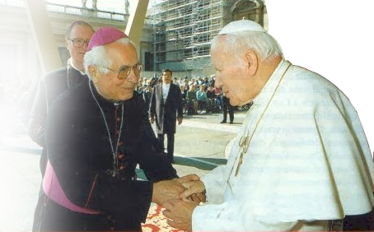
historically,
Bishop Hnilica and Pope Paul VI
Maybe, if the bishops of former Yugoslavia had accepted these messages more seriously, it would not have gone that far […]”
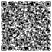
Then the Pope told me: “Then, bishop Hnilica is convinced that my action of consecration to the Immaculate Heart of Mary was valid?” I answered: “Certainly it was valid; the only question is how many bishops really did the same consecration in union with the Holy Father.” ⮥
Bishop Hnilica and Pope John Paul II
https://web.archive.org/web/20250906074553/http://www.medjugorje.hr/en/news/medjugorje-and-pope-john-paul-ii---an-interview-with-bishop-hnilica,1132.html

https://croatiafidelis.hr/cenz/260129-bp-hnilica-medjugorje-hr/
This translation from German was (and is it still?) on the official Međugorje website. The text is verbatim from the archived page, QR-code with the very long link, and see the study, the small QR-code and shorter link.
B.P.H: In 1991 (10 years after the first message: “Peace, peace and only peace”), when the war broke out in Croatia, I met the Pope once again, and he asked me: “How can the apparitions of Medjugorje be explained in the midst of the war in Bosnia?” Really, the war was terrible, so I answered: “It seems that we are in the same situation as in Fatima. If Russia had immediately been consecrated to the Immaculate Heart of Mary, the Second World War and the spreading of the Communism and atheism would have been avoided.
From Interview with Bishop Pavol Hnilica for German Politik und Religion, December 2004
- Why is it so important that other bishops should have done the same in the sense of what Holy Father has done?
B.P.H. – It is expressing the collegiality of the Church; in other words, the unity of the bishops with the Pope gives to it a far deeper meaning. When Carol Woytila was elected a Pope in 1978, I congratulated him, but I immediately told him that something would be missing to his pontificate if he does not consecrate Russia together with all the bishops.

Holy Father, as soon as, in 1984, you consecrated Russia to the Immaculate Heart of Mary, countless changes took place in Russia, and the fall of
the communism began. Nobody took these messages seriously.
He told me then: “If you manage to convince bishops about this, I will do it tomorrow.” This is why, after the consecration (25.03.1984), he asked me how many bishops concelebrated with me. As I could not answer him to this question, the Pope said: “Every bishop must prepare his diocese […]”
historically,
Bishop Hnilica and Pope Paul VI
Maybe, if the bishops of former Yugoslavia had accepted these messages more seriously, it would not have gone that far […]”
Then the Pope told me: “Then, bishop Hnilica is convinced that my action of consecration to the Immaculate Heart of Mary was valid?” I answered: “Certainly it was valid; the only question is how many bishops really did the same consecration in union with the Holy Father.” ⮥
Bishop Hnilica and Pope John Paul II
https://web.archive.org/web/20250906074553/http://www.medjugorje.hr/en/news/medjugorje-and-pope-john-paul-ii---an-interview-with-bishop-hnilica,1132.html
https://croatiafidelis.hr/cenz/260129-bp-hnilica-medjugorje-hr/
This translation from German was (and is it still?) on the official Međugorje website. The text is verbatim from the archived page, QR-code with the very long link, and see the study, the small QR-code and shorter link.
B.P.H: In 1991 (10 years after the first message: “Peace, peace and only peace”), when the war broke out in Croatia, I met the Pope once again, and he asked me: “How can the apparitions of Medjugorje be explained in the midst of the war in Bosnia?” Really, the war was terrible, so I answered: “It seems that we are in the same situation as in Fatima. If Russia had immediately been consecrated to the Immaculate Heart of Mary, the Second World War and the spreading of the Communism and atheism would have been avoided.
From Interview with Bishop Pavol Hnilica for German Politik und Religion, December 2004
- Why is it so important that other bishops should have done the same in the sense of what Holy Father has done?
B.P.H. – It is expressing the collegiality of the Church; in other words, the unity of the bishops with the Pope gives to it a far deeper meaning. When Carol Woytila was elected a Pope in 1978, I congratulated him, but I immediately told him that something would be missing to his pontificate if he does not consecrate Russia together with all the bishops.

Holy Father, as soon as, in 1984, you consecrated Russia to the Immaculate Heart of Mary, countless changes took place in Russia, and the fall of
the communism began. Nobody took these messages seriously.
He told me then: “If you manage to convince bishops about this, I will do it tomorrow.” This is why, after the consecration (25.03.1984), he asked me how many bishops concelebrated with me. As I could not answer him to this question, the Pope said: “Every bishop must prepare his diocese […]”
historically,
Bishop Hnilica and Pope Paul VI
Maybe, if the bishops of former Yugoslavia had accepted these messages more seriously, it would not have gone that far […]”
Then the Pope told me: “Then, bishop Hnilica is convinced that my action of consecration to the Immaculate Heart of Mary was valid?” I answered: “Certainly it was valid; the only question is how many bishops really did the same consecration in union with the Holy Father.” ⮥
Bishop Hnilica and Pope John Paul II
https://web.archive.org/web/20250906074553/http://www.medjugorje.hr/en/news/medjugorje-and-pope-john-paul-ii---an-interview-with-bishop-hnilica,1132.html
https://croatiafidelis.hr/cenz/260129-bp-hnilica-medjugorje-hr/
This translation from German was (and is it still?) on the official Međugorje website. The text is verbatim from the archived page, QR-code with the very long link, and see the study, the small QR-code and shorter link.
B.P.H: In 1991 (10 years after the first message: “Peace, peace and only peace”), when the war broke out in Croatia, I met the Pope once again, and he asked me: “How can the apparitions of Medjugorje be explained in the midst of the war in Bosnia?” Really, the war was terrible, so I answered: “It seems that we are in the same situation as in Fatima. If Russia had immediately been consecrated to the Immaculate Heart of Mary, the Second World War and the spreading of the Communism and atheism would have been avoided.
From Interview with Bishop Pavol Hnilica for German Politik und Religion, December 2004
- Why is it so important that other bishops should have done the same in the sense of what Holy Father has done?
B.P.H. – It is expressing the collegiality of the Church; in other words, the unity of the bishops with the Pope gives to it a far deeper meaning. When Carol Woytila was elected a Pope in 1978, I congratulated him, but I immediately told him that something would be missing to his pontificate if he does not consecrate Russia together with all the bishops.

Holy Father, as soon as, in 1984, you consecrated Russia to the Immaculate Heart of Mary, countless changes took place in Russia, and the fall of
the communism began. Nobody took these messages seriously.
He told me then: “If you manage to convince bishops about this, I will do it tomorrow.” This is why, after the consecration (25.03.1984), he asked me how many bishops concelebrated with me. As I could not answer him to this question, the Pope said: “Every bishop must prepare his diocese […]”
historically,
Bishop Hnilica and Pope Paul VI
Maybe, if the bishops of former Yugoslavia had accepted these messages more seriously, it would not have gone that far […]”
Then the Pope told me: “Then, bishop Hnilica is convinced that my action of consecration to the Immaculate Heart of Mary was valid?” I answered: “Certainly it was valid; the only question is how many bishops really did the same consecration in union with the Holy Father.” ⮥
Bishop Hnilica and Pope John Paul II
https://web.archive.org/web/20250906074553/http://www.medjugorje.hr/en/news/medjugorje-and-pope-john-paul-ii---an-interview-with-bishop-hnilica,1132.html
https://croatiafidelis.hr/cenz/260129-bp-hnilica-medjugorje-hr/
This translation from German was (and is it still?) on the official Međugorje website. The text is verbatim from the archived page, QR-code with the very long link, and see the study, the small QR-code and shorter link.
B.P.H: In 1991 (10 years after the first message: “Peace, peace and only peace”), when the war broke out in Croatia, I met the Pope once again, and he asked me: “How can the apparitions of Medjugorje be explained in the midst of the war in Bosnia?” Really, the war was terrible, so I answered: “It seems that we are in the same situation as in Fatima. If Russia had immediately been consecrated to the Immaculate Heart of Mary, the Second World War and the spreading of the Communism and atheism would have been avoided.
From Interview with Bishop Pavol Hnilica for German Politik und Religion, December 2004
- Why is it so important that other bishops should have done the same in the sense of what Holy Father has done?
B.P.H. – It is expressing the collegiality of the Church; in other words, the unity of the bishops with the Pope gives to it a far deeper meaning. When Carol Woytila was elected a Pope in 1978, I congratulated him, but I immediately told him that something would be missing to his pontificate if he does not consecrate Russia together with all the bishops.

Holy Father, as soon as, in 1984, you consecrated Russia to the Immaculate Heart of Mary, countless changes took place in Russia, and the fall of
the communism began. Nobody took these messages seriously.
He told me then: “If you manage to convince bishops about this, I will do it tomorrow.” This is why, after the consecration (25.03.1984), he asked me how many bishops concelebrated with me. As I could not answer him to this question, the Pope said: “Every bishop must prepare his diocese […]”
historically,
Bishop Hnilica and Pope Paul VI
Maybe, if the bishops of former Yugoslavia had accepted these messages more seriously, it would not have gone that far […]”
Then the Pope told me: “Then, bishop Hnilica is convinced that my action of consecration to the Immaculate Heart of Mary was valid?” I answered: “Certainly it was valid; the only question is how many bishops really did the same consecration in union with the Holy Father.” ⮥
Bishop Hnilica and Pope John Paul II
https://web.archive.org/web/20250906074553/http://www.medjugorje.hr/en/news/medjugorje-and-pope-john-paul-ii---an-interview-with-bishop-hnilica,1132.html
https://croatiafidelis.hr/cenz/260129-bp-hnilica-medjugorje-hr/
This translation from German was (and is it still?) on the official Međugorje website. The text is verbatim from the archived page, QR-code with the very long link, and see the study, the small QR-code and shorter link.
Our Lady’s message from Međugorje, February 25th 2026 through seer Marija Pavlović Lunetti
Dear children!
In this time of grace, anew, I am calling you to offer your lives to God that He may lead you towards the resurrection through your personal conversion. Little children, God is near to you and heeds your prayers, but you are lulled to sleep, and that is why He sent me to you to awaken you, and that you may shine holiness like a spring flower.
Thank you for having responded to my call.

(With ecclesiastical approval)
taken from https://www.medjugorje.hr/, compared to locations https://marytv.tv/, https://spiritdaily.org/, https://www.privaterevelation.org/, https://www.countdowntothekingdom.com/, https://mysticpost.com/

Our Lady’s message from Međugorje, February 25th 2026 through seer Marija Pavlović Lunetti
Dear children!
In this time of grace, anew, I am calling you to offer your lives to God that He may lead you towards the resurrection through your personal conversion. Little children, God is near to you and heeds your prayers, but you are lulled to sleep, and that is why He sent me to you to awaken you, and that you may shine holiness like a spring flower.
Thank you for having responded to my call.

(With ecclesiastical approval)
taken from https://www.medjugorje.hr/, compared to locations https://marytv.tv/, https://spiritdaily.org/, https://www.privaterevelation.org/, https://www.countdowntothekingdom.com/, https://mysticpost.com/

Our Lady’s message from Međugorje, February 25th 2026 through seer Marija Pavlović Lunetti
Dear children!
In this time of grace, anew, I am calling you to offer your lives to God that He may lead you towards the resurrection through your personal conversion. Little children, God is near to you and heeds your prayers, but you are lulled to sleep, and that is why He sent me to you to awaken you, and that you may shine holiness like a spring flower.
Thank you for having responded to my call.

(With ecclesiastical approval)
taken from https://www.medjugorje.hr/, compared to locations https://marytv.tv/, https://spiritdaily.org/, https://www.privaterevelation.org/, https://www.countdowntothekingdom.com/, https://mysticpost.com/

Our Lady’s message from Međugorje, February 25th 2026 through seer Marija Pavlović Lunetti
Dear children!
In this time of grace, anew, I am calling you to offer your lives to God that He may lead you towards the resurrection through your personal conversion. Little children, God is near to you and heeds your prayers, but you are lulled to sleep, and that is why He sent me to you to awaken you, and that you may shine holiness like a spring flower.
Thank you for having responded to my call.

(With ecclesiastical approval)
taken from https://www.medjugorje.hr/, compared to locations https://marytv.tv/, https://spiritdaily.org/, https://www.privaterevelation.org/, https://www.countdowntothekingdom.com/, https://mysticpost.com/

Our Lady’s message from Međugorje, February 25th 2026 through seer Marija Pavlović Lunetti
Dear children!
In this time of grace, anew, I am calling you to offer your lives to God that He may lead you towards the resurrection through your personal conversion. Little children, God is near to you and heeds your prayers, but you are lulled to sleep, and that is why He sent me to you to awaken you, and that you may shine holiness like a spring flower.
Thank you for having responded to my call.

(With ecclesiastical approval)
taken from https://www.medjugorje.hr/, compared to locations https://marytv.tv/, https://spiritdaily.org/, https://www.privaterevelation.org/, https://www.countdowntothekingdom.com/, https://mysticpost.com/

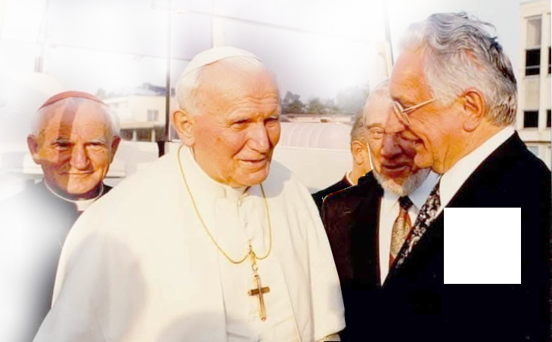

From the article entitled The Pope and Medjugorje (previously, and still?) on official medjugorje.hr website (more in the links you get with the QR-codes):
Moved by the meeting at the shrine and the cheers of the large gathered crowd of over 30,000 people that came to greet him from all parts of Bosnia-Hercegovina, Mr. President stayed for a talk with the assembled priests. [Present were Medjugorje and surrounding parishes priests, Franciscan provincial Tomislav Pervan, local bishop Ratko Perić and a number of highest ranking officials of Croatia and Bosnia-Hercegovina.]
The Croatian President, Dr. Franjo Tudjman, on March 15, 1997 participated in the re-opening for production of the local aluminum factory in Mostar.
https://croatiafidelis.hr/cenz/260227-jp2-tudjman-medjugorje-hr/

After the festivities in Mostar the Croatian President, by his own expressed desire, came to visit the Shrine of the Queen of Peace in Medjugorje. ⮥
Among other things, Dr. Franjo Tudjman also said the following: "Again I repeat that on the occasion of my last conversation with him Pope John Paul II said that, on the occasion of his visit to Bosnia-Hercegovina, he would like also to visit Medjugorje.

On April 12th 1997 John Paul visits Sarajevo, but his visit to Međugorje does not happen.
The picture is from John Paul II September 1994 visit to Croatia. From right: President Tuđman, the Pope, Crd. Franjo Kuharić, Abp. of Zagreb and the Pope’s great friend. And below is the message that Our Lady gave just previous to that one of His three visits to Croatia.
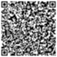
Međugorje Message, August 25th 1994
(Croatia was still partly occupied in 1994, so the dream of independence has not yet been fulfilled.)
That article can be found on at least www.medjugorje.ws and medjugorje.org.
“Dear children! Today I am united with you in prayer in a special way, praying for the gift of the presence of my most beloved son in your home country. Pray, little children, for the health of my most beloved son, who suffers, and whom I have chosen for these times. I pray and intercede before my Son, Jesus, so that the dream that your fathers had may be fulfilled. Pray, little children, in a special way, because Satan is strong and wants to destroy hope in your heart. I bless you. Thank you for having responded to my call.”
https://web.archive.org/web/20170714180944/https://www.medjugorje.hr/en/medjugorje-phenomenon/church/bishops/shepherds/pope/

From the article entitled The Pope and Medjugorje (previously, and still?) on official medjugorje.hr website (more in the links you get with the QR-codes):
The Croatian President, Dr. Franjo Tudjman, on March 15, 1997 participated in the re-opening for production of the local aluminum factory in Mostar.
Moved by the meeting at the shrine and the cheers of the large gathered crowd of over 30,000 people that came to greet him from all parts of Bosnia-Hercegovina, Mr. President stayed for a talk with the assembled priests. [Present were Medjugorje and surrounding parishes priests, Franciscan provincial Tomislav Pervan, local bishop Ratko Perić and a number of highest ranking officials of Croatia and Bosnia-Hercegovina.]
https://croatiafidelis.hr/cenz/260227-jp2-tudjman-medjugorje-hr/

After the festivities in Mostar the Croatian President, by his own expressed desire, came to visit the Shrine of the Queen of Peace in Medjugorje. ⮥
Among other things, Dr. Franjo Tudjman also said the following: "Again I repeat that on the occasion of my last conversation with him Pope John Paul II said that, on the occasion of his visit to Bosnia-Hercegovina, he would like also to visit Medjugorje.

On April 12th 1997 John Paul visits Sarajevo, but his visit to Međugorje does not happen.
The picture is from John Paul II September 1994 visit to Croatia. From right: President Tuđman, the Pope, Crd. Franjo Kuharić, Abp. of Zagreb and the Pope’s great friend. And below is the message that Our Lady gave just previous to that one of His three visits to Croatia.
That article can be found on at least www.medjugorje.ws and medjugorje.org.
Međugorje Message, August 25th 1994
(Croatia was still partly occupied in 1994, so the dream of independence has not yet been fulfilled.)
Bishop Hnilica and Pope John Paul II
“Dear children! Today I am united with you in prayer in a special way, praying for the gift of the presence of my most beloved son in your home country. Pray, little children, for the health of my most beloved son, who suffers, and whom I have chosen for these times. I pray and intercede before my Son, Jesus, so that the dream that your fathers had may be fulfilled. Pray, little children, in a special way, because Satan is strong and wants to destroy hope in your heart. I bless you. Thank you for having responded to my call.”
https://web.archive.org/web/20170714180944/https://www.medjugorje.hr/en/medjugorje-phenomenon/church/bishops/shepherds/pope/

From the article entitled The Pope and Medjugorje (previously, and still?) on official medjugorje.hr website (more in the links you get with the QR-codes):
The Croatian President, Dr. Franjo Tudjman, on March 15, 1997 participated in the re-opening for production of the local aluminum factory in Mostar.
Moved by the meeting at the shrine and the cheers of the large gathered crowd of over 30,000 people that came to greet him from all parts of Bosnia-Hercegovina, Mr. President stayed for a talk with the assembled priests. [Present were Medjugorje and surrounding parishes priests, Franciscan provincial Tomislav Pervan, local bishop Ratko Perić and a number of highest ranking officials of Croatia and Bosnia-Hercegovina.]
https://croatiafidelis.hr/cenz/260227-jp2-tudjman-medjugorje-hr/

After the festivities in Mostar the Croatian President, by his own expressed desire, came to visit the Shrine of the Queen of Peace in Medjugorje. ⮥
Among other things, Dr. Franjo Tudjman also said the following: "Again I repeat that on the occasion of my last conversation with him Pope John Paul II said that, on the occasion of his visit to Bosnia-Hercegovina, he would like also to visit Medjugorje.

On April 12th 1997 John Paul visits Sarajevo, but his visit to Međugorje does not happen.
The picture is from John Paul II September 1994 visit to Croatia. From right: President Tuđman, the Pope, Crd. Franjo Kuharić, Abp. of Zagreb and the Pope’s great friend. And below is the message that Our Lady gave just previous to that one of His three visits to Croatia.
That article can be found on at least www.medjugorje.ws and medjugorje.org.
Međugorje Message, August 25th 1994
(Croatia was still partly occupied in 1994, so the dream of independence has not yet been fulfilled.)
Bishop Hnilica and Pope John Paul II
“Dear children! Today I am united with you in prayer in a special way, praying for the gift of the presence of my most beloved son in your home country. Pray, little children, for the health of my most beloved son, who suffers, and whom I have chosen for these times. I pray and intercede before my Son, Jesus, so that the dream that your fathers had may be fulfilled. Pray, little children, in a special way, because Satan is strong and wants to destroy hope in your heart. I bless you. Thank you for having responded to my call.”
https://web.archive.org/web/20170714180944/https://www.medjugorje.hr/en/medjugorje-phenomenon/church/bishops/shepherds/pope/

From the article entitled The Pope and Medjugorje (previously, and still?) on official medjugorje.hr website (more in the links you get with the QR-codes):
The Croatian President, Dr. Franjo Tudjman, on March 15, 1997 participated in the re-opening for production of the local aluminum factory in Mostar.
Moved by the meeting at the shrine and the cheers of the large gathered crowd of over 30,000 people that came to greet him from all parts of Bosnia-Hercegovina, Mr. President stayed for a talk with the assembled priests. [Present were Medjugorje and surrounding parishes priests, Franciscan provincial Tomislav Pervan, local bishop Ratko Perić and a number of highest ranking officials of Croatia and Bosnia-Hercegovina.]
https://croatiafidelis.hr/cenz/260227-jp2-tudjman-medjugorje-hr/

After the festivities in Mostar the Croatian President, by his own expressed desire, came to visit the Shrine of the Queen of Peace in Medjugorje. ⮥
Among other things, Dr. Franjo Tudjman also said the following: "Again I repeat that on the occasion of my last conversation with him Pope John Paul II said that, on the occasion of his visit to Bosnia-Hercegovina, he would like also to visit Medjugorje.

On April 12th 1997 John Paul visits Sarajevo, but his visit to Međugorje does not happen.
The picture is from John Paul II September 1994 visit to Croatia. From right: President Tuđman, the Pope, Crd. Franjo Kuharić, Abp. of Zagreb and the Pope’s great friend. And below is the message that Our Lady gave just previous to that one of His three visits to Croatia.
That article can be found on at least www.medjugorje.ws and medjugorje.org.
Međugorje Message, August 25th 1994
Bishop Hnilica and Pope John Paul II
“Dear children! Today I am united with you in prayer in a special way, praying for the gift of the presence of my most beloved son in your home country. Pray, little children, for the health of my most beloved son, who suffers, and whom I have chosen for these times. I pray and intercede before my Son, Jesus, so that the dream that your fathers had may be fulfilled. Pray, little children, in a special way, because Satan is strong and wants to destroy hope in your heart. I bless you. Thank you for having responded to my call.”

From the article entitled The Pope and Medjugorje (previously, and still?) on official medjugorje.hr website (more in the links you get with the QR-codes):
The Croatian President, Dr. Franjo Tudjman, on March 15, 1997 participated in the re-opening for production of the local aluminum factory in Mostar.
Moved by the meeting at the shrine and the cheers of the large gathered crowd of over 30,000 people that came to greet him from all parts of Bosnia-Hercegovina, Mr. President stayed for a talk with the assembled priests. [Present were Medjugorje and surrounding parishes priests, Franciscan provincial Tomislav Pervan, local bishop Ratko Perić and a number of highest ranking officials of Croatia and Bosnia-Hercegovina.]
https://croatiafidelis.hr/cenz/260227-jp2-tudjman-medjugorje-hr/

After the festivities in Mostar the Croatian President, by his own expressed desire, came to visit the Shrine of the Queen of Peace in Medjugorje. ⮥
Among other things, Dr. Franjo Tudjman also said the following: "Again I repeat that on the occasion of my last conversation with him Pope John Paul II said that, on the occasion of his visit to Bosnia-Hercegovina, he would like also to visit Medjugorje.

On April 12th 1997 John Paul visits Sarajevo, but his visit to Međugorje does not happen.
The picture is from John Paul II September 1994 visit to Croatia. From right: President Tuđman, the Pope, Crd. Franjo Kuharić, Abp. of Zagreb and the Pope’s great friend. And below is the message that Our Lady gave just previous to that one of His three visits to Croatia.
That article can be found on at least www.medjugorje.ws and medjugorje.org.
Međugorje Message, August 25th 1994
(Croatia was still partly occupied in 1994, so the dream of independence has not yet been fulfilled.)
Bishop Hnilica and Pope John Paul II
“Dear children! Today I am united with you in prayer in a special way, praying for the gift of the presence of my most beloved son in your home country. Pray, little children, for the health of my most beloved son, who suffers, and whom I have chosen for these times. I pray and intercede before my Son, Jesus, so that the dream that your fathers had may be fulfilled. Pray, little children, in a special way, because Satan is strong and wants to destroy hope in your heart. I bless you. Thank you for having responded to my call.”
https://web.archive.org/web/20170714180944/https://www.medjugorje.hr/en/medjugorje-phenomenon/church/bishops/shepherds/pope/

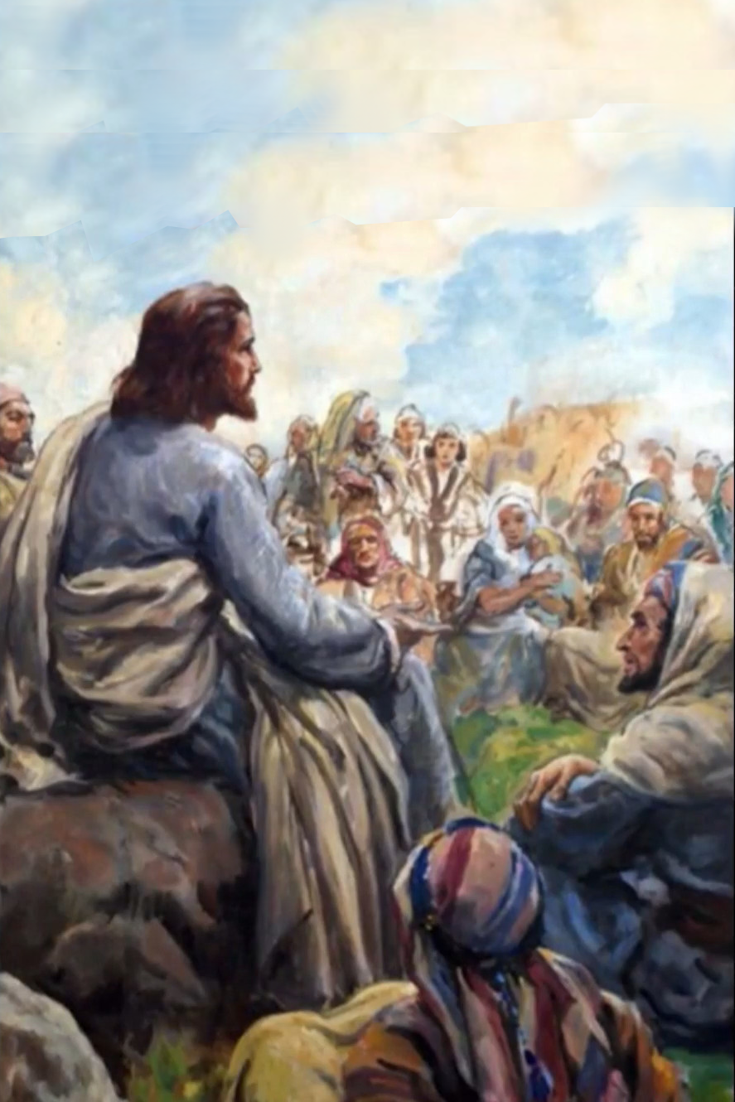
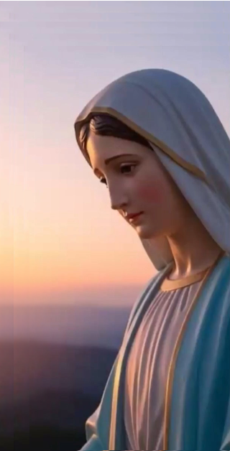
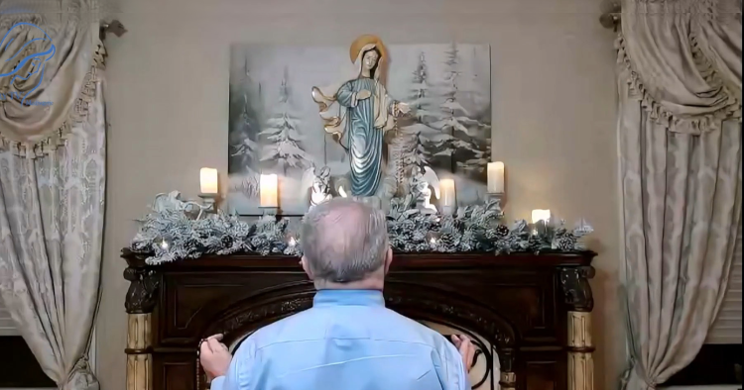
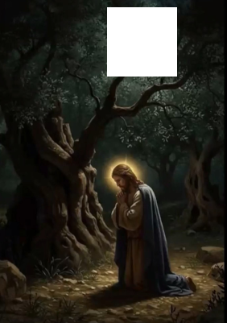

February 8th 2026
Our Lady’s Apparition and Message through Ivan Dragičević
https://video.marytv.tv/watch/mt7Y6csX8Ui
Ivan describes and relates: Also today she came to us joyful and merry and greets us all with Her motherly greeting: "Praised be Jesus,
my dear children!".
After that She extends Her hands over all of us and in Her Aramaic language prays over us all. She especially prays over you priests present and you sick who are present. After that She addresses us all with these words:
"Dear children, this is time of grace that is given to you. I call you dear children in this time to return to my Son through prayer, fasting and deeds of love. Do not be afraid of silence, dear children, because God speaks in silence. Purify your hearts of unrest, selfishness and fear and allow God’s love to transform you. Thank you dear children also today for having responded to my call!”


[…] After that Our Lady keeps on for some time, prays especially for peace in the world, in the families, and particularly among the youth. And in that prayer She leaves in the sign of the light of the Cross with the greeting: "Go in peace, my dear children!"

https://video.marytv.tv/watch/mt7Y6csX8Ui
February 8th 2026
Our Lady’s Apparition and Message through Ivan Dragičević
Ivan describes and relates: Also today she came to us joyful and merry and greets us all with Her motherly greeting: "Praised be Jesus,
my dear children!".
After that She extends Her hands over all of us and in Her Aramaic language prays over us all. She especially prays over you priests present and you sick who are present. After that She addresses us all with these words:
"Dear children, this is time of grace that is given to you. I call you dear children in this time to return to my Son through prayer, fasting and deeds of love. Do not be afraid of silence, dear children, because God speaks in silence. Purify your hearts of unrest, selfishness and fear and allow God’s love to transform you. Thank you dear children also today for having responded to my call!”

[…] After that Our Lady keeps on for some time, prays especially for peace in the world, in the families, and particularly among the youth. And in that prayer She leaves in the sign of the light of the Cross with the greeting: "Go in peace, my dear children!"

https://video.marytv.tv/watch/mt7Y6csX8Ui
February 8th 2026
Our Lady’s Apparition and Message through Ivan Dragičević
Ivan describes and relates: Also today she came to us joyful and merry and greets us all with Her motherly greeting: "Praised be Jesus,
my dear children!".
After that She extends Her hands over all of us and in Her Aramaic language prays over us all. She especially prays over you priests present and you sick who are present. After that She addresses us all with these words:
"Dear children, this is time of grace that is given to you. I call you dear children in this time to return to my Son through prayer, fasting and deeds of love. Do not be afraid of silence, dear children, because God speaks in silence. Purify your hearts of unrest, selfishness and fear and allow God’s love to transform you. Thank you dear children also today for having responded to my call!”

[…] After that Our Lady keeps on for some time, prays especially for peace in the world, in the families, and particularly among the youth. And in that prayer She leaves in the sign of the light of the Cross with the greeting: "Go in peace, my dear children!"

https://video.marytv.tv/watch/mt7Y6csX8Ui
February 8th 2026
Our Lady’s Apparition and Message through Ivan Dragičević
Ivan describes and relates: Also today she came to us joyful and merry and greets us all with Her motherly greeting: "Praised be Jesus,
my dear children!".
After that She extends Her hands over all of us and in Her Aramaic language prays over us all. She especially prays over you priests present and you sick who are present. After that She addresses us all with these words:
"Dear children, this is time of grace that is given to you. I call you dear children in this time to return to my Son through prayer, fasting and deeds of love. Do not be afraid of silence, dear children, because God speaks in silence. Purify your hearts of unrest, selfishness and fear and allow God’s love to transform you. Thank you dear children also today for having responded to my call!”

[…] After that Our Lady keeps on for some time, prays especially for peace in the world, in the families, and particularly among the youth. And in that prayer She leaves in the sign of the light of the Cross with the greeting: "Go in peace, my dear children!"

https://video.marytv.tv/watch/mt7Y6csX8Ui
February 8th 2026
Our Lady’s Apparition and Message through Ivan Dragičević
Ivan describes and relates: Also today she came to us joyful and merry and greets us all with Her motherly greeting: "Praised be Jesus,
my dear children!".
After that She extends Her hands over all of us and in Her Aramaic language prays over us all. She especially prays over you priests present and you sick who are present. After that She addresses us all with these words:
"Dear children, this is time of grace that is given to you. I call you dear children in this time to return to my Son through prayer, fasting and deeds of love. Do not be afraid of silence, dear children, because God speaks in silence. Purify your hearts of unrest, selfishness and fear and allow God’s love to transform you. Thank you dear children also today for having responded to my call!”

[…] After that Our Lady keeps on for some time, prays especially for peace in the world, in the families, and particularly among the youth. And in that prayer She leaves in the sign of the light of the Cross with the greeting: "Go in peace, my dear children!"

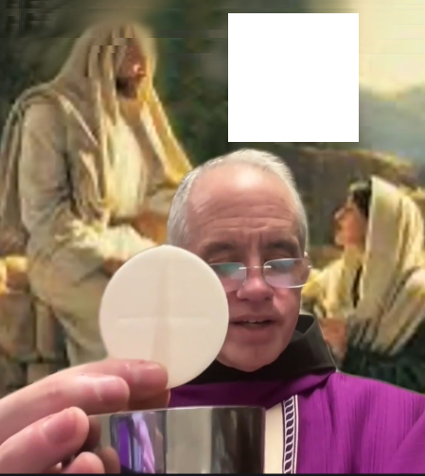
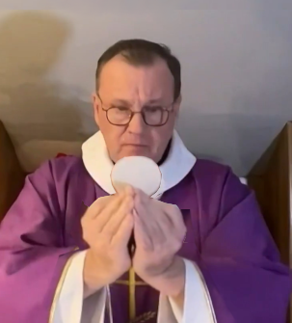
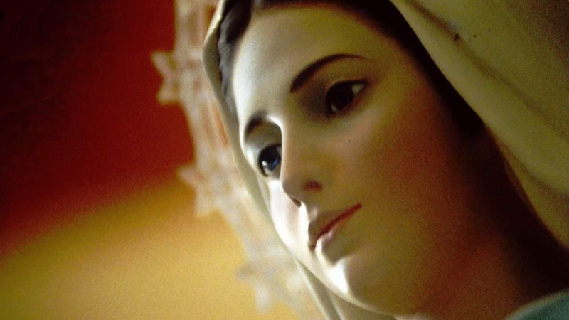
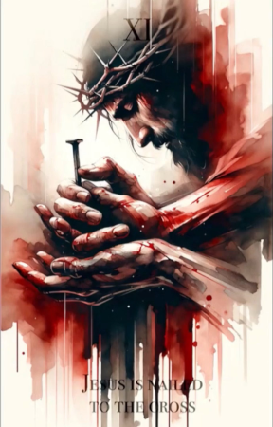

February 28th 2026
Our Lady’s Apparitions to Ivan Dragičević
https://video.marytv.tv/watch/mwNmn6sk0w9
March 8th 2026
There, today as well Our Lady came to us joyful and merry and She greets us all with Her motherly greeting: "Praised be Jesus, my dear children!"

Also today Mother came to us joyful, not as joyful as She often is when She comes, because She is worried, and Her worry can be seen because of all that unrest in the world and the wars.
[…] She extends Her hands upon us all, in Her Aramaic toungue She prays over us all for some time. In particular She prays for peace in the world for a longer time.
And after that She bestows on us all Her motherly blessing.

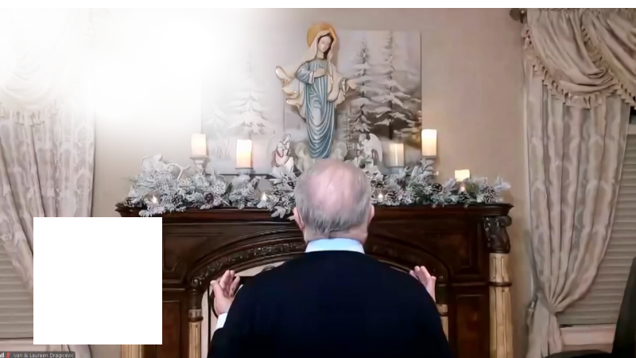

I’d like to particularly stress today that Our Lady for a longer time prayed especially over all of us and for peace in the world.

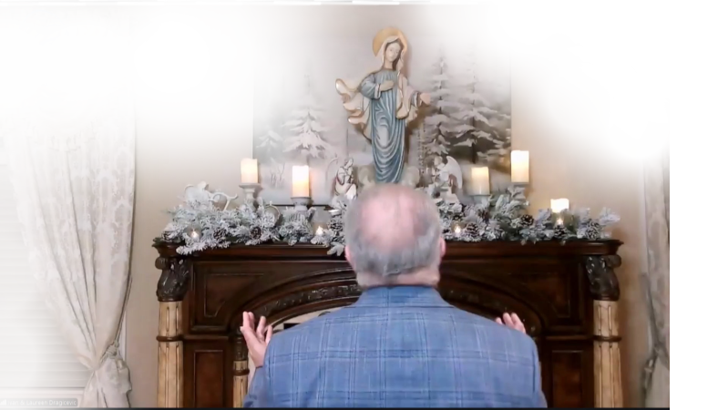



https://video.marytv.tv/watch/mwZneqsk2fV
February 28th 2026
Our Lady’s Apparitions to Ivan Dragičević
March 8th 2026
https://video.marytv.tv/watch/mwNmn6sk0w9
There, today as well Our Lady came to us joyful and merry and She greets us all with Her motherly greeting: "Praised be Jesus, my dear children!"

Also today Mother came to us joyful, not as joyful as She often is when She comes, because She is worried, and Her worry can be seen because of all that unrest in the world and the wars.
[…] She extends Her hands upon us all, in Her Aramaic toungue She prays over us all for some time. In particular She prays for peace in the world for a longer time.
And after that She bestows on us all Her motherly blessing.

I’d like to particularly stress today that Our Lady for a longer time prayed especially over all of us and for peace in the world.

https://video.marytv.tv/watch/mwZneqsk2fV
February 28th 2026
Our Lady’s Apparitions to Ivan Dragičević
March 8th 2026
https://video.marytv.tv/watch/mwNmn6sk0w9
There, today as well Our Lady came to us joyful and merry and She greets us all with Her motherly greeting: "Praised be Jesus, my dear children!"

Also today Mother came to us joyful, not as joyful as She often is when She comes, because She is worried, and Her worry can be seen because of all that unrest in the world and the wars.
[…] She extends Her hands upon us all, in Her Aramaic toungue She prays over us all for some time. In particular She prays for peace in the world for a longer time.
And after that She bestows on us all Her motherly blessing.

I’d like to particularly stress today that Our Lady for a longer time prayed especially over all of us and for peace in the world.

https://video.marytv.tv/watch/mwZneqsk2fV
February 28th 2026
Our Lady’s Apparitions to Ivan Dragičević
March 8th 2026
https://video.marytv.tv/watch/mwNmn6sk0w9
There, today as well Our Lady came to us joyful and merry and She greets us all with Her motherly greeting: "Praised be Jesus, my dear children!"

Also today Mother came to us joyful, not as joyful as She often is when She comes, because She is worried, and Her worry can be seen because of all that unrest in the world and the wars.
[…] She extends Her hands upon us all, in Her Aramaic toungue She prays over us all for some time. In particular She prays for peace in the world for a longer time.
And after that She bestows on us all Her motherly blessing.

I’d like to particularly stress today that Our Lady for a longer time prayed especially over all of us and for peace in the world.

https://video.marytv.tv/watch/mwZneqsk2fV
Our Lady’s Apparitions to Ivan Dragičević
February 28th 2026
March 8th 2026
https://video.marytv.tv/watch/mwNmn6sk0w9
There, today as well Our Lady came to us joyful and merry and She greets us all with Her motherly greeting: "Praised be Jesus, my dear children!"

Also today Mother came to us joyful, not as joyful as She often is when She comes, because She is worried, and Her worry can be seen because of all that unrest in the world and the wars.
[…] She extends Her hands upon us all, in Her Aramaic toungue She prays over us all for some time. In particular She prays for peace in the world for a longer time.
And after that She bestows on us all Her motherly blessing.

I’d like to particularly stress today that Our Lady for a longer time prayed especially over all of us and for peace in the world.

https://video.marytv.tv/watch/mwZneqsk2fV
Our Lady’s Message from Međugorje, March 25th 2026 through seer Marija Pavlović Lunetti

Dear children!
The poison of selfishness and hatred rules human hearts and that is why you do not have peace. I am calling you, little children: be love and my extended hands to all those whom you meet. In humility, pray for peace and work on reconciliation among people, so that it may be good for every person on earth.
Thank you for having responded to my call.

(with ecclesiastical approval)

taken from https://www.medjugorje.hr, compared to locations https://www.medjugorje.ws/, https://marytv.tv, https://www.catholicjourneys.com, https://www.callofthekingdom.com/
Our Lady’s Message from Međugorje, March 18th 2026 through seer Mirjana Dragičević Soldo

Dear children, never forget how great the love of God is. Through that love I am with you. Do not forget how great His mercy is. Through that mercy I am showing you the way to true happiness and perfect peace. That is the way to my Son. Therefore, my children, with complete trust, abandon yourselves to my Son and do not be afraid. Do not be afraid of the future because it belongs entirely to the will of my Son. Therefore, my children, renounce everything that distances you from my Son: false happiness, false hope, false splendor. Trust my Son. Tell Him about your pains, sufferings, desires and hopes. You will feel His love and His blessing. Thank you!
(with ecclesiastical approval)
taken from https://www.medjugorje.hr, compared to locations https://vwww.catholic365 com/, https://marytv.tv, https://www.callofthekingdom.com, https://medjugorje.ws

Our Lady’s Message from Međugorje, March 25th 2026 through seer Marija Pavlović Lunetti
Dear children!
The poison of selfishness and hatred rules human hearts and that is why you do not have peace. I am calling you, little children: be love and my extended hands to all those whom you meet. In humility, pray for peace and work on reconciliation among people, so that it may be good for every person on earth.
Thank you for having responded to my call.

(with ecclesiastical approval)

taken from https://www.medjugorje.hr, compared to locations https://www.medjugorje.ws/, https://marytv.tv, https://www.catholicjourneys.com, https://www.callofthekingdom.com/
Our Lady’s Message from Međugorje, March 18th 2026 through seer Mirjana Dragičević Soldo

Dear children, never forget how great the love of God is. Through that love I am with you. Do not forget how great His mercy is. Through that mercy I am showing you the way to true happiness and perfect peace. That is the way to my Son. Therefore, my children, with complete trust, abandon yourselves to my Son and do not be afraid. Do not be afraid of the future because it belongs entirely to the will of my Son. Therefore, my children, renounce everything that distances you from my Son: false happiness, false hope, false splendor. Trust my Son. Tell Him about your pains, sufferings, desires and hopes. You will feel His love and His blessing. Thank you!
(with ecclesiastical approval)
taken from https://www.medjugorje.hr, compared to locations https://vwww.catholic365 com/, https://marytv.tv, https://www.callofthekingdom.com, https://medjugorje.ws

Our Lady’s Message from Međugorje, March 25th 2026 through seer Marija Pavlović Lunetti
Dear children!
The poison of selfishness and hatred rules human hearts and that is why you do not have peace. I am calling you, little children: be love and my extended hands to all those whom you meet. In humility, pray for peace and work on reconciliation among people, so that it may be good for every person on earth.
Thank you for having responded to my call.

(with ecclesiastical approval)

taken from https://www.medjugorje.hr, compared to locations https://www.medjugorje.ws/, https://marytv.tv, https://www.catholicjourneys.com, https://www.callofthekingdom.com/
Our Lady’s Message from Međugorje, March 18th 2026 through seer Mirjana Dragičević Soldo

Dear children, never forget how great the love of God is. Through that love I am with you. Do not forget how great His mercy is. Through that mercy I am showing you the way to true happiness and perfect peace. That is the way to my Son. Therefore, my children, with complete trust, abandon yourselves to my Son and do not be afraid. Do not be afraid of the future because it belongs entirely to the will of my Son. Therefore, my children, renounce everything that distances you from my Son: false happiness, false hope, false splendor. Trust my Son. Tell Him about your pains, sufferings, desires and hopes. You will feel His love and His blessing. Thank you!
(with ecclesiastical approval)
taken from https://www.medjugorje.hr, compared to locations https://vwww.catholic365 com/, https://marytv.tv, https://www.callofthekingdom.com, https://medjugorje.ws

Our Lady’s Message from Međugorje, March 25th 2026 through seer Marija Pavlović Lunetti
Dear children!
The poison of selfishness and hatred rules human hearts and that is why you do not have peace. I am calling you, little children: be love and my extended hands to all those whom you meet. In humility, pray for peace and work on reconciliation among people, so that it may be good for every person on earth.
Thank you for having responded to my call.

(with ecclesiastical approval)

taken from https://www.medjugorje.hr, compared to locations https://www.medjugorje.ws/, https://marytv.tv, https://www.catholicjourneys.com, https://www.callofthekingdom.com/
Our Lady’s Message from Međugorje, March 18th 2026 through seer Mirjana Dragičević Soldo

Dear children, never forget how great the love of God is. Through that love I am with you. Do not forget how great His mercy is. Through that mercy I am showing you the way to true happiness and perfect peace. That is the way to my Son. Therefore, my children, with complete trust, abandon yourselves to my Son and do not be afraid. Do not be afraid of the future because it belongs entirely to the will of my Son. Therefore, my children, renounce everything that distances you from my Son: false happiness, false hope, false splendor. Trust my Son. Tell Him about your pains, sufferings, desires and hopes. You will feel His love and His blessing. Thank you!
(with ecclesiastical approval)
taken from https://www.medjugorje.hr, compared to locations https://vwww.catholic365 com/, https://marytv.tv, https://www.callofthekingdom.com, https://medjugorje.ws

Our Lady’s Message from Međugorje, March 25th 2026 through seer Marija Pavlović Lunetti
Dear children!
The poison of selfishness and hatred rules human hearts and that is why you do not have peace. I am calling you, little children: be love and my extended hands to all those whom you meet. In humility, pray for peace and work on reconciliation among people, so that it may be good for every person on earth.
Thank you for having responded to my call.

(with ecclesiastical approval)

taken from https://www.medjugorje.hr, compared to locations https://www.medjugorje.ws/, https://marytv.tv, https://www.catholicjourneys.com, https://www.callofthekingdom.com/
Our Lady’s Message from Međugorje, March 18th 2026 through seer Mirjana Dragičević Soldo

Dear children, never forget how great the love of God is. Through that love I am with you. Do not forget how great His mercy is. Through that mercy I am showing you the way to true happiness and perfect peace. That is the way to my Son. Therefore, my children, with complete trust, abandon yourselves to my Son and do not be afraid. Do not be afraid of the future because it belongs entirely to the will of my Son. Therefore, my children, renounce everything that distances you from my Son: false happiness, false hope, false splendor. Trust my Son. Tell Him about your pains, sufferings, desires and hopes. You will feel His love and His blessing. Thank you!
(with ecclesiastical approval)
taken from https://www.medjugorje.hr, compared to locations https://vwww.catholic365 com/, https://marytv.tv, https://www.callofthekingdom.com, https://medjugorje.ws

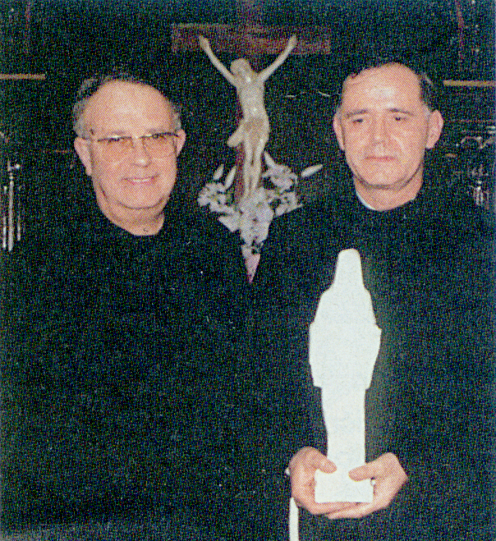
Pope John Paul II: “What else should happen that you may come to believe?”, Arena No. 2177, yr. 2002, pages 12-15
February 2nd 1995 daughter Jessica (in the picture in bottom with the mother, father and the youngest brother in 2005) was the first to see the bloody tears of the statue, then her father Fabio (in the picture) and many more witnesses, for instance the policemen who guarded the statue.
A little statue of the Queen of Peace from Međugorje in the yard of Gregori family in Civitavecchia not far from Rome weeped tears of blood in February and March 1995. The news of that event was in media all over the world. Sceptical at start, the local bishop Girolamo Grillo (in the picture at the very right with Father Jozo Zovko) witnessed in person to a weeping of the little statue.
That little statue of the Queen of Peace from Međugorje is taken by Bp. Grillo to Crd. Ratzinger (the then Prefekt of the Congregation for the Doctrine of the Faith, future Pope Benedict XVI) who reports about it to Pope John Paul II, and takes the statue to him. Father Jozo Zovko relates what Bp. Grillo recounted to him. While this holy Pope held the statue, Bp. Grillo explained to him how the tears streamed down its face, and Pope’s hands shivered. At the suspicion of others present the Pope asked: “What else should happen that you may come to believe?”

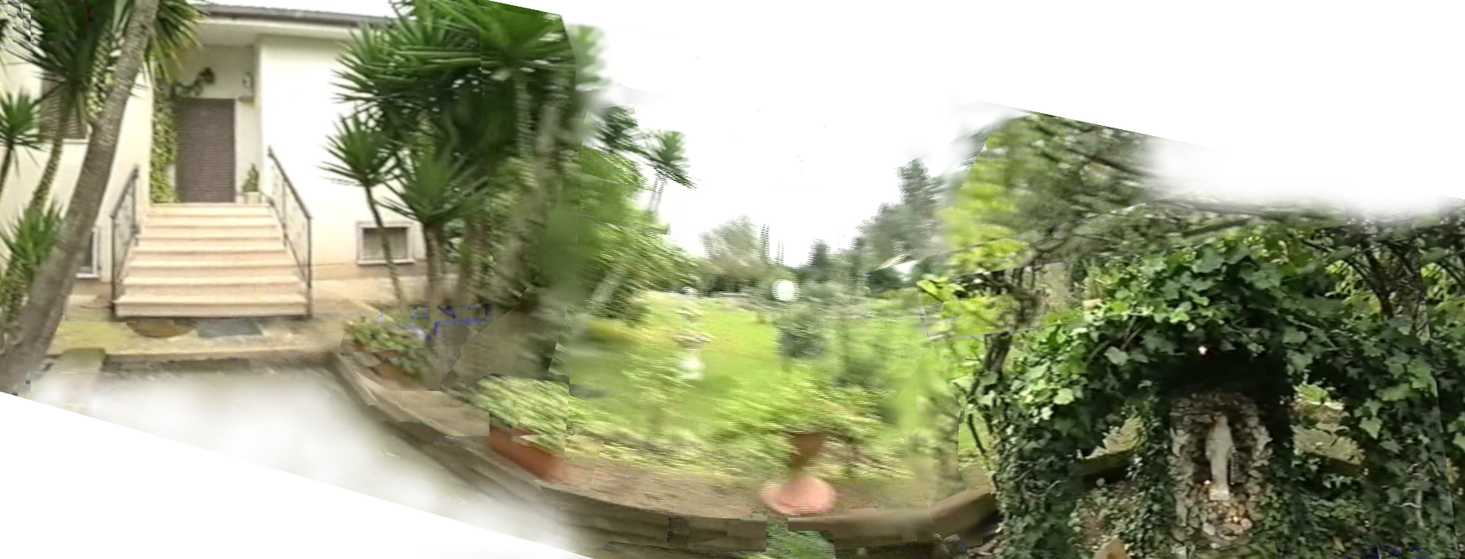
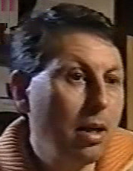
The picture of the bishop with Father Jozo, and the testimony on the Pope’s words are from Arena, a Croatian magazine of the time. All the other pictures are from a recording of the Rai Uno program
which we hope you can view at:
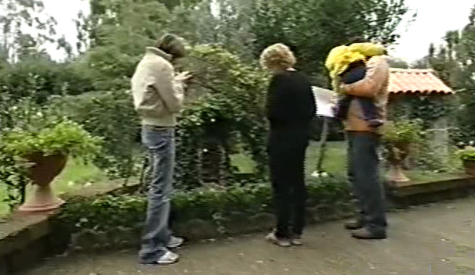
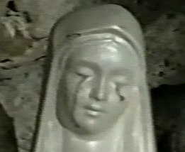
https://rumble.com/v77m4am-rai-uno-2005-civitavecchia.html

The home of Gregori
family, panoramic view,
the little wall is actually straight,
the statue faces the entrance door

Pope John Paul II: “What else should happen that you may come to believe?”, Arena No. 2177, yr. 2002, pages 12-15
A little statue of the Queen of Peace from Međugorje in the yard of Gregori family in Civitavecchia not far from Rome weeped tears of blood in February and March 1995. The news of that event was in media all over the world. Sceptical at start, the local bishop Girolamo Grillo (in the picture at the very right with Father Jozo Zovko) witnessed in person to a weeping of the little statue.
February 2nd 1995 daughter Jessica (in the picture in bottom with the mother, father and the youngest brother in 2005) was the first to see the bloody tears of the statue, then her father Fabio (in the picture) and many more witnesses, for instance the policemen who guarded the statue.
That little statue of the Queen of Peace from Međugorje is taken by Bp. Grillo to Crd. Ratzinger (the then Prefekt of the Congregation for the Doctrine of the Faith, future Pope Benedict XVI) who reports about it to Pope John Paul II, and takes the statue to him. Father Jozo Zovko relates what Bp. Grillo recounted to him. While this holy Pope held the statue, Bp. Grillo explained to him how the tears streamed down its face, and Pope’s hands shivered. At the suspicion of others present the Pope asked: “What else should happen that you may come to believe?”

The picture of the bishop with Father Jozo, and the testimony on the Pope’s words are from Arena, a Croatian magazine of the time. All the other pictures are from a recording of the Rai Uno program
which we hope you can view at:
https://rumble.com/v77m4am-rai-uno-2005-civitavecchia.html
The home of Gregori
family, panoramic view,
the little wall is actually straight,
the statue faces the entrance door

Pope John Paul II: “What else should happen that you may come to believe?”, Arena No. 2177, yr. 2002, pages 12-15
A little statue of the Queen of Peace from Međugorje in the yard of Gregori family in Civitavecchia not far from Rome weeped tears of blood in February and March 1995. The news of that event was in media all over the world. Sceptical at start, the local bishop Girolamo Grillo (in the picture at the very right with Father Jozo Zovko) witnessed in person to a weeping of the little statue.
February 2nd 1995 daughter Jessica (in the picture in bottom with the mother, father and the youngest brother in 2005) was the first to see the bloody tears of the statue, then her father Fabio (in the picture) and many more witnesses, for instance the policemen who guarded the statue.
That little statue of the Queen of Peace from Međugorje is taken by Bp. Grillo to Crd. Ratzinger (the then Prefekt of the Congregation for the Doctrine of the Faith, future Pope Benedict XVI) who reports about it to Pope John Paul II, and takes the statue to him. Father Jozo Zovko relates what Bp. Grillo recounted to him. While this holy Pope held the statue, Bp. Grillo explained to him how the tears streamed down its face, and Pope’s hands shivered. At the suspicion of others present the Pope asked: “What else should happen that you may come to believe?”

The picture of the bishop with Father Jozo, and the testimony on the Pope’s words are from Arena, a Croatian magazine of the time. All the other pictures are from a recording of the Rai Uno program
which we hope you can view at:
https://rumble.com/v77m4am-rai-uno-2005-civitavecchia.html
The home of Gregori
family, panoramic view,
the little wall is actually straight,
the statue faces the entrance door

Pope John Paul II: “What else should happen that you may come to believe?”, Arena No. 2177, yr. 2002, pages 12-15
A little statue of the Queen of Peace from Međugorje in the yard of Gregori family in Civitavecchia not far from Rome weeped tears of blood in February and March 1995. The news of that event was in media all over the world. Sceptical at start, the local bishop Girolamo Grillo (in the picture at the very right with Father Jozo Zovko) witnessed in person to a weeping of the little statue.
February 2nd 1995 daughter Jessica (in the picture in bottom with the mother, father and the youngest brother in 2005) was the first to see the bloody tears of the statue, then her father Fabio (in the picture) and many more witnesses, for instance the policemen who guarded the statue.
That little statue of the Queen of Peace from Međugorje is taken by Bp. Grillo to Crd. Ratzinger (the then Prefekt of the Congregation for the Doctrine of the Faith, future Pope Benedict XVI) who reports about it to Pope John Paul II, and takes the statue to him. Father Jozo Zovko relates what Bp. Grillo recounted to him. While this holy Pope held the statue, Bp. Grillo explained to him how the tears streamed down its face, and Pope’s hands shivered. At the suspicion of others present the Pope asked: “What else should happen that you may come to believe?”

The picture of the bishop with Father Jozo, and the testimony on the Pope’s words are from Arena, a Croatian magazine of the time. All the other pictures are from a recording of the Rai Uno program which we hope you can view at:
https://rumble.com/v77m4am-rai-uno-2005-civitavecchia.html
The home of Gregori
family, panoramic view,
the little wall is actually straight,
the statue faces the entrance door

Pope John Paul II: “What else should happen that you may come to believe?”, Arena No. 2177, yr. 2002, pages 12-15
A little statue of the Queen of Peace from Međugorje in the yard of Gregori family in Civitavecchia not far from Rome weeped tears of blood in February and March 1995. The news of that event was in media all over the world. Sceptical at start, the local bishop Girolamo Grillo (in the picture at the very right with Father Jozo Zovko) witnessed in person to a weeping of the little statue.
February 2nd 1995 daughter Jessica (in the picture in bottom with the mother, father and the youngest brother in 2005) was the first to see the bloody tears of the statue, then her father Fabio (in the picture) and many more witnesses, for instance the policemen who guarded the statue.
That little statue of the Queen of Peace from Međugorje is taken by Bp. Grillo to Crd. Ratzinger (the then Prefekt of the Congregation for the Doctrine of the Faith, future Pope Benedict XVI) who reports about it to Pope John Paul II, and takes the statue to him. Father Jozo Zovko relates what Bp. Grillo recounted to him. While this holy Pope held the statue, Bp. Grillo explained to him how the tears streamed down its face, and Pope’s hands shivered. At the suspicion of others present the Pope asked: “What else should happen that you may come to believe?”

The picture of the bishop with Father Jozo, and the testimony on the Pope’s words are from Arena, a Croatian magazine of the time. All the other pictures are from a recording of the Rai Uno program
which we hope you can view at:
https://rumble.com/v77m4am-rai-uno-2005-civitavecchia.html
The home of Gregori
family, panoramic view,
the little wall is actually straight,
the statue faces the entrance door
Our Lady’s message from Međugorje, April 25th 2026 through visionary Marija Pavlović Lunetti
Dear children!
I am praying for you and encourage you to a new life, a life in joy and prayer. May the Holy Spirit fill you, little children, with joy so that you may be like a spring of pure and drinkable water; that you, little children, may be in God and with God missionaries of love and peace. Your life is short here on earth and that is why I am with you to lead you towards Heaven.
Thank you for having responded to my call.

(with Ecclesiastical approval)
taken from https://www.medjugorje.hr, compared to locations https://medjugorje.ws, https://centermirmedjugorje.com, https://www.medjugorje.cc, https://marytv.tv, https://rosasparalagospa.com, https://themedjugorjewitness.org

Our Lady’s message from Međugorje, April 25th 2026 through visionary Marija Pavlović Lunetti
Dear children!
I am praying for you and encourage you to a new life, a life in joy and prayer. May the Holy Spirit fill you, little children, with joy so that you may be like a spring of pure and drinkable water; that you, little children, may be in God and with God missionaries of love and peace. Your life is short here on earth and that is why I am with you to lead you towards Heaven.
Thank you for having responded to my call.

(with Ecclesiastical approval)
taken from https://www.medjugorje.hr, compared to locations https://medjugorje.ws, https://centermirmedjugorje.com, https://www.medjugorje.cc, https://marytv.tv, https://rosasparalagospa.com, https://themedjugorjewitness.org

Our Lady’s message from Međugorje, April 25th 2026 through visionary Marija Pavlović Lunetti
Dear children!
I am praying for you and encourage you to a new life, a life in joy and prayer. May the Holy Spirit fill you, little children, with joy so that you may be like a spring of pure and drinkable water; that you, little children, may be in God and with God missionaries of love and peace. Your life is short here on earth and that is why I am with you to lead you towards Heaven.
Thank you for having responded to my call.

(with Ecclesiastical approval)
taken from https://www.medjugorje.hr, compared to locations https://medjugorje.ws, https://centermirmedjugorje.com, https://www.medjugorje.cc, https://marytv.tv, https://rosasparalagospa.com, https://themedjugorjewitness.org

Our Lady’s message from Međugorje, April 25th 2026 through visionary Marija Pavlović Lunetti
Dear children!
I am praying for you and encourage you to a new life, a life in joy and prayer. May the Holy Spirit fill you, little children, with joy so that you may be like a spring of pure and drinkable water; that you, little children, may be in God and with God missionaries of love and peace. Your life is short here on earth and that is why I am with you to lead you towards Heaven.
Thank you for having responded to my call.

(with Ecclesiastical approval)
taken from https://www.medjugorje.hr, compared to locations https://medjugorje.ws, https://centermirmedjugorje.com, https://www.medjugorje.cc, https://marytv.tv, https://rosasparalagospa.com, https://themedjugorjewitness.org

Our Lady’s message from Međugorje, April 25th 2026 through visionary Marija Pavlović Lunetti
Dear children!
I am praying for you and encourage you to a new life, a life in joy and prayer. May the Holy Spirit fill you, little children, with joy so that you may be like a spring of pure and drinkable water; that you, little children, may be in God and with God missionaries of love and peace. Your life is short here on earth and that is why I am with you to lead you towards Heaven.
Thank you for having responded to my call.

(with Ecclesiastical approval)
taken from https://www.medjugorje.hr, compared to locations https://medjugorje.ws, https://centermirmedjugorje.com, https://www.medjugorje.cc, https://marytv.tv, https://rosasparalagospa.com, https://themedjugorjewitness.org

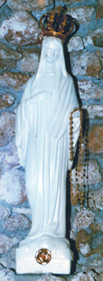

August 26th 1995, from ppg. 75-76 of the book of messages “Our Lady of Civitavecchia” by Fr Flavio Ubodi:
Il Messagero of Wednesday, June 1st 2005
Holy Father John Paul II venerated the Međugorje statue of Our Lady of Civitavecchia
Vatican City - “The Madonna of Civitavecchia will do great things” said Benedict XVI on Monday, as he was greeting bishop Girolamo Grillo at the end of the meeting with the Italian Episcopal Conference. Exactly on April 1st, the day before the death of John Paul II, the bishop of Civitavecchia gave a dossier to the Congregation for the Doctrine of faith chaired by Crd. Ratzinger. […] Repeating things partly already known, but adding other new details, Grillo told that one evening […] in 1995, he carried the miraculous statuette to the Vatican to John Paul II, who venerated it, prayed in front of it and, at the end, placed on the head of the Virgin a crown which he had brought himself. A meticulous account of the evening and the veneration that the Pontiff expressed is written in the journal of Msgr. Grillo who, fearing he would not be believed after his death on the gestures accomplished by Pope Wojtyla, asked of his secretary Msgr. Stanislaw Dziwisz a kind of testimony of the Pontiff himself. A copy of the pages of the journal was sent to the Vatican, and the Pope authenticated it with his signature: “Joannes Paulus PP II” and the date October 20, 2000.
My dear children, I cry because I am talking to you in every part of the world giving you extraordinary signs, but you don’t listen to me. I am presenting to you in every form, but you do not accept me with true love in your hearts.
You look at my tears as a sign of curiosity, but your heart remains hard and you don’t permit the ligtht of God to enter.

My sweet beloved children, consacrate to my Immaculate Heart, full of Divine love.
Jesus jelously safeguards you in his Divine plan full of love.
Keep on being simple, full of Love for everybody. Pray, pray, pray.
I entreat you, accept this mournful invitation of mine, which I am giving you, today still, from this sacred place that God has consacrated, directed to all the nations of the world.
Open your hearts and your arms in the same fashion and love with which one’s own child is embraced, so to be ready to embrace Christ in the spendor of His glory, because His great advent is about to arrive.
Pray and never get tired of praying. Sweet children of mine, love each other, because love in Christ my son is your key to enter by the small door that leads into the Kingdom of God.
https://archive.medjugorje.hr/en/medjugorje-phenomenon/church/bishops/2005/

Civitavecchia statuette, the crown and rosary gift by John Paul II

report on the left is from official Međugorje web location, QR-code
above will give the link;
more with this QR-code/link:

https://exdeo.net/medjugor/civitavecchia/

August 26th 1995, from ppg. 75-76 of the book of messages “Our Lady of Civitavecchia” by Fr Flavio Ubodi:
Il Messagero of Wednesday, June 1st 2005
Holy Father John Paul II venerated the Međugorje statue of Our Lady of Civitavecchia
Vatican City - “The Madonna of Civitavecchia will do great things” said Benedict XVI on Monday, as he was greeting bishop Girolamo Grillo at the end of the meeting with the Italian Episcopal Conference. Exactly on April 1st, the day before the death of John Paul II, the bishop of Civitavecchia gave a dossier to the Congregation for the Doctrine of faith chaired by Crd. Ratzinger. […] Repeating things partly already known, but adding other new details, Grillo told that one evening […] in 1995, he carried the miraculous statuette to the Vatican to John Paul II, who venerated it, prayed in front of it and, at the end, placed on the head of the Virgin a crown which he had brought himself. A meticulous account of the evening and the veneration that the Pontiff expressed is written in the journal of Msgr. Grillo who, fearing he would not be believed after his death on the gestures accomplished by Pope Wojtyla, asked of his secretary Msgr. Stanislaw Dziwisz a kind of testimony of the Pontiff himself. A copy of the pages of the journal was sent to the Vatican, and the Pope authenticated it with his signature: “Joannes Paulus PP II” and the date October 20, 2000.
My dear children, I cry because I am talking to you in every part of the world giving you extraordinary signs, but you don’t listen to me. I am presenting to you in every form, but you do not accept me with true love in your hearts.
You look at my tears as a sign of curiosity, but your heart remains hard and you don’t permit the ligtht of God to enter.

My sweet beloved children, consacrate to my Immaculate Heart, full of Divine love.
Jesus jelously safeguards you in his Divine plan full of love.
Keep on being simple, full of Love for everybody. Pray, pray, pray.
I entreat you, accept this mournful invitation of mine, which I am giving you, today still, from this sacred place that God has consacrated, directed to all the nations of the world.
Open your hearts and your arms in the same fashion and love with which one’s own child is embraced, so to be ready to embrace Christ in the spendor of His glory, because His great advent is about to arrive.
Pray and never get tired of praying. Sweet children of mine, love each other, because love in Christ my son is your key to enter by the small door that leads into the Kingdom of God.
https://archive.medjugorje.hr/en/medjugorje-phenomenon/church/bishops/2005/

Civitavecchia statuette, the crown and rosary gift by John Paul II

report on the left is from official Međugorje web location, QR-code
above will give the link;
more with this QR-code/link:
https://exdeo.net/medjugor/civitavecchia/

August 26th 1995, from ppg. 75-76 of the book of messages “Our Lady of Civitavecchia” by Fr Flavio Ubodi:
Il Messagero of Wednesday, June 1st 2005
Holy Father John Paul II venerated the Međugorje statue of Our Lady of Civitavecchia
Vatican City - “The Madonna of Civitavecchia will do great things” said Benedict XVI on Monday, as he was greeting bishop Girolamo Grillo at the end of the meeting with the Italian Episcopal Conference. Exactly on April 1st, the day before the death of John Paul II, the bishop of Civitavecchia gave a dossier to the Congregation for the Doctrine of faith chaired by Crd. Ratzinger. […] Repeating things partly already known, but adding other new details, Grillo told that one evening […] in 1995, he carried the miraculous statuette to the Vatican to John Paul II, who venerated it, prayed in front of it and, at the end, placed on the head of the Virgin a crown which he had brought himself. A meticulous account of the evening and the veneration that the Pontiff expressed is written in the journal of Msgr. Grillo who, fearing he would not be believed after his death on the gestures accomplished by Pope Wojtyla, asked of his secretary Msgr. Stanislaw Dziwisz a kind of testimony of the Pontiff himself. A copy of the pages of the journal was sent to the Vatican, and the Pope authenticated it with his signature: “Joannes Paulus PP II” and the date October 20, 2000.
My dear children, I cry because I am talking to you in every part of the world giving you extraordinary signs, but you don’t listen to me. I am presenting to you in every form, but you do not accept me with true love in your hearts.
You look at my tears as a sign of curiosity, but your heart remains hard and you don’t permit the ligtht of God to enter.

My sweet beloved children, consacrate to my Immaculate Heart, full of Divine love.
Jesus jelously safeguards you in his Divine plan full of love.
Keep on being simple, full of Love for everybody. Pray, pray, pray.
I entreat you, accept this mournful invitation of mine, which I am giving you, today still, from this sacred place that God has consacrated, directed to all the nations of the world.
Open your hearts and your arms in the same fashion and love with which one’s own child is embraced, so to be ready to embrace Christ in the spendor of His glory, because His great advent is about to arrive.
Pray and never get tired of praying. Sweet children of mine, love each other, because love in Christ my son is your key to enter by the small door that leads into the Kingdom of God.
https://archive.medjugorje.hr/en/medjugorje-phenomenon/church/bishops/2005/

Civitavecchia statuette, the crown and rosary gift by John Paul II

report on the left is from official Međugorje web location, QR-code
above will give the link;
more with this QR-code/link:

https://exdeo.net/medjugor/civitavecchia/

August 26th 1995, from ppg. 75-76 of the book of messages “Our Lady of Civitavecchia” by Fr Flavio Ubodi:
Il Messagero of Wednesday, June 1st 2005
Holy Father John Paul II venerated the Međugorje statue of Our Lady of Civitavecchia
Vatican City - “The Madonna of Civitavecchia will do great things” said Benedict XVI on Monday, as he was greeting bishop Girolamo Grillo at the end of the meeting with the Italian Episcopal Conference. Exactly on April 1st, the day before the death of John Paul II, the bishop of Civitavecchia gave a dossier to the Congregation for the Doctrine of faith chaired by Crd. Ratzinger. […] Repeating things partly already known, but adding other new details, Grillo told that one evening […] in 1995, he carried the miraculous statuette to the Vatican to John Paul II, who venerated it, prayed in front of it and, at the end, placed on the head of the Virgin a crown which he had brought himself. A meticulous account of the evening and the veneration that the Pontiff expressed is written in the journal of Msgr. Grillo who, fearing he would not be believed after his death on the gestures accomplished by Pope Wojtyla, asked of his secretary Msgr. Stanislaw Dziwisz a kind of testimony of the Pontiff himself. A copy of the pages of the journal was sent to the Vatican, and the Pope authenticated it with his signature: “Joannes Paulus PP II” and the date October 20, 2000.
My dear children, I cry because I am talking to you in every part of the world giving you extraordinary signs, but you don’t listen to me. I am presenting to you in every form, but you do not accept me with true love in your hearts.
You look at my tears as a sign of curiosity, but your heart remains hard and you don’t permit the ligtht of God to enter.

My sweet beloved children, consacrate to my Immaculate Heart, full of Divine love.
Jesus jelously safeguards you in his Divine plan full of love.
Keep on being simple, full of Love for everybody. Pray, pray, pray.
I entreat you, accept this mournful invitation of mine, which I am giving you, today still, from this sacred place that God has consacrated, directed to all the nations of the world.
Open your hearts and your arms in the same fashion and love with which one’s own child is embraced, so to be ready to embrace Christ in the spendor of His glory, because His great advent is about to arrive.
Pray and never get tired of praying. Sweet children of mine, love each other, because love in Christ my son is your key to enter by the small door that leads into the Kingdom of God.
https://archive.medjugorje.hr/en/medjugorje-phenomenon/church/bishops/2005/

Civitavecchia statuette, the crown and rosary gift by John Paul II

report on the left is from official Međugorje web location, QR-code
above will give the link;
more with this QR-code/link:
https://exdeo.net/medjugor/civitavecchia/

August 26th 1995, from ppg. 75-76 of the book of messages “Our Lady of Civitavecchia” by Fr Flavio Ubodi:
Il Messagero of Wednesday, June 1st 2005
Holy Father John Paul II venerated the Međugorje statue of Our Lady of Civitavecchia
Vatican City - “The Madonna of Civitavecchia will do great things” said Benedict XVI on Monday, as he was greeting bishop Girolamo Grillo at the end of the meeting with the Italian Episcopal Conference. Exactly on April 1st, the day before the death of John Paul II, the bishop of Civitavecchia gave a dossier to the Congregation for the Doctrine of faith chaired by Crd. Ratzinger. […] Repeating things partly already known, but adding other new details, Grillo told that one evening […] in 1995, he carried the miraculous statuette to the Vatican to John Paul II, who venerated it, prayed in front of it and, at the end, placed on the head of the Virgin a crown which he had brought himself. A meticulous account of the evening and the veneration that the Pontiff expressed is written in the journal of Msgr. Grillo who, fearing he would not be believed after his death on the gestures accomplished by Pope Wojtyla, asked of his secretary Msgr. Stanislaw Dziwisz a kind of testimony of the Pontiff himself. A copy of the pages of the journal was sent to the Vatican, and the Pope authenticated it with his signature: “Joannes Paulus PP II” and the date October 20, 2000.
My dear children, I cry because I am talking to you in every part of the world giving you extraordinary signs, but you don’t listen to me. I am presenting to you in every form, but you do not accept me with true love in your hearts.
You look at my tears as a sign of curiosity, but your heart remains hard and you don’t permit the ligtht of God to enter.

My sweet beloved children, consacrate to my Immaculate Heart, full of Divine love.
Jesus jelously safeguards you in his Divine plan full of love.
Keep on being simple, full of Love for everybody. Pray, pray, pray.
I entreat you, accept this mournful invitation of mine, which I am giving you, today still, from this sacred place that God has consacrated, directed to all the nations of the world.
Open your hearts and your arms in the same fashion and love with which one’s own child is embraced, so to be ready to embrace Christ in the spendor of His glory, because His great advent is about to arrive.
Pray and never get tired of praying. Sweet children of mine, love each other, because love in Christ my son is your key to enter by the small door that leads into the Kingdom of God.
https://archive.medjugorje.hr/en/medjugorje-phenomenon/church/bishops/2005/

Civitavecchia statuette, the crown and rosary gift by John Paul II

report on the left is from official Međugorje web location, QR-code
above will give the link;
more with this QR-code/link:
https://exdeo.net/medjugor/civitavecchia/
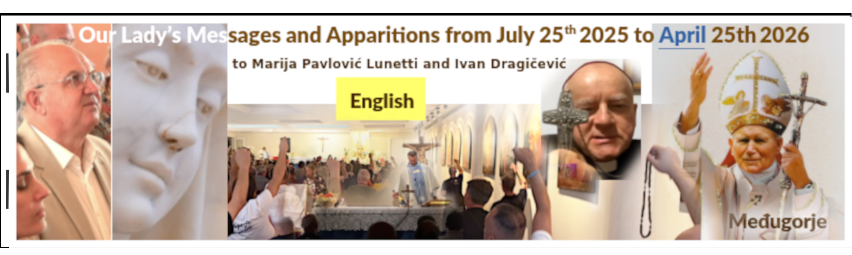

Some of our Office documents, including this that you might be reading you get by scanning the QR-code to the left to visit the link below (unless we’re censored and/or our domain blocked/hacked), so that who want may print them themselves:
https://exdeo.net/medjugor/print/

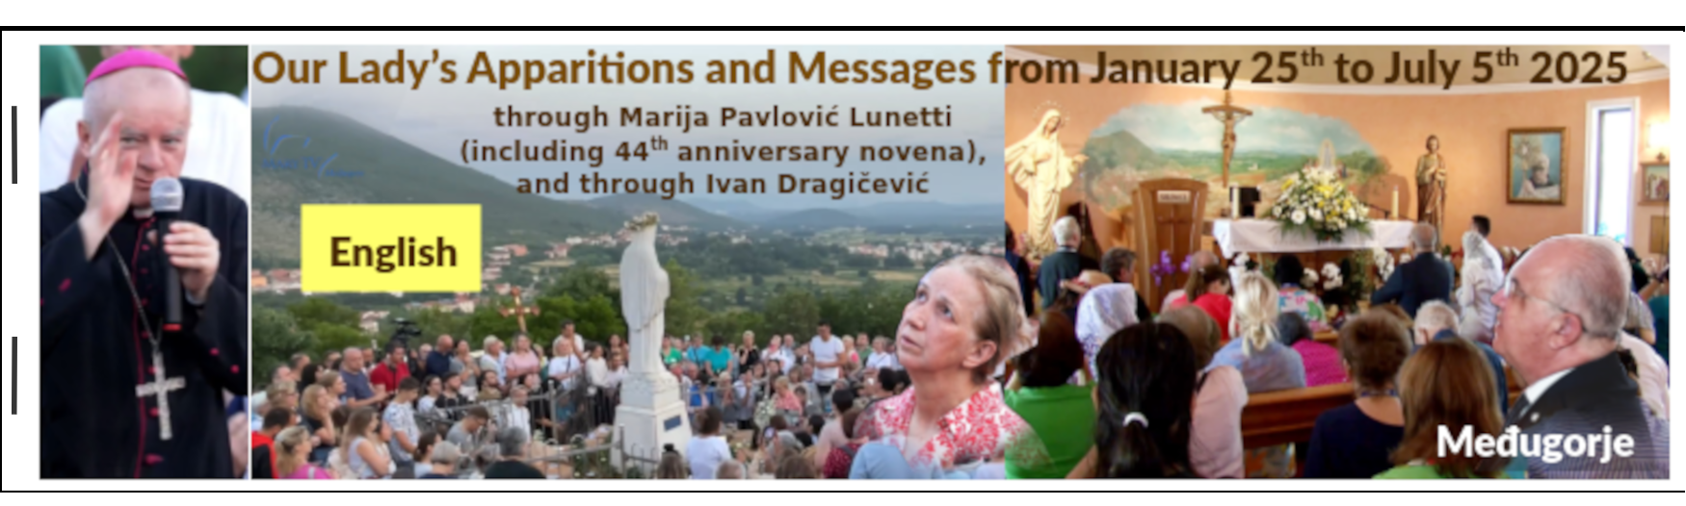

https://rumble.com/v6uv951-medjugorje-print.html
And here’s how almost anyone can print this and other booklets like this with not so much financial investment, just a relatively cheap printer, a good cutter and a few even simpler tools. However, the time needed to manually do all the printing, and all the cutting and sorting and stapling with this inexpert method may be a real obstacle.

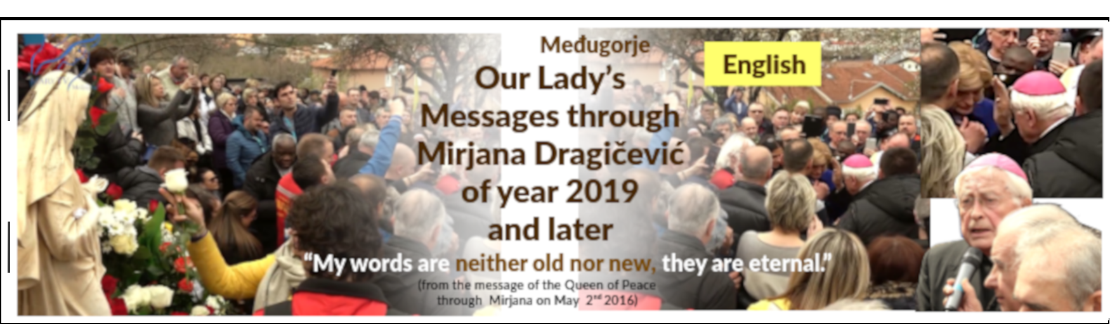

https://rumble.com/v77r9ik-medjugorje-print.html
In the above method the sorting is wrong. I show here how the sorting and cutting of sheets is done right, and much easier and faster, to then staple-bind the booklets. And the booklets are thus correcly bound and look right.

Some of our Office documents, including this that you might be reading you get by scanning the QR-code to the left to visit the link below (unless we’re censored and/or our domain blocked/hacked), so that who want may print them themselves:
https://exdeo.net/medjugor/print/

https://rumble.com/v6uv951-medjugorje-print.html
And here’s how almost anyone can print this and other booklets like this with not so much financial investment, just a relatively cheap printer, a good cutter and a few even simpler tools. However, the time needed to manually do all the printing, and all the cutting and sorting and stapling with this inexpert method may be a real obstacle.

https://rumble.com/v77r9ik-medjugorje-print.html
In the above method the sorting is wrong. I show here how the sorting and cutting of sheets is done right, and much easier and faster, to then staple-bind the booklets. And the booklets are thus correcly bound and look right.

Some of our Office documents, including this that you might be reading you get by scanning the QR-code to the left to visit the link below (unless we’re censored and/or our domain blocked/hacked), so that who want may print them themselves:
https://exdeo.net/medjugor/print/

https://rumble.com/v6uv951-medjugorje-print.html
And here’s how almost anyone can print this and other booklets like this with not so much financial investment, just a relatively cheap printer, a good cutter and a few even simpler tools. However, the time needed to manually do all the printing, and all the cutting and sorting and stapling with this inexpert method may be a real obstacle.

https://rumble.com/v77r9ik-medjugorje-print.html
In the above method the sorting is wrong. I show here how the sorting and cutting of sheets is done right, and much easier and faster, to then staple-bind the booklets. And the booklets are thus correcly bound and look right.

Some of our Office documents, including this that you might be reading you get by scanning the QR-code to the left to visit the link below (unless we’re censored and/or our domain blocked/hacked), so that who want may print them themselves:
https://exdeo.net/medjugor/print/

https://rumble.com/v6uv951-medjugorje-print.html
And here’s how almost anyone can print this and other booklets like this with not so much financial investment, just a relatively cheap printer, a good cutter and a few even simpler tools. However, the time needed to manually do all the printing, and all the cutting and sorting and stapling with this inexpert method may be a real obstacle.

https://rumble.com/v77r9ik-medjugorje-print.html
In the above method the sorting is wrong. I show here how the sorting and cutting of sheets is done right, and much easier and faster, to then staple-bind the booklets. And the booklets are thus correcly bound and look right.

Some of our Office documents, including this that you might be reading you get by scanning the QR-code to the left to visit the link below (unless we’re censored and/or our domain blocked/hacked), so that who want may print them themselves:
https://exdeo.net/medjugor/print/

https://rumble.com/v6uv951-medjugorje-print.html
And here’s how almost anyone can print this and other booklets like this with not so much financial investment, just a relatively cheap printer, a good cutter and a few even simpler tools. However, the time needed to manually do all the printing, and all the cutting and sorting and stapling with this inexpert method may be a real obstacle.

https://rumble.com/v77r9ik-medjugorje-print.html
In the above method the sorting is wrong. I show here how the sorting and cutting of sheets is done right, and much easier and faster, to then staple-bind the booklets. And the booklets are thus correcly bound and look right.

